Nagios

Lab Guide

**www.zippyops.com**

172-172, 5th floor Old Mahabalipuram Road

(Above Axis Bank-PTC Bus Stop)  
Thuraipakkam  
Chennai 600097

**🖂**[**zippyops@gmail.com**](mailto:zippyops@gmail.com)

**✆+91 7010585768**

# Setting up Lab with virtual box

In this Lab we are going to use virtual box to setup our lab environment. In this Lab we will use 4 machines, following are the details

**Centos Server:**

OS: CentOS 7 (Server installation)

Vcpu: 1

Ram: 2 GB

Disk: 20 GB

**Centos Node:**

OS: CentOS 7 (Server installation)

Vcpu: 1

Ram: 1 GB

Disk: 20 GB

**centos Node:**

OS: Ubuntu 16.04.1 LTS

Vcpu: 1

Ram: 1 GB

Disk: 20 GB

## Install Virtual Box

VirtualBox allows you to run an entire operating system inside another operating system. You can download the latest version of virtual box for windows in below link

https://www.virtualbox.org/wiki/Downloads

Install it the same way you would any normal Windows program

## Configure Host Only network

By using this type of adapter, you’ll be able to access a private, virtual network consisting solely of your host and any guests. Any of the member machines can access each other, but nothing outside of this self-contained “network in a box” can get in.

VirtualBox can create several of these virtual host-only networks. You can configure these in the VirtualBox Preferences.

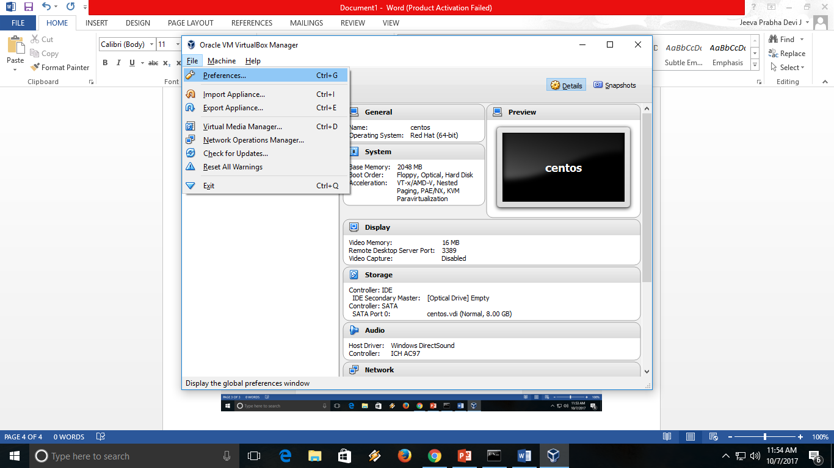In the preference window select “Network” and select “Host only Networks”

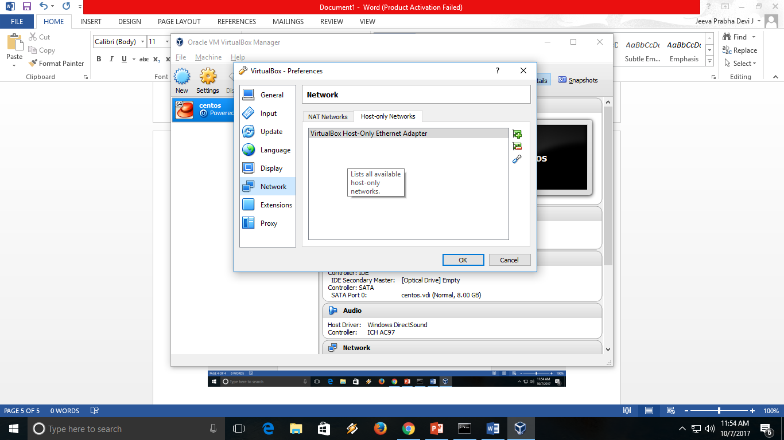

You should see the default “VirtualBox Host Only Ethernet Adapter”. If not click on the add network button and create one as shown below

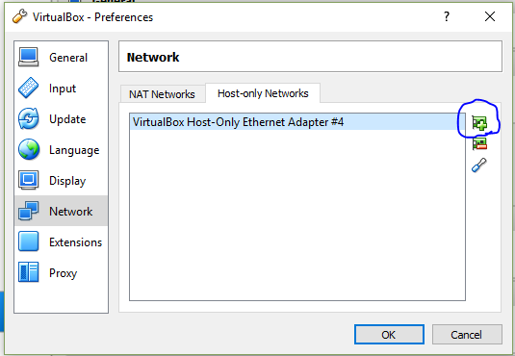

Select the network and click on screw driver icon in the window, you should see the below screen

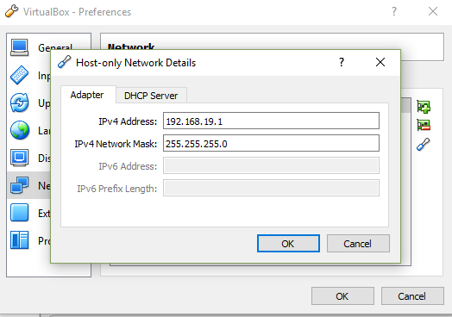

In the IPV4 address enter 192.168.19.1 and enter 255.255.255.0 as Network Mask.

Note: You can select any private IP range you are comfortable with.

Click on DHCP Server

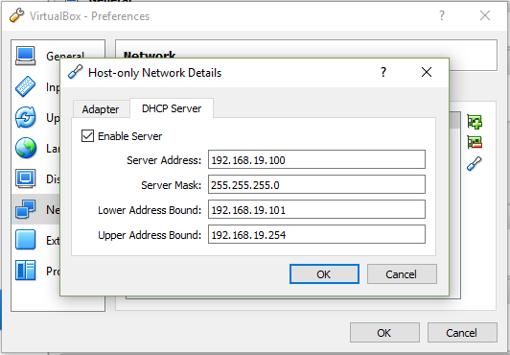

Enter the Ip address mentioned in the screen shot. Click ok to save and close

Note: If you have chosen different Ip range, enter the IP address appropriately.

## Configuration before installation

Click New to create a new server

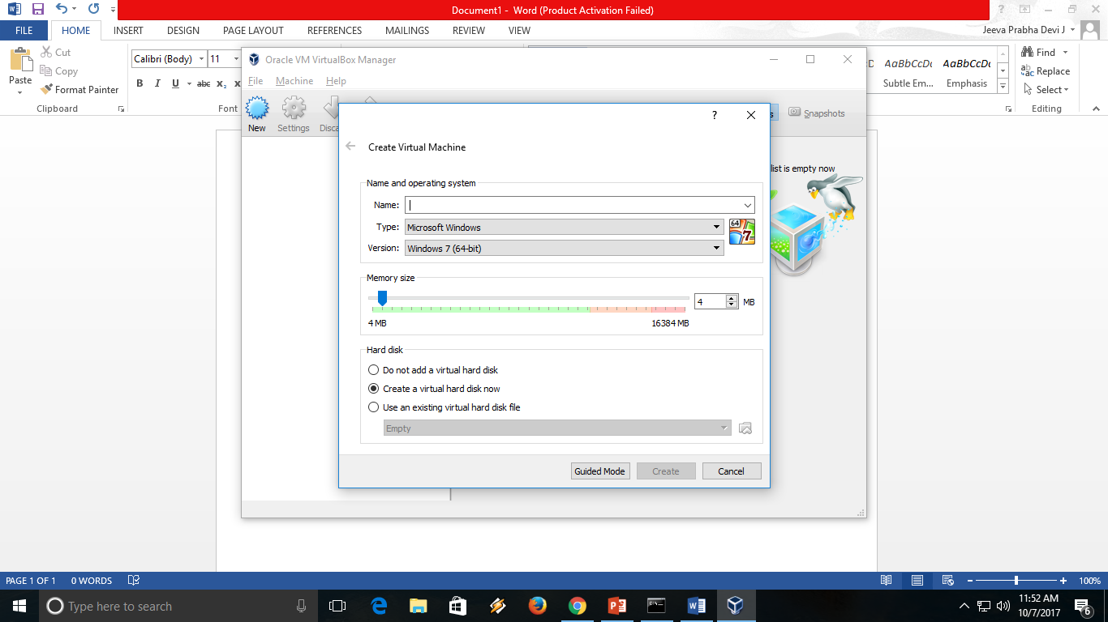

Enter name as centos base, so that we can reuse the same to clone centos node. It will automatically select the type as RedHat, leave as it is.

Enter memory size as 2048 MB and click create

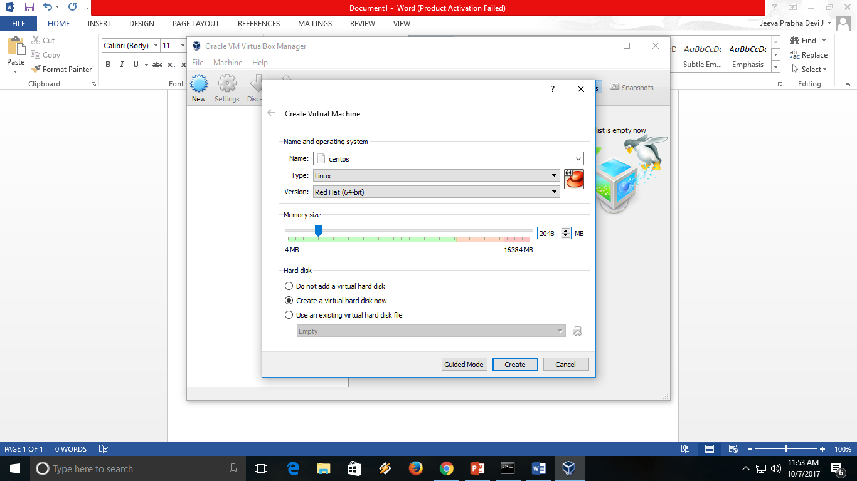

Select file size as 20 Gb

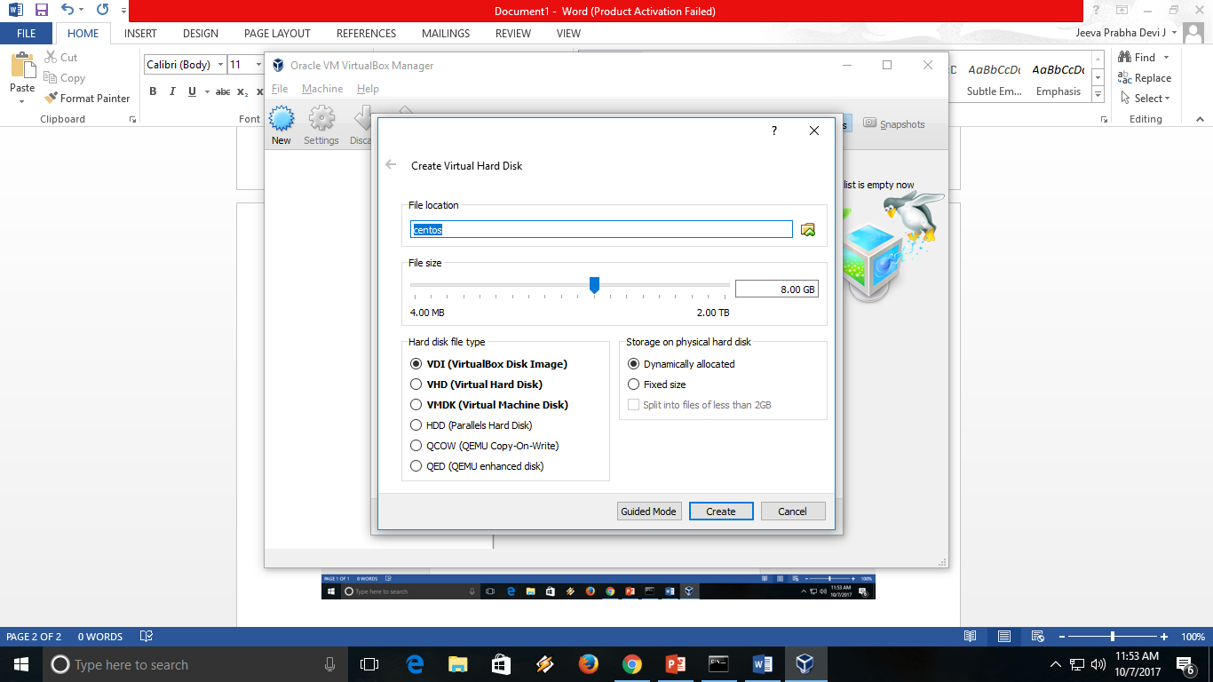

After created select the centos base, which is newly created and click on settings.

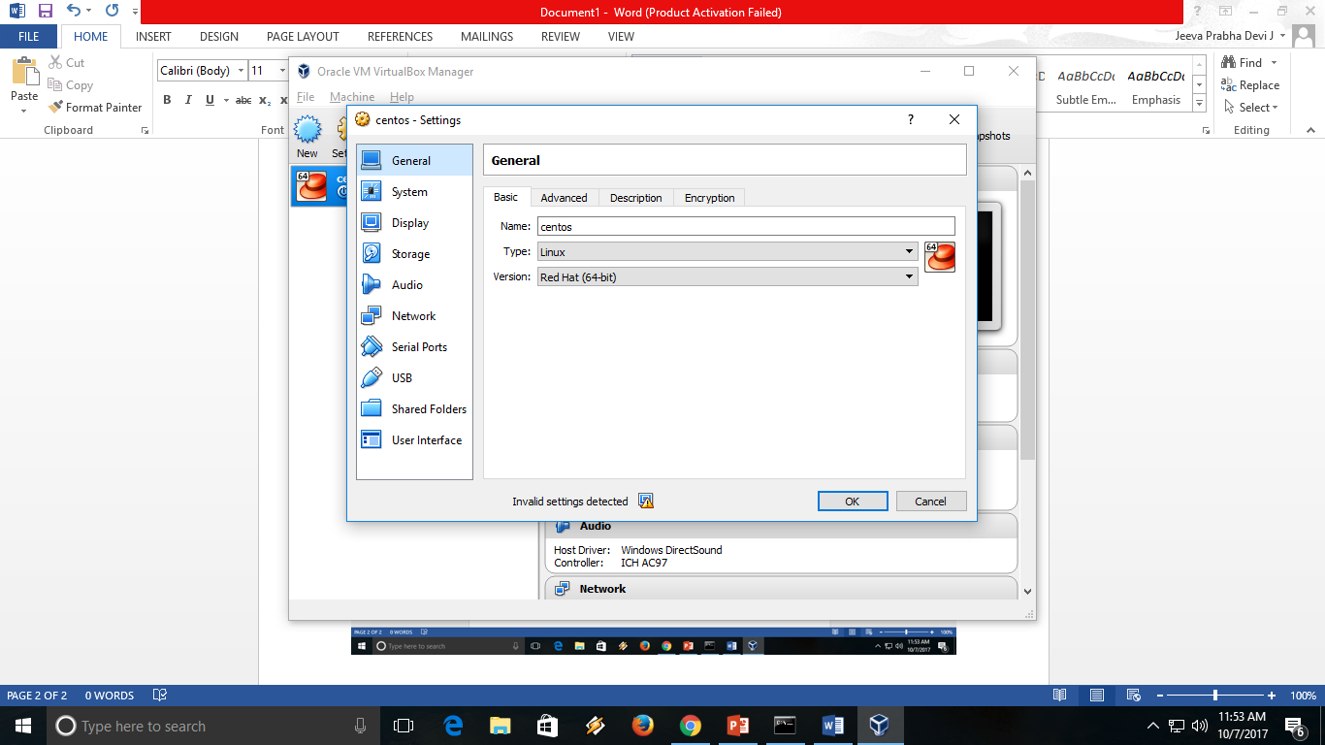

Select Network, in the adapter 1 leave default NAT. This network interface is used to connect to internet via Natting with the host.

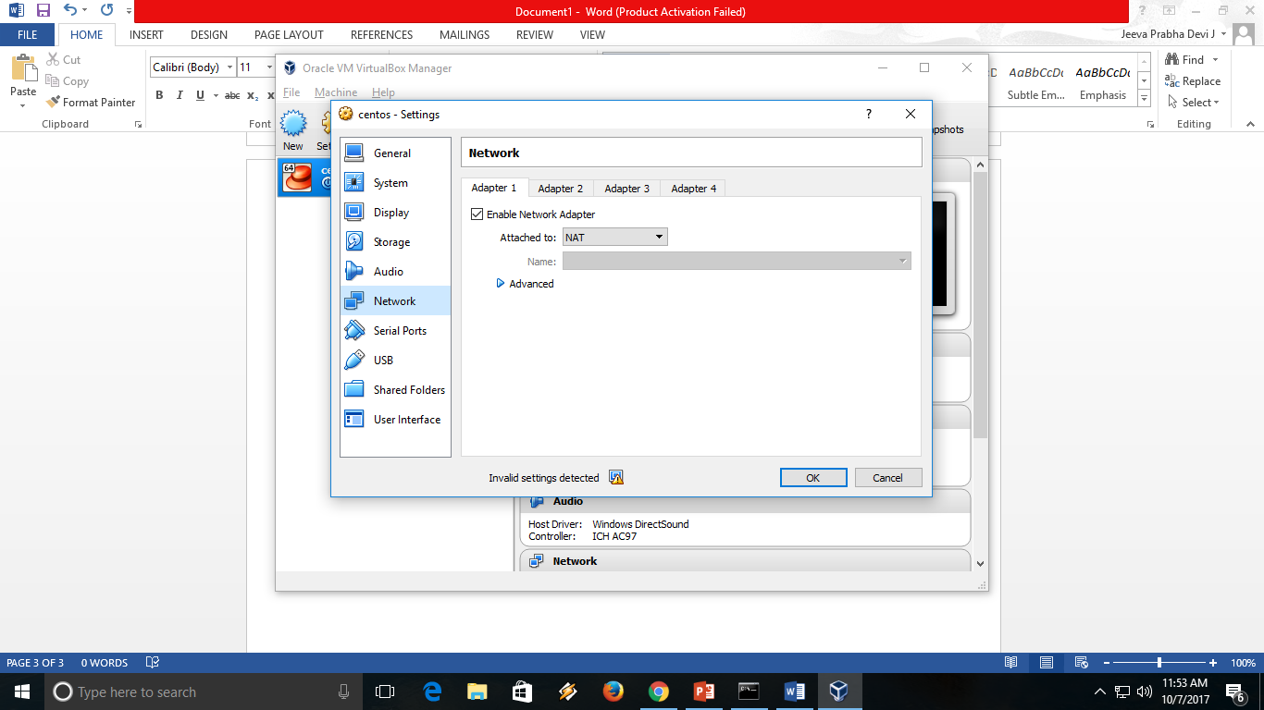

In the Adapter 2, select enable and select the host only adapter we created early

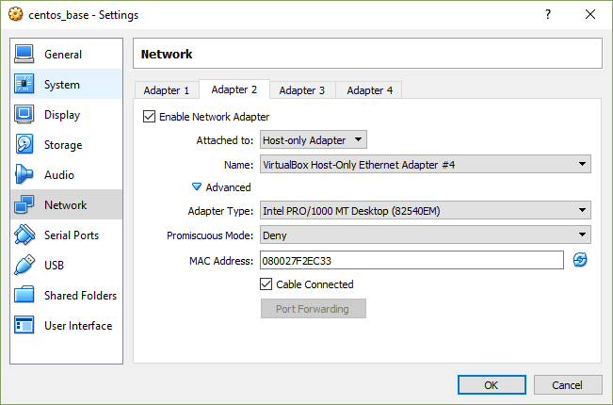

Click on storage , under IDE select empty. Click on the CD icon on the Optical drive and select the OS image stored on the host

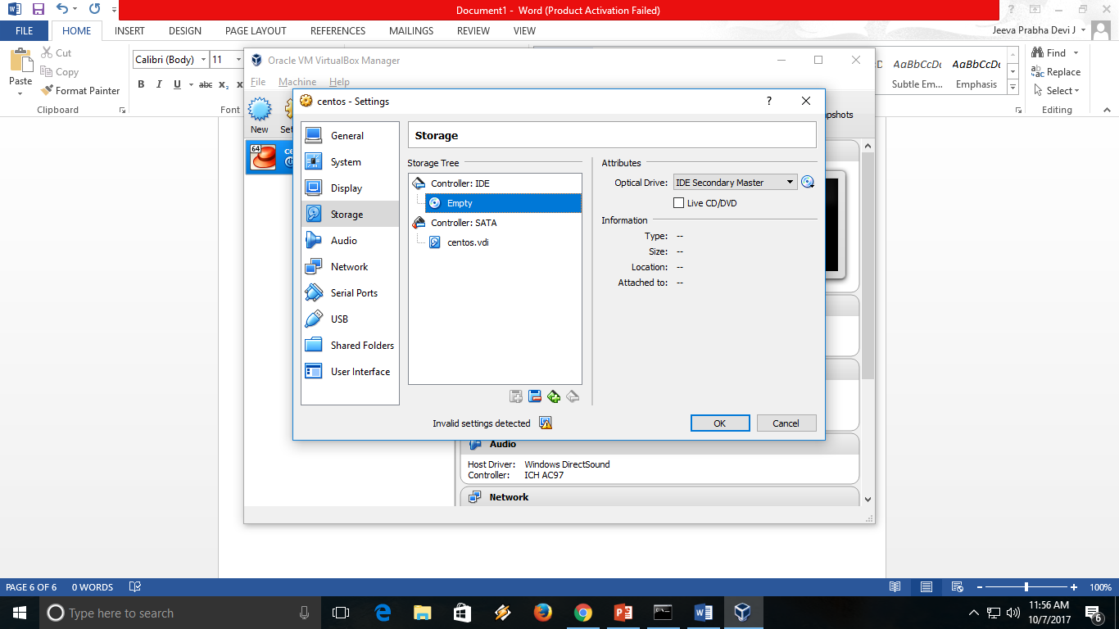

## Install CentOs

Double click on the new virtual machine to start the machine

Once booted, select install Centos

Select language for installation as English and click continue

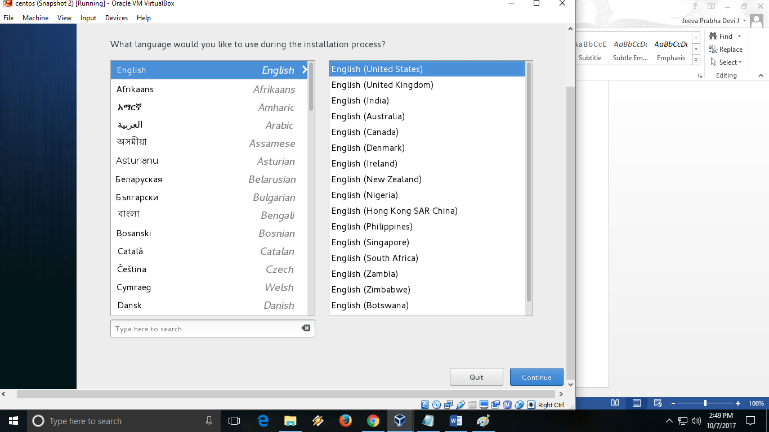

If your mouse is trapped inside the virtual box, press “CTRL” key on the right hand side of the keyboard to release the same.

If you double click inside the virtual box, you will be able to use the mouse inside the guest machine.

In the next screen, select software selection 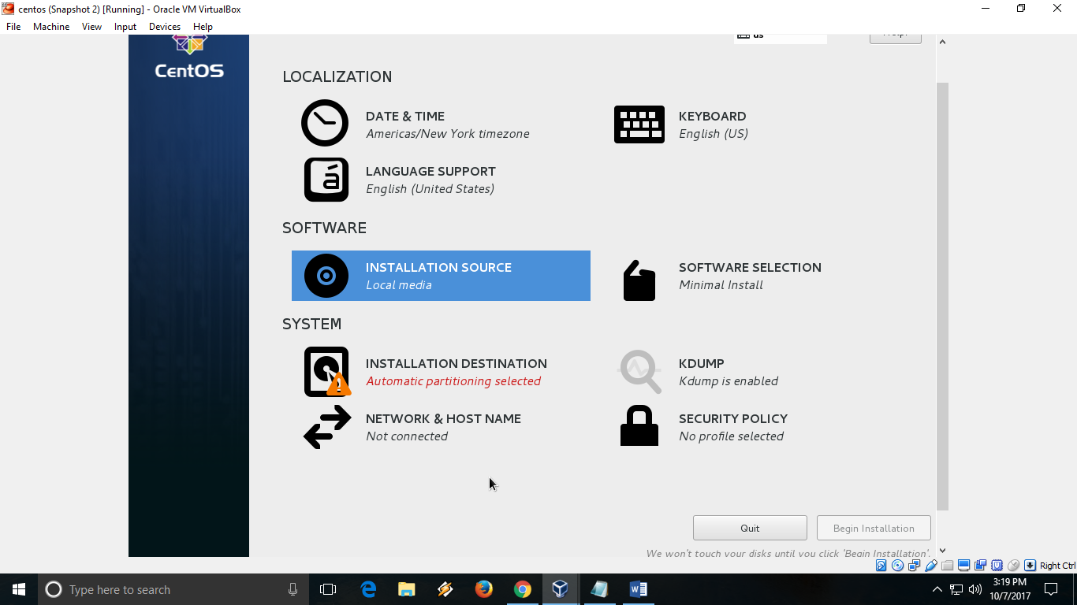

Select server with GUI

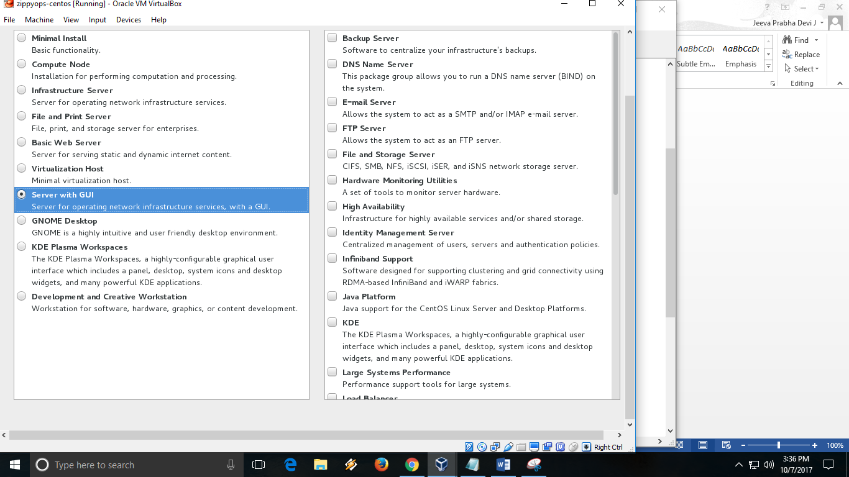

Click on installation destination and click done

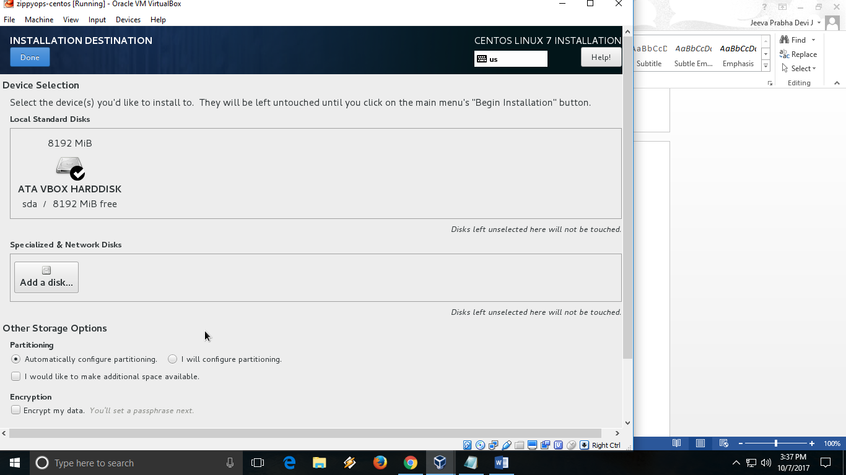

Click Begin installation

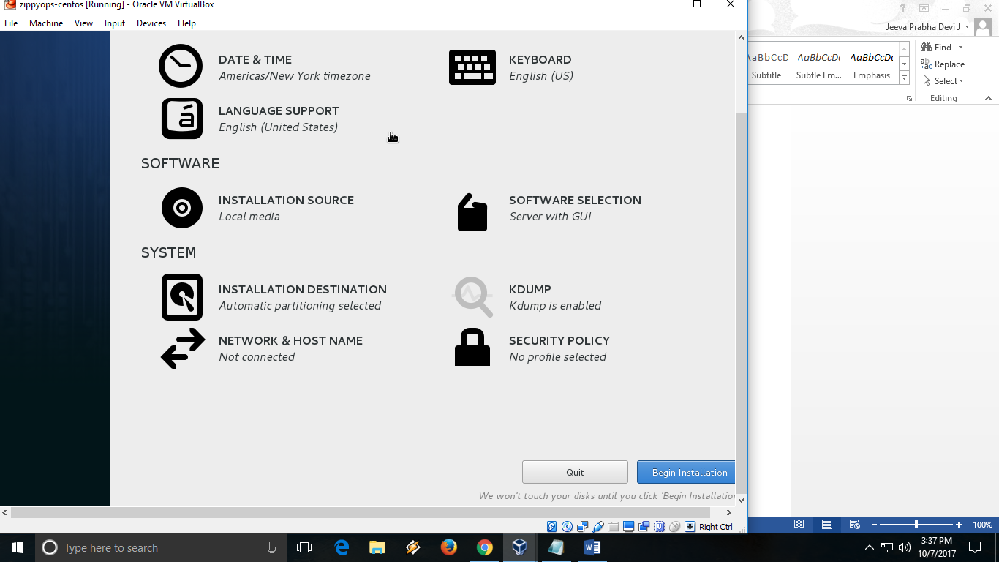

During the installation, set the root password and create a user. Click on root password

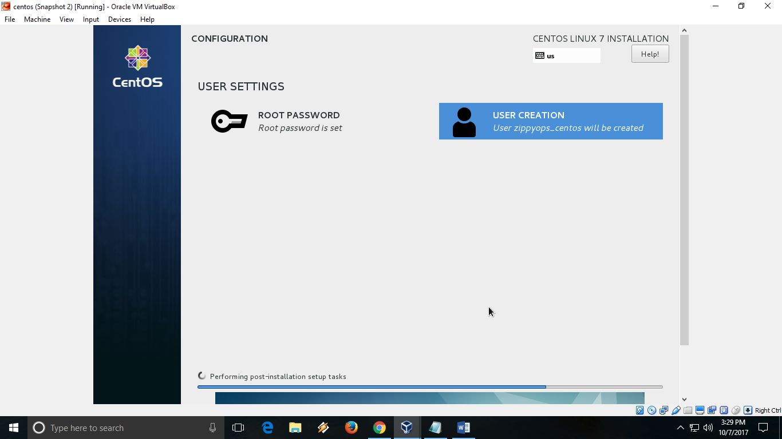

Set a root password and write it somewhere safe.

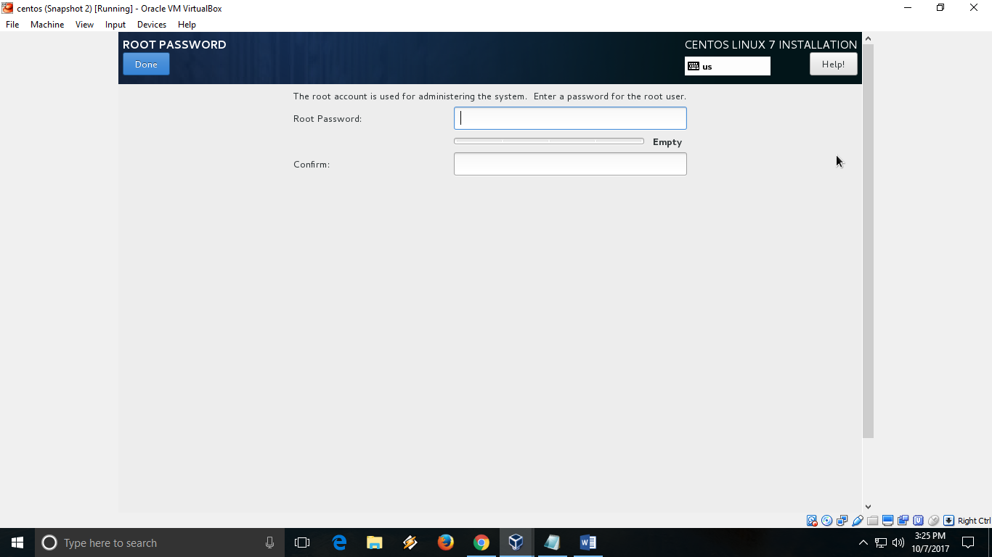

Note : If you have a simple password, you have to press done twice to use a simple password

Crete a user by providing a full name, password. Make sure you select the “Make this user administrator”

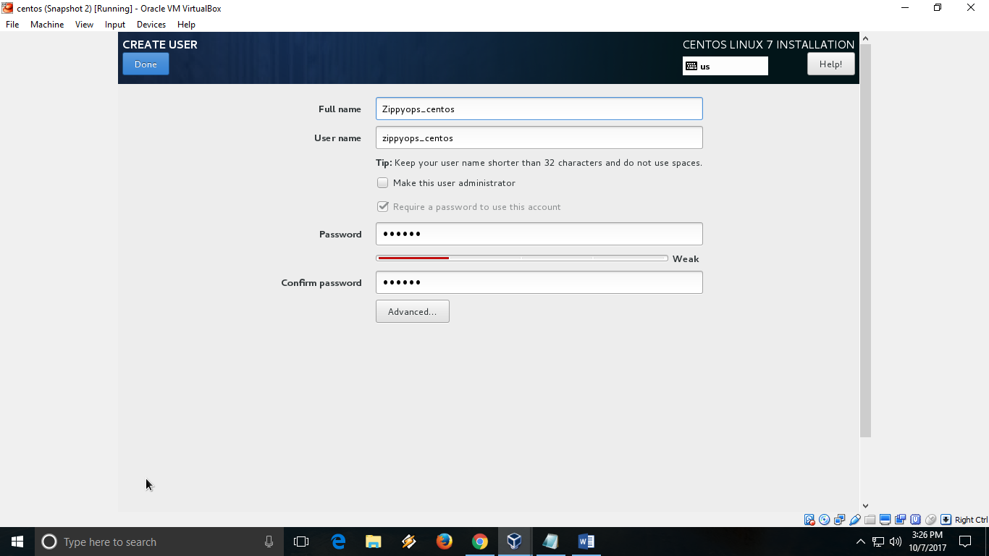

After installation is completed, it will ask you to restart. Click reboot to restart the server.

After reboot, you will see the below screen.

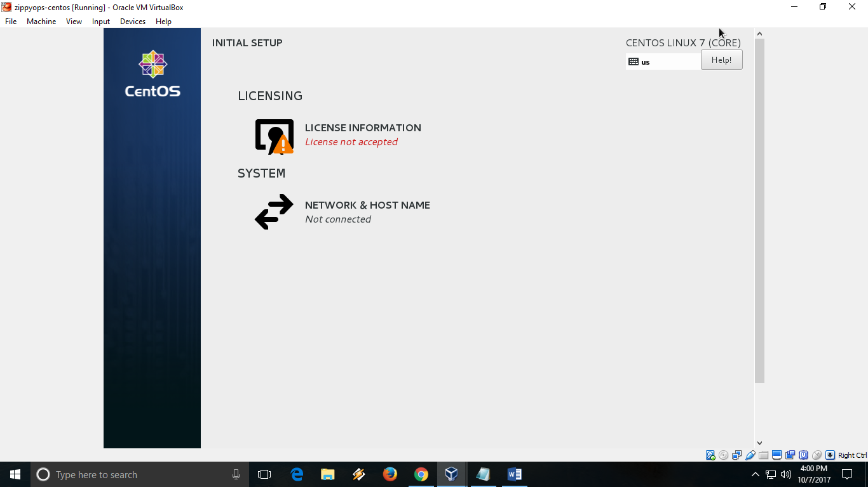

Click on License information and accept the EULA

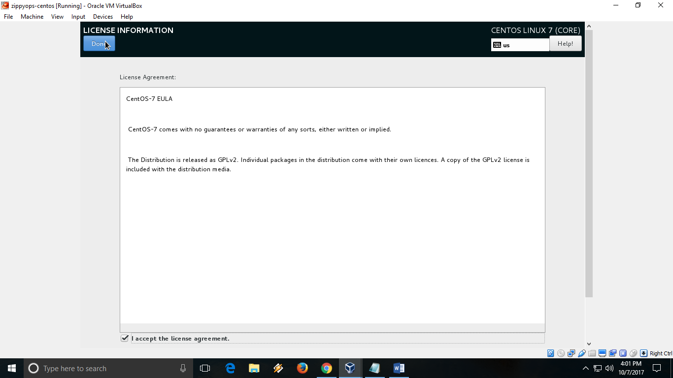

Select Network and HOST Name and enable both the network adapters

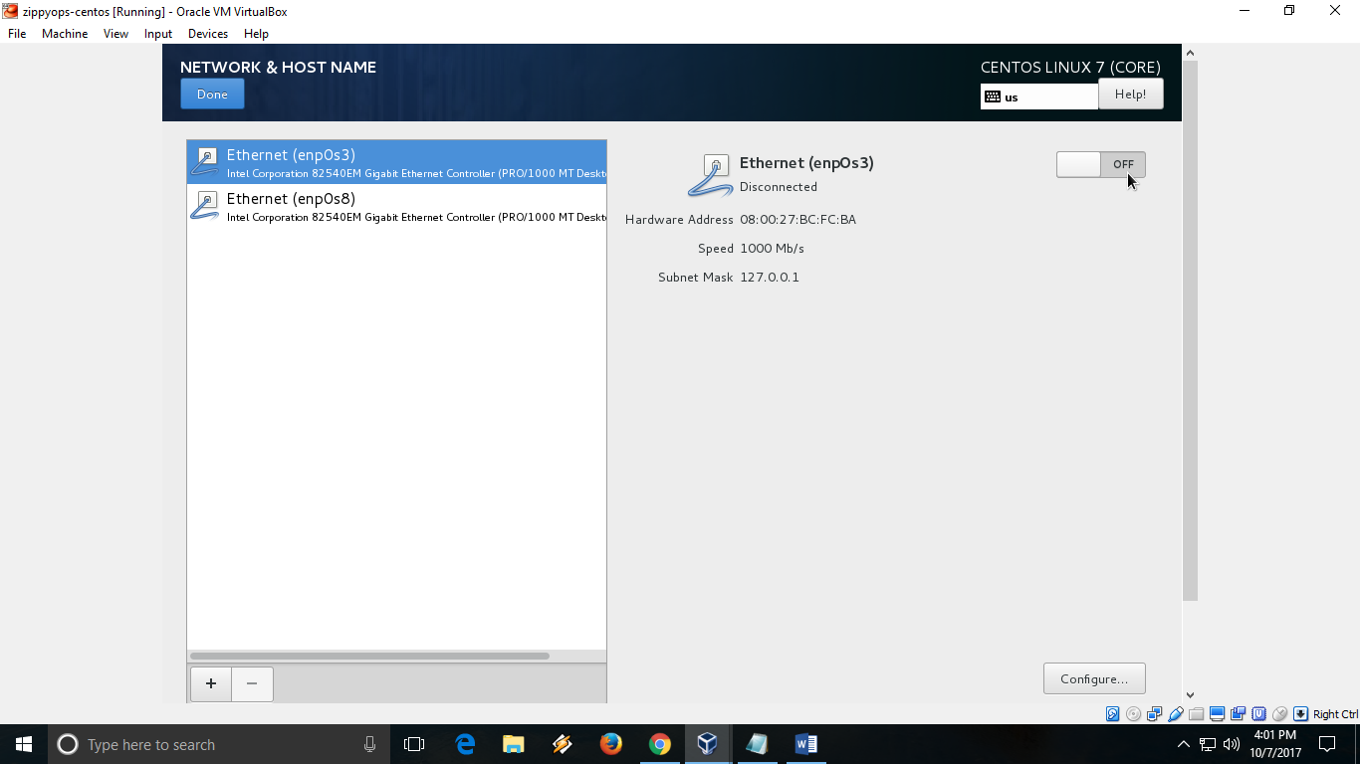

Toggle the switch to ON

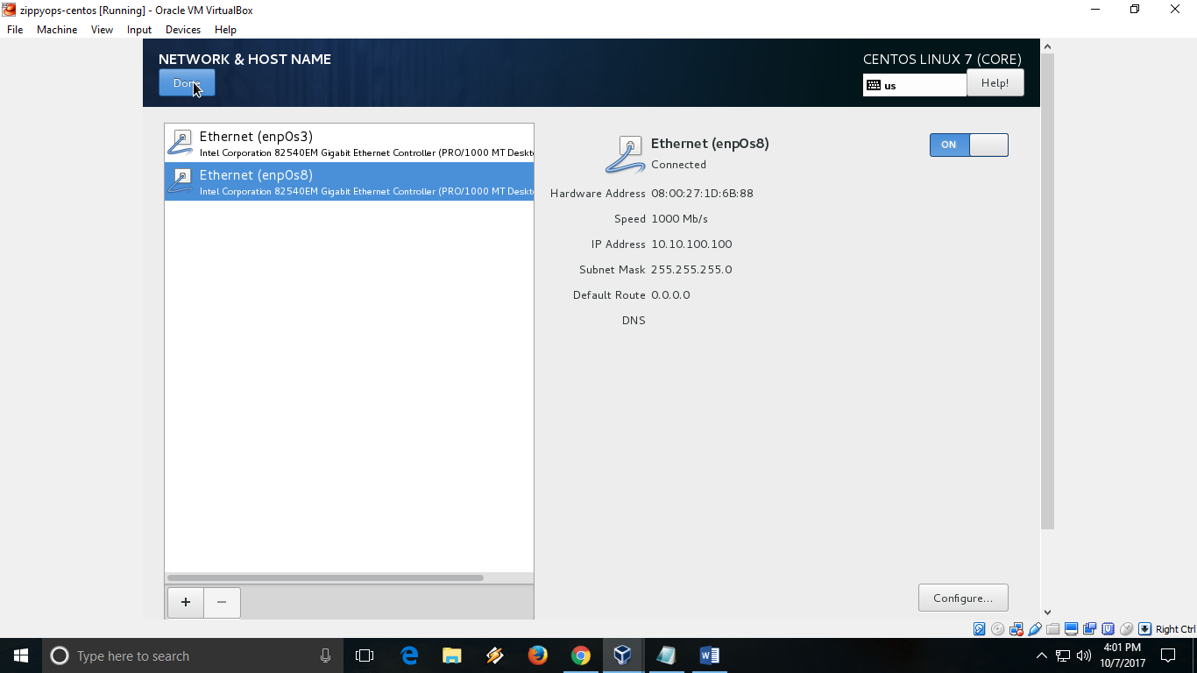

Click on the user created during installation and enter the password to login to the server.

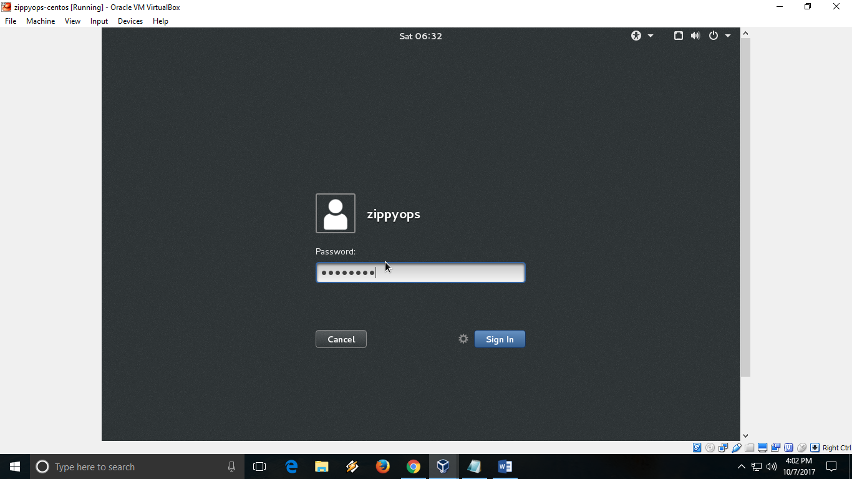

Right click and select “Open Terminal”

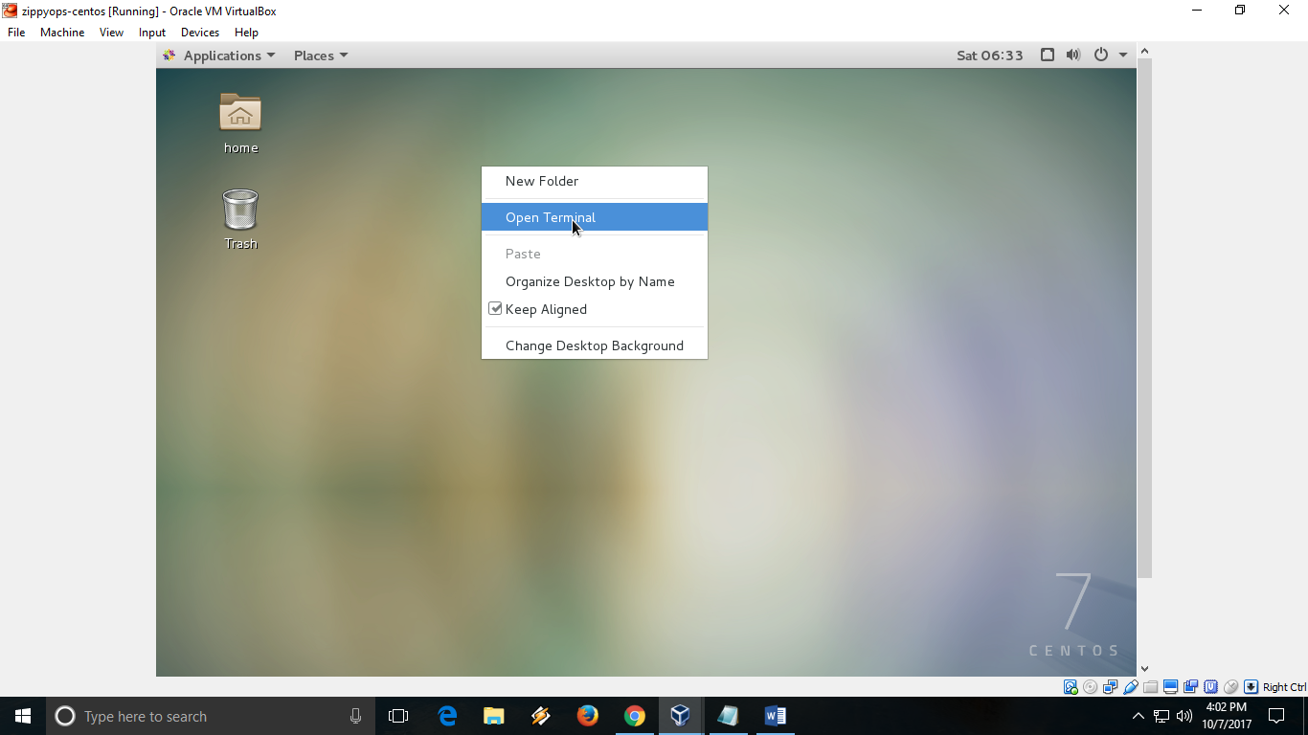

In the terminal enter the below command to get latest update

sudo yum update

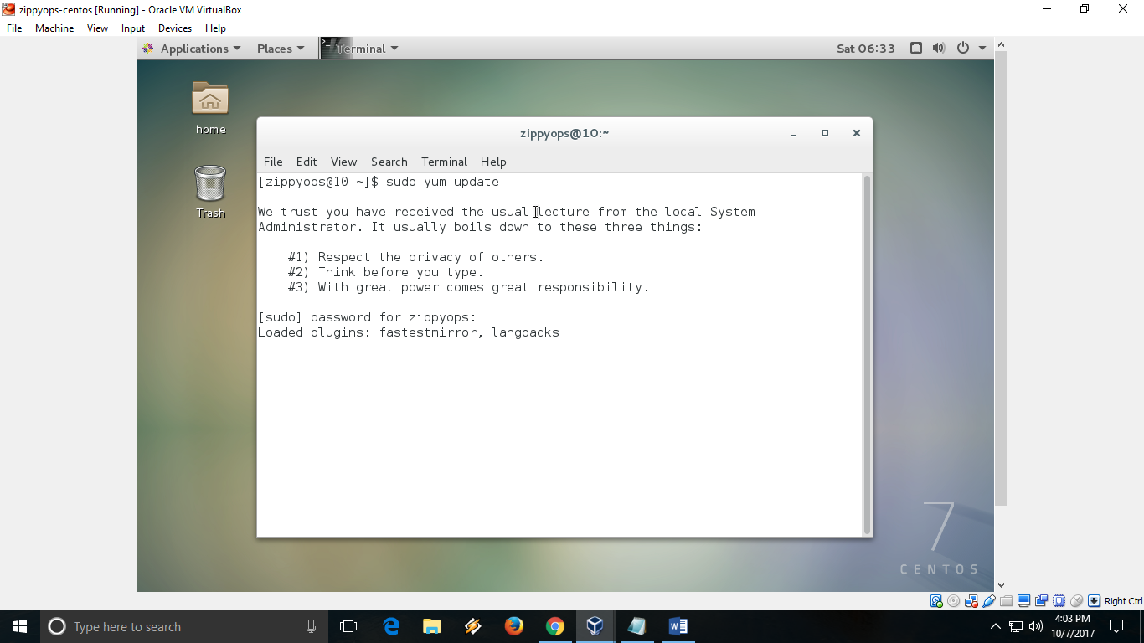

Enter the password of the user to get sudo permission

Once update is completed, enter the below command to install developer tools and kernel packages

sudoyum group install "Development Tools"

sudoyum install kernal*

Once the installation done, select “insert Guest Additional CD image” in devices menu as shown below.

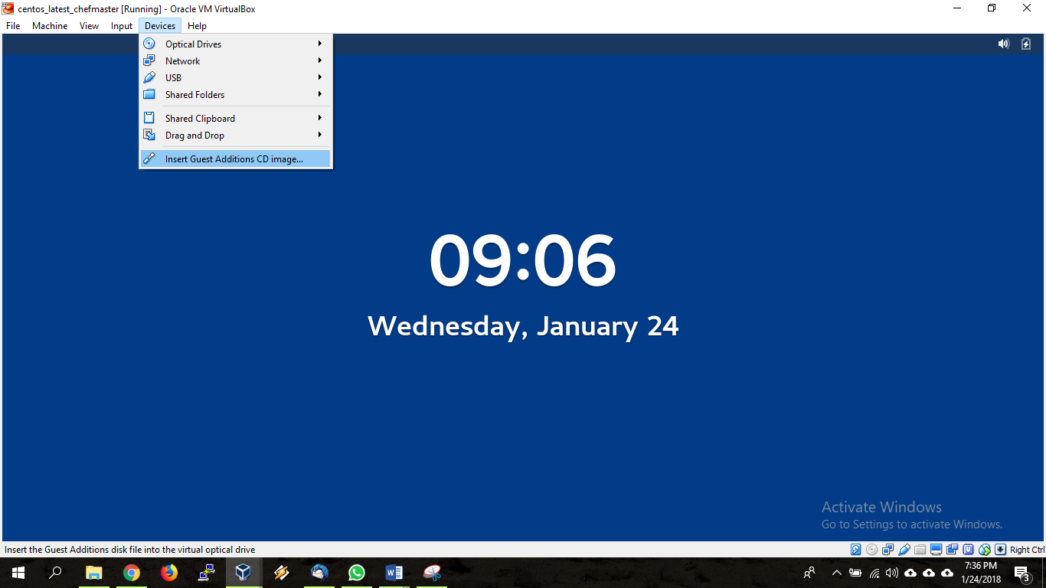

Once its mounted, it will prompt you to run a script and follow on screen instruction. After the installation you will be able to easily navigate between guest and host machines.

Shut down the machine.

# Configure nagios centos system:

We have to disable the selinux ,

[root@10 zippyops]# vi /etc/selinux/config

# This file controls the state of SELinux on the system.

# SELINUX= can take one of these three values:

# enforcing - SELinux security policy is enforced.

# permissive - SELinux prints warnings instead of enforcing.

# disabled - No SELinux policy is loaded.

SELINUX=disabled

# SELINUXTYPE= can take one of three two values:

# targeted - Targeted processes are protected,

# minimum - Modification of targeted policy. Only selected processes are protected.

# mls - Multi Level Security protection.

SELINUXTYPE=targeted

After that , stop the firewalld ,

[root@nagios zippyops]# systemctl stop firewalld

[root@nagios zippyops]# systemctl status firewalld

● firewalld.service - firewalld - dynamic firewall daemon

Loaded: loaded (/usr/lib/systemd/system/firewalld.service; enabled; vendor preset: enabled)

Active: inactive (dead) since Mon 2018-06-11 02:09:37 EDT; 7s ago

Docs: man:firewalld(1)

Process: 738 ExecStart=/usr/sbin/firewalld --nofork --nopid $FIREWALLD_ARGS (code=exited, status=0/SUCCESS)

Main PID: 738 (code=exited, status=0/SUCCESS)

Jun 11 02:00:51 localhost.localdomain systemd[1]: Starting firewalld - dynami...

Jun 11 02:00:55 localhost.localdomain systemd[1]: Started firewalld - dynamic...

Jun 11 02:09:36 nagios.zippyops.com systemd[1]: Stopping firewalld - dynamic....

Jun 11 02:09:37 nagios.zippyops.com systemd[1]: Stopped firewalld - dynamic ....

Hint: Some lines were ellipsized, use -l to show in full.

[root@nagios zippyops]#

# Install Prerequisites :

We now need to install the programs that Core will need in order to function / install properly

[root@nagios zippyops]# yum install httpd php php-cli gcc glibc glibc-common gd gd-devel net-snmp openssl-devel wget unzip

To start apache service :

[root@nagios zippyops]# service httpd start

Redirecting to /bin/systemctl start httpd.service

[root@nagios zippyops]# service httpd status

Redirecting to /bin/systemctl status httpd.service

● httpd.service - The Apache HTTP Server

Loaded: loaded (/usr/lib/systemd/system/httpd.service; disabled; vendor preset: disabled)

Active: active (running) since Mon 2018-06-11 02:15:15 EDT; 5s ago

Docs: man:httpd(8)

man:apachectl(8)

Main PID: 3428 (httpd)

Status: "Processing requests..."

Tasks: 6

CGroup: /system.slice/httpd.service

├─3428 /usr/sbin/httpd -DFOREGROUND

├─3433 /usr/sbin/httpd -DFOREGROUND

├─3434 /usr/sbin/httpd -DFOREGROUND

├─3435 /usr/sbin/httpd -DFOREGROUND

├─3436 /usr/sbin/httpd -DFOREGROUND

└─3437 /usr/sbin/httpd -DFOREGROUND

Jun 11 02:15:12 nagios.zippyops.com systemd[1]: Starting The Apache HTTP Ser....

Jun 11 02:15:15 nagios.zippyops.com systemd[1]: Started The Apache HTTP Server.

Hint: Some lines were ellipsized, use -l to show in full.

[root@nagios zippyops]#

# Setup User Accounts :

Now create a new nagios user account and setup a password to this account

[root@nagios zippyops]# useradd nagios

[root@nagios zippyops]# passwd nagios

Now create a groud for nagios setup “nagcmd” and add nagios user to this group. Also add nagios user in apache group.

[root@nagios zippyops]# groupadd nagcmd

[root@nagios zippyops]# usermod -a -G nagcmd nagios

[root@nagios zippyops]# usermod -a -G nagcmd apache

# Install Nagios Core Service :

After installing required dependencies and adding user accounts. Let’s start with Nagios core installation. Download latest Nagios core service from the official site.

[root@nagios opt]# cd /opt/

[root@nagios opt]# wget https://assets.nagios.com/downloads/nagioscore/releases/nagios-4.3.4.tar.gz

--2018-06-11 02:20:58-- https://assets.nagios.com/downloads/nagioscore/releases/nagios-4.3.4.tar.gz

Resolving assets.nagios.com (assets.nagios.com)... 72.14.181.71, 2600:3c00::f03c:91ff:fedf:b821

Connecting to assets.nagios.com (assets.nagios.com)|72.14.181.71|:443... connected.

HTTP request sent, awaiting response... 200 OK

Length: 11101966 (11M) [application/x-gzip]

Saving to: ‘nagios-4.3.4.tar.gz’

100%[======================================>] 11,101,966 2.63MB/s in 4.5s

2018-06-11 02:21:04 (2.33 MB/s) - ‘nagios-4.3.4.tar.gz’ saved [11101966/11101966]

[root@nagios opt]# ls

nagios-4.3.4.tar.gz rh VBoxGuestAdditions-5.2.8

We have installed the nagios core pakage , we can unzip this package ,

[root@nagios opt]# tar xzf nagios-4.3.4.tar.gz

[root@nagios opt]# ls

nagios-4.3.4 nagios-4.3.4.tar.gz rh VBoxGuestAdditions-5.2.8

[root@nagios opt]#

Now we can go inside nagios directory ,

[root@nagios opt]# cd nagios-4.3.4

[root@nagios nagios-4.3.4]# ls

base CONTRIBUTING.md INSTALLING nagios.spec tap

cgi daemon-init.in install-sh nagios.sysconfig test

Changelog docs LEGAL openrc-init.in THANKS

common doxy.conf lib pkginfo.in t-tap

config.guess functions LICENSE README update-version

config.sub html Makefile.in README.asciidoc UPGRADING

configure include make-tarball sample-config worker

configure.ac indent-all.sh mkpackage subst.in xdata

contrib indent.sh module t

[root@nagios nagios-4.3.4]#

We can configure this using below command ,

[root@nagios nagios-4.3.4]# ./configure --with-command-group=nagcmd

Configuration done means , we can give a command ,

[root@nagios nagios-4.3.4]# make all

To compile all files and install ,

[root@nagios nagios-4.3.4]# make install

[root@nagios nagios-4.3.4]# make install-init

[root@nagios nagios-4.3.4]# make install-config

[root@nagios nagios-4.3.4]# make install-commandmode

Now use below command to setup apache configuration for Nagios installation.

[root@nagios nagios-4.3.4]# make install-webconf

# Configure Apache Authentication :

We need to setup apache authentication for user nagiosadmin. Do not change this username. else you would required more changes in configuration.

[root@nagios nagios-4.3.4]# htpasswd -c /usr/local/nagios/etc/htpasswd.users nagiosadmin

Now restart Apache service to make the new settings take effect.

[root@nagios nagios-4.3.4]# service httpd restart

Redirecting to /bin/systemctl restart httpd.service

# Install Nagios Plugins :

After installing and configuring Nagios core service, Download latest nagios-plugins source and install using following commands.

[root@nagios nagios-4.3.4]# cd /opt

[root@nagios opt]# wget <http://nagios-plugins.org/download/nagios-plugins-2.2.1.tar.gz>

[root@nagios opt]# tar xzf nagios-plugins-2.2.1.tar.gz

[root@nagios opt]# cd nagios-plugins-2.2.1

Now compile and install nagios plugins

[root@nagios nagios-plugins-2.2.1]# ./configure --with-nagios-user=nagios --with-nagios-group=nagios

[root@nagios nagios-plugins-2.2.1]# make

[root@nagios nagios-plugins-2.2.1]# make install

# Verify and Start Nagios

First, verify the Nagios configuration file using the following command.

[root@nagios nagios-plugins-2.2.1]# /usr/local/nagios/bin/nagios -v /usr/local/nagios/etc/nagios.cfg

If there are not error, lets start the Nagios service

[root@nagios nagios-plugins-2.2.1]# service nagios start

Reloading systemd: [ OK ]

Starting nagios (via systemctl): [ OK ]

[root@nagios nagios-plugins-2.2.1]# chkconfig --add nagios

[root@nagios nagios-plugins-2.2.1]# chkconfig nagios on

# Access Nagios in Web Browser :

Nagios creates its own apache configuration file /etc/httpd/conf.d/nagios.conf. There are no need to make any changes to it. Simply open below url in browser

<http://your-domainname> or –IP /nagios/

Prompting for Apache Authentication Password –

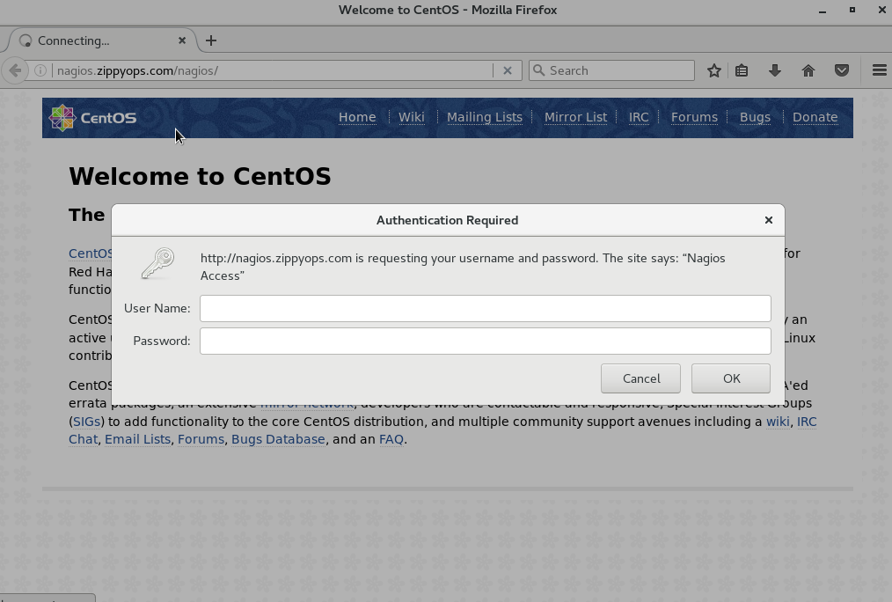

We can give here as , user name: nagiosadmin and password.

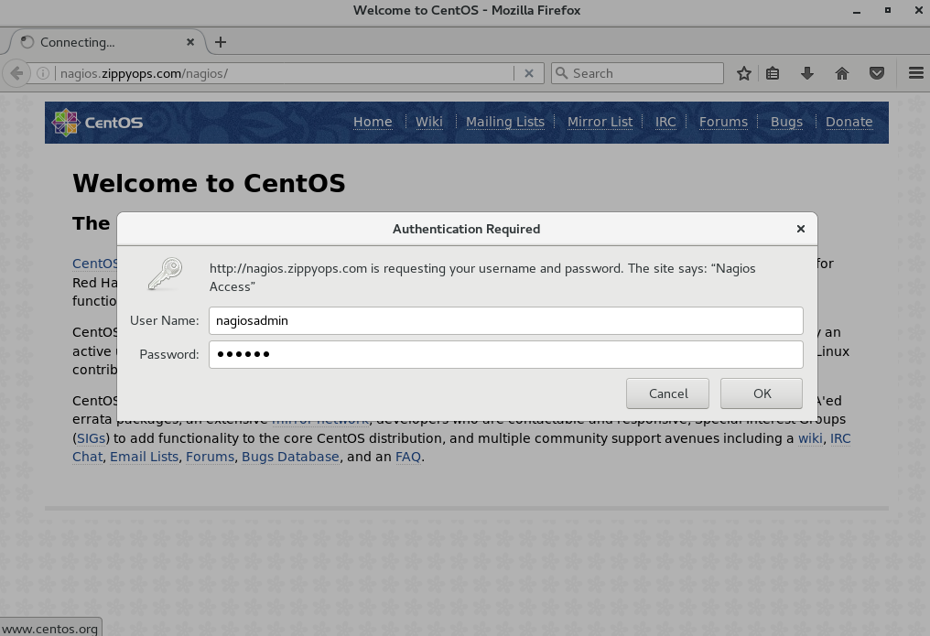

Nagios After login screen –

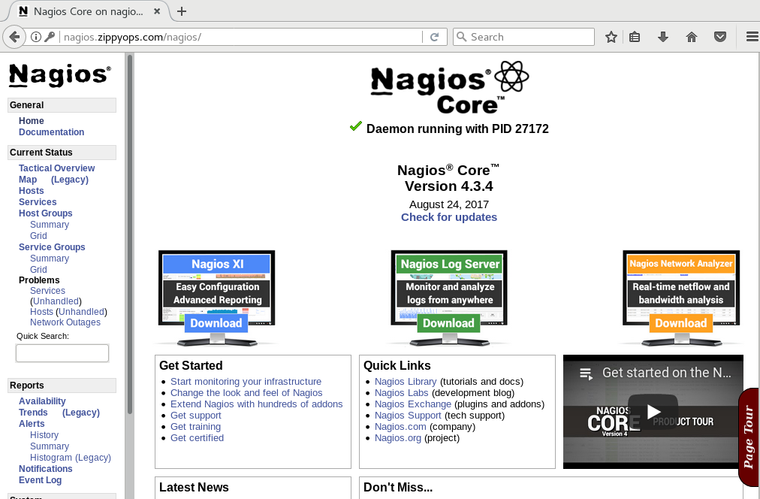

Now you have successfully installed and configured Nagios core service in your system.

Directory structure :

[root@nagios /]# cd /usr/local/nagios/

[root@nagios nagios]# pwd

/usr/local/nagios

[root@nagios nagios]# ls

bin etc include libexec sbin share var

[root@nagios nagios]#

* /usr/local/nagios/bin -binary file(nagios.nagiosstat)
* /usr/local/nagios/sbin-CGI files (ex:tac.cgi)
* /usr/local/nagios/libexec-(plugins ex:check_ping)
* /usr/local/nagios/share-(PHP files)
* /usr/localnagios/etc-(configuration files)
* /usr/local/nagios/var -(logs,lock)

# Configuration files:

* Configuration done in text files , based on templates
* Nagios reads its configuration from a directory. You determine how to divide your configuration files.
* Uses parallel checking and forking for scalability.

Heart of the nagios:

* /usr/local/nagios/etc/nagios.cfg

Supporting files:(/usr/local/nagios/etc/objects)

* commands.cfg
* localhost.cfg
* switch.cfg
* timeperiods.cfg
* contacts.cfg
* printer.cfg
* templates.cfg
* windows.cfg

First we can edit nagios.cfg file , in this file first nagios read

[root@nagios etc]# pwd

/usr/local/nagios/etc

[root@nagios etc]# ls

cgi.cfg htpasswd.users nagios.cfg objects resource.cfg

[nagios@nagios etc]$ vi nagios.cfg

Now find an uncomment this line by deleting the #:

#cfg_dir=/usr/local/nagios/etc/servers

Save and exit.

Object configuration :

Notice that we have created sub-directories for most our object type in /usr/local/nagios/etc/objects. When managing more than just a few object type. its wise to break objects into specific categories. How you group these is ultimately up to you; it may be ideal to group objects by location, IP address, functions, etc. For below we are going to group objects by purpose. We will build on this structure.

mkdir -v /usr/local/nagios/etc/objects/commands

mkdir -v /usr/local/nagios/etc/objects/contacts

mkdir -v /usr/local/nagios/etc/objects/contactgroups

mkdir -v /usr/local/nagios/etc/objects/hosts

mkdir -v /usr/local/nagios/etc/objects/hostgroups

mkdir -v /usr/local/nagios/etc/objects/services

mkdir -v /usr/local/nagios/etc/objects/servicegroups

mkdir -v /usr/local/nagios/etc/objects/templates

mkdir -v /usr/local/nagios/etc/objects/timeperiods

mkdir -v /usr/local/nagios/etc/objects/unused

this is we can create directory ,

[nagios@nagios objects]$ mkdir -v /usr/local/nagios/etc/objects/commands

mkdir: created directory ‘/usr/local/nagios/etc/objects/commands’

[nagios@nagios objects]$ mkdir -v /usr/local/nagios/etc/objects/contacts

mkdir: created directory ‘/usr/local/nagios/etc/objects/contacts’

[nagios@nagios objects]$ mkdir -v /usr/local/nagios/etc/objects/contactgroups

mkdir: created directory ‘/usr/local/nagios/etc/objects/contactgroups’

[nagios@nagios objects]$ mkdir -v /usr/local/nagios/etc/objects/hosts

mkdir: created directory ‘/usr/local/nagios/etc/objects/hosts’

[nagios@nagios objects]$ mkdir -v /usr/local/nagios/etc/objects/hostgroups

mkdir: created directory ‘/usr/local/nagios/etc/objects/hostgroups’

[nagios@nagios objects]$ mkdir -v /usr/local/nagios/etc/objects/services

mkdir: created directory ‘/usr/local/nagios/etc/objects/services’

[nagios@nagios objects]$ mkdir -v /usr/local/nagios/etc/objects/servicegroups

mkdir: created directory ‘/usr/local/nagios/etc/objects/servicegroups’

[nagios@nagios objects]$ mkdir -v /usr/local/nagios/etc/objects/templates

mkdir: created directory ‘/usr/local/nagios/etc/objects/templates’

[nagios@nagios objects]$ mkdir -v /usr/local/nagios/etc/objects/timeperiods

mkdir: created directory ‘/usr/local/nagios/etc/objects/timeperiods’

[nagios@nagios objects]$ mkdir -v /usr/local/nagios/etc/objects/unused

mkdir: created directory ‘/usr/local/nagios/etc/objects/unused’

[nagios@nagios objects]$ ls -la

total 52

drwxrwxr-x. 12 nagios nagios 4096 Jun 13 07:40 .

drwxrwxr-x. 3 nagios nagios 96 Jun 13 05:30 ..

drwxrwxr-x 2 nagios nagios 6 Jun 13 07:38 commands

-rw-rw-r--. 1 nagios nagios 7688 Jun 11 02:29 commands.cfg

drwxrwxr-x 2 nagios nagios 6 Jun 13 07:38 contactgroups

drwxrwxr-x 2 nagios nagios 6 Jun 13 07:38 contacts

-rw-rw-r--. 1 nagios nagios 2138 Jun 11 02:29 contacts.cfg

drwxrwxr-x 2 nagios nagios 6 Jun 13 07:39 hostgroups

drwxrwxr-x 2 nagios nagios 6 Jun 13 07:38 hosts

-rw-rw-r--. 1 nagios nagios 5379 Jun 11 02:29 localhost.cfg

-rw-rw-r--. 1 nagios nagios 3069 Jun 11 02:29 printer.cfg

drwxrwxr-x 2 nagios nagios 6 Jun 13 07:39 servicegroups

drwxrwxr-x 2 nagios nagios 6 Jun 13 07:39 services

-rw-rw-r--. 1 nagios nagios 3252 Jun 11 02:29 switch.cfg

drwxrwxr-x 2 nagios nagios 6 Jun 13 07:39 templates

-rw-rw-r--. 1 nagios nagios 10595 Jun 11 02:29 templates.cfg

drwxrwxr-x 2 nagios nagios 6 Jun 13 07:39 timeperiods

-rw-rw-r--. 1 nagios nagios 3178 Jun 11 02:29 timeperiods.cfg

drwxrwxr-x 2 nagios nagios 6 Jun 13 07:40 unused

-rw-rw-r--. 1 nagios nagios 3991 Jun 11 02:29 windows.cfg

[nagios@nagios objects]$

Now move the existing configuration files to their proper locations, we will use these in the main configuration file

mv localhost.cfg ./hosts

mv contacts.cfg ./contacts

mv commands.cfg ./commands

mv templates.cfg ./templates

mv timeperiods.cfg ./timeperiods

After this the only remaining *.cfg files in /usr/local/nagios/etc are unneeded, so we move them into the unused directory.  
[nagios@nagios objects]$ mv localhost.cfg ./hosts

[nagios@nagios objects]$ mv contacts.cfg ./contacts

[nagios@nagios objects]$ mv commands.cfg ./commands

[nagios@nagios objects]$ mv templates.cfg ./templates

[nagios@nagios objects]$ mv timeperiods.cfg ./timeperiods

[nagios@nagios objects]$ ls -ls

total 12

0 drwxrwxr-x 2 nagios nagios 26 Jun 13 07:57 commands

0 drwxrwxr-x 2 nagios nagios 6 Jun 13 07:38 contactgroups

0 drwxrwxr-x 2 nagios nagios 26 Jun 13 07:57 contacts

0 drwxrwxr-x 2 nagios nagios 6 Jun 13 07:39 hostgroups

0 drwxrwxr-x 2 nagios nagios 27 Jun 13 07:57 hosts

4 -rw-rw-r--. 1 nagios nagios 3069 Jun 11 02:29 printer.cfg

0 drwxrwxr-x 2 nagios nagios 6 Jun 13 07:39 servicegroups

0 drwxrwxr-x 2 nagios nagios 6 Jun 13 07:39 services

4 -rw-rw-r--. 1 nagios nagios 3252 Jun 11 02:29 switch.cfg

0 drwxrwxr-x 2 nagios nagios 27 Jun 13 07:57 templates

0 drwxrwxr-x 2 nagios nagios 29 Jun 13 07:57 timeperiods

0 drwxrwxr-x 2 nagios nagios 6 Jun 13 07:40 unused

4 -rw-rw-r--. 1 nagios nagios 3991 Jun 11 02:29 windows.cfg

[nagios@nagios objects]$

Now we can move all other files to unused directory ,

[nagios@nagios hosts]$ mv printer.cfg switch.cfg windows.cfg ../unused/

[nagios@nagios hosts]$ cd ..

[nagios@nagios objects]$ cd unused/

[nagios@nagios unused]$ ls

printer.cfg switch.cfg windows.cfg

[nagios@nagios unused]$

## System Directory creation

### log directory

We will need to define the location of the nagios log file directory . create this directory and make sure the nagios user and group have the proper permission to it.

[root@nagios unused]# mkdir -v /var/log/nagios

mkdir: created directory ‘/var/log/nagios’

[root@nagios unused]# chown -R nagios:nagios /var/log/nagios

[root@nagios unused]# chmod -R 0755 /var/log/nagios

[root@nagios unused]#

### Runtime information Directory

We will create this at /var/nagios:

[root@nagios unused]# mkdir -v /var/run/nagios

mkdir: created directory ‘/var/run/nagios’

[root@nagios unused]# chown -R nagios:nagios /var/run/nagios

[root@nagios unused]# chmod -R 0755 /var/run/nagios

## The main nagios configuration file

We are going to create basic configuration file, and build on it through this cource. Move the existing configuration file for safe-keeping:

[root@nagios etc]# ls

cgi.cfg htpasswd.users nagios.cfg objects resource.cfg

[root@nagios etc]# mv nagios.cfg nagios.cfg.old

We can add our configuration directory to that file ,

[root@nagios etc]# vi nagios.cfg

# log files

log_file=/var/log/nagios/nagios.log

# object configuration directories

cfg_dir=/usr/local/nagios/etc/objects/commands

cfg_dir=/usr/local/nagios/etc/objects/contacts

cfg_dir=/usr/local/nagios/etc/objects/contactgroups

cfg_dir=/usr/local/nagios/etc/objects/hosts

cfg_dir=/usr/local/nagios/etc/objects/hostsgroups

cfg_dir=/usr/local/nagios/etc/objects/services

cfg_dir=/usr/local/nagios/etc/objects/servicegroups

cfg_dir=/usr/local/nagios/etc/objects/templates

cfg_dir=/usr/local/nagios/etc/objects/timeperiods

# resource file

resource_file=/usr/local/nagios/etc/resource.cfg

# status

status_file=/var/run/nagios/status.dat

status_update_intervel=10

# nagios system user and group

nagios_user=nagios

nagios_group=nagios

# don't log to syslog

use_syslog=0

# read external check commands

check_external_commands=1

# accept passive service and hosts checks

accept_passive_service_checks=1

accept_passive_host_checks=1

# strip illegal characters from macro output

illegal_macro_output_chars='~$^&"|'<>

# set default interval length to 60 seconds

interval_length=60

Now we can verify our configuration using below command ,

[root@nagios etc]# /usr/local/nagios/bin/nagios -v /usr/local/nagios/etc/nagios.cfg

Nagios Core 4.3.4

Copyright (c) 2009-present Nagios Core Development Team and Community Contributors

Copyright (c) 1999-2009 Ethan Galstad

Last Modified: 2017-08-24

License: GPL

Website: https://www.nagios.org

Reading configuration data...

Read main config file okay...

Read object config files okay...

Running pre-flight check on configuration data...

Checking objects...

Checked 8 services.

Checked 1 hosts.

Checked 1 host groups.

Checked 0 service groups.

Checked 1 contacts.

Checked 1 contact groups.

Checked 24 commands.

Checked 5 time periods.

Checked 0 host escalations.

Checked 0 service escalations.

Checking for circular paths...

Checked 1 hosts

Checked 0 service dependencies

Checked 0 host dependencies

Checked 5 timeperiods

Checking global event handlers...

Checking obsessive compulsive processor commands...

Checking misc settings...

Total Warnings: 0

Total Errors: 0

Things look okay - No serious problems were detected during the pre-flight check

[root@nagios etc]#

No error detected we have configure successfully !!!

# Plugins :

Plugins are standalone programs (scripts or binaries compiled from source) that do the "footwork" of monitoring. plugins exist in the libexec subdirectory of our nagios installation and can be called from the command line like any other program.

We use command objects to abstract plugins in nagios. We need a dynamic way to construct and pass parameters to the plugins, and commands are how we accomplish this. still, it is wise to acquaint yourself with the plugins themselves. If you cd into /usr/local/nagios/libexec, you can view the plugins that are installed with nagios by default.

As we might expect from any program. the plugins take argument and parameters. By convention, all plugins must support a standard set of parameters and arguments. We can view this information by executing the plugins from the shell and passing the -h or --help parameter:

/opt/nagios/libexec/check_swap --help

The plugins returns the parameters that are required are optional and describe any arguments that may be used. An example is also provided.

Below all are plugins :

[root@nagios nagios]# ls

bin etc include libexec sbin share var

[root@nagios nagios]# cd libexec/

[root@nagios libexec]# ls

check_apt check_flexlm check_mailq check_overcr check_swap

check_breeze check_ftp check_mrtg check_ping check_tcp

check_by_ssh check_http check_mrtgtraf check_pop check_time

check_clamd check_icmp check_nagios check_procs check_udp

check_cluster check_ide_smart check_nntp check_real check_ups

check_dhcp check_ifoperstatus check_nntps check_rpc check_uptime

check_dig check_ifstatus check_nt check_sensors check_users

check_disk check_imap check_ntp check_simap check_wave

check_disk_smb check_ircd check_ntp_peer check_smtp negate

check_dns check_jabber check_ntp_time check_spop urlize

check_dummy check_load check_nwstat check_ssh utils.pm

check_file_age check_log check_oracle check_ssmtp utils.sh

[root@nagios libexec]#

For example I can execute one command ,

[root@nagios libexec]# ./check_swap -h

check_swap v2.2.1 (nagios-plugins 2.2.1)

Copyright (c) 2000-2014 Nagios Plugin Development Team

<devel@nagios-plugins.org>

Check swap space on local machine.

Usage:

check_swap [-av] -w <percent_free>% -c <percent_free>%

-w <bytes_free> -c <bytes_free>

Options:

-h, --help

Print detailed help screen

-V, --version

Print version information

--extra-opts=[section][@file]

Read options from an ini file. See

https://www.nagios-plugins.org/doc/extra-opts.html

for usage and examples.

-w, --warning=INTEGER

Exit with WARNING status if less than INTEGER bytes of swap space are free

-w, --warning=PERCENT%%

Exit with WARNING status if less than PERCENT of swap space is free

-c, --critical=INTEGER

Exit with CRITICAL status if less than INTEGER bytes of swap space are free

-c, --critical=PERCENT%%

Exit with CRITICAL status if less than PERCENT of swap space is free

-a, --allswaps

Conduct comparisons for all swap partitions, one by one

-v, --verbose

Show details for command-line debugging (Nagios may truncate output)

Notes:

Both INTEGER and PERCENT thresholds can be specified, they are all checked.

On AIX, if -a is specified, uses lsps -a, otherwise uses lsps -s.

Send email to help@nagios-plugins.org if you have questions regarding use

of this software. To submit patches or suggest improvements, send email to

devel@nagios-plugins.org

[root@nagios libexec]#

Above shown that option to use this command ,

For an example , warning gives me when memory reaches 50% ,

[root@nagios libexec]# ./check_swap -a -w 50%

SWAP OK - 100% free (1515 MB out of 1515 MB) |swap=1515MB;757;0;0;1515

### A note about plugins and extensibility :

Because plugins are program external to nagios,they can be used for just about any purpose. The only caveat is that they must accept input and return output according the conventions established by nagios. this opens a world of opportunities in terms of monitoring. Frustrated because configuring zabbix to configure free space in MYSQL tables is a real Kludge? nagios can do it with plugin. This makes developing plugins relatively simply and straightforward.

## Understanding checks: Host, Services, and commands

Before we move into authoring objects, it is important to understand how nagios builds checks. Each check is comprised basically of three different definition as they exist in the relevant object type files:

* A host definition
* A service definitions
* A command definition

The parameters of a host definition provide host-specific informationn used to build commands. The same is true of service definitions. The parameters there are combined with the information provided by the host object. These are combined with the information provided in the command definition to generate a check.

[**graphic**]

This means that host, service and command definitions are inter-related.

We are going to take a look at host definitions, command definitions and macros before we look at the other object types.

# Authoring Host definitions

Hosts are objects we use to describe device we wish to monitor. These can be anything: virtual machines, network-attached devices like a media center, or run-of-the-mill servers in a data center.

our host definitions provide nagios with some critical information: The name, a description, the IP or FQDN, when and how the host should be monitored and who should be contacted if problems arise.

Host definitions exist as objects defined in the files located within the /usr/local/nagios/etc/object/host directory. A host definition must have the following parameters

* host_name
* max_check_attempts
* check_period
* contacts
* contact_groups
* notification_interval
* notification_period

Example:

define_host {

host_name dbmaster1

alias db1

address dbmaster1.domain.com

}

define_host {

host_name oracle-server

alias db

address oracle-server.somedomain.com

you may notice that the above example do not include all of the parameters required. This is because our default configuration makes use of nagios templating feature which we discuss shortly.

A full list of the host definition parameters is found in the appendices.

## Host groups

Hosts may be grouped together for any number of resons: by geographic location, for instance or perhaps by purpose(all webservers or servers running ssh , etc.)

Hostgroups only require a host group name and alias. see the full listing of hostgroup definition directives in the appendicese.

## Object file definition syntax

The syntax for object files follows the syntax explained above. many of the parameters are used across several types of objects; when this is the case the meaning of the parameters is unchanged.(so address means FQDN or IP address for example regardless of the type of object being defined)

## The Nagios Core Host Definition

The host object for the Nagios core host(which we are logged in to) is located in the localhost.cfg file in /usr/local/nagios/etc/object/hosts/localhost.cfg.

We are now going to copy that file to back it up, and create our own localhost.cfg

cd /usr/local/nagios/etc/object/hosts

mv localhost.cfg localhost.cfg.old

vi localhost.cfg

make sure your new localhost configuration file looks like this:

# localhost: Nagios core Host

define host{

host_name nagios-core-host

alias Nagios Core Host

check_period 24x7

check_interval 5

retry_interval 1

max_check_attempts 3

check_command check-host-by-ping

contact_groups admins

notfications_enabled 1

event_handler_enabled 1

flap_detection_enabled 1

process_perf_data 1

retain_status_information 1

retain_nonstatus_information 1

notification_interval 5

notification_options d,u,r

notification_period 24x7

}

This defines the following:

* The host nickname(the one we see in the UI) localhost
* Host can be found at address localhost
* The host should be checked 24hours a day, 7 days a week
* The host is checked every 5 mints
* check retries are spaced 1 minutes apart
* nagios will try at most 10 times to check the host
* The command object check-host-by-pain is invoked to execute the plugin which performs the check
* This host is part of the contact group admins more on that later
* Notifications are enabled for this host
* The event handler for this host is enabled; this means that when the host changed state, pre-configured actions can be taken to handle the change of state appropriately
* Flapping occurs when a host changes to and from states rapidly. This can be the result of misconfiguration, network problems, etc. enabling flap detection allows nagios to avoid excessive alerting in such cases.

# Macros

Nagios macro system provides a wonderful amount of flexibility and reusability. Macros are consistent in definition and use and are context-dependent variables. In addition to the macros defined by default, nagios provides the functionality to define custom macros.

Macros are used in command definitions and allow information from other objects to be referenced dynamically. This reduces the number of commands we have to write. Depending on nagios configuration, the built-in macros can also be exported as environment variable. Macros exported as environment variables are named NAGIOS_[variable-name] in the plugins execution environment.

Note that the $USER. Macros are not exported to the environment at all.

## Defining Macros

Macros begin and end with a dollar sign ($). For example

define host {

host_name myserver

address 10.0.0.1

check_command check-host-alive

}

define_command {

command_name check-host-alive

command_line $USER1$/../libexec/check_ping -H $HOSTADDRESS$ -p 5

}

## Special macros

The $USER1$ macro references the directory which contains the file indicated by the resource_file directive in the main nagios configuration file.

Custom Macros(On-Demand Macros)

Macros can be also be customized. They may be used in command definitions and are defined in other object files. Inside the object defining the macro,the directive starts with an underscore and is written in uppercase.

For example in the following host definition, we define the custom macro_CLUSTERID:

define hopst {

host\_name gallera-1

address 10.0.0.1

_CLUSTERID 2

check_command check-host-by-ping

}

in the command definition the variable can be referenced by prefixing the variable name with the object type, which may be one of the following:

* $_CONTACT for variables defined in contact objects
* $_HOST for variables defined in host object
* $_SERVICE for variables defined in service objects

So, to reference the_CLUSTERID variable defined in our host object above, we use $_HOSTCLUSTERID in the command definition:

define command {

command_name check-host-by-ping

command_line $USER1$/../libexec/check_ping -H $_HOSTCLUSTERID$

}

on-demand macros are not exported to the environment.

# Authoring service Definitions

Services describe functionality offered by a given host. In the context of Nagios, services are not synonymous with daemons such as "SSHD" or "mysqld"; instead, a service object represent any resource that may be observed. For instance: Free disk space, TCP errors, InnoDB buffer cache use, etc.

Services are always associated with a host and are identified by their description. As such services descriptions must be unique on a per-host basis. You cannot have two services with identical descriptions.

At least one service must be defined for every host.

Service definitions exist as part of the service objects defined in the /usr/local/nagios/object/service directory. A service definition must have the following parameters:

* host_name
* service_description
* check_command
* max_check_attempts
* check_interval_retry_interval
* check_period
* notification_interval
* notification_period
* contacts
* contact_groups

## Authoring a service Definition

The first service definition we author is for the Nagios core Host. We are going to ensure that our system clock is synchronized to the NTP server pools, providing for a reasonable window of variance.

Lets create our service definition file:

cd /usr/local/nagios/etc/objects/services

vi long-time-variance.cfg

Our first directive is the host name, which indicates to Nagios which host the service is running on. if you recall, our localhost.cfg hostfile had a host_name directive. Because we want to monitor this service on our nagios core host, we will use the name specified in the host file :

define service{

host_name localhost

Our next directive is the service_description, which is used to uniquely services on a host. Because we are checking the variance of the local clock from NTP servers, we donot reference NTP or tis daemon in the description. While this check is a good determinant of wether or not NTP is functioning properly, we are not monitoring the daemon process directory.

service_description local-clock-offset

Now we need to defined the check_command directive. We are going to hold off on defining this for now- we delve into commands in a couple of chapters. For the time being, We will include the directive , but not give it a value:

check_command

Next, we want to tell Nagios how many times we want to execute this check before determining that it it down. Since we are testing the local system clock(which should be available unless the host is down), we are going to set this value to /.

max_check_attempts 1

Now we want to define the time period in which the service should be monitored. Here we inform Nagios that we can check this service 24 hours a day, 7 days a week:

check_period 24x7

Next on our list of required directives are our contacts. We have not discussed defining contacts of contact groups, so we will leave these directives undefined for now:

contacts

contact_groups

our last two required directives pertain to notification; these are the notification interval and period. We want to be notified if the clock is not in sync once every 8 hours and allow that notification to be sent at any time:

notification_interval 480

notification_period 24x7

Our local-time-variance.cfg file should now look like this :

define service{

host_name localhost

service_description local-clock-offset

check_command

max_check_attempts 1

check_period 24x7

contacts

contact_groups

notifications_interval 480

notification_period 24x7

}

# Authoring Command Definitions:

commands define how host checks, service checks, and notifications should be performing a given check and can be used to check services , run other commands, inform users of issues, and handle events- in short, commands are the glue that ties plugins to Nagios core.

Unlike other types of objects, commands are short: Typically, a command is defined with a name and a string that contains the actual command itself.

Event handlers are commands that are executed in response to a change in host or service status.

## Building Our First Command

Recall from the previous chapter that we want to check the time offset of the local clock against the time reported by the NTP server pool. We continue that effort here, using one of the plugins provided by Nagios.

Examining Our plugin and Its Output

If you examine the check_ntp_time plugin in /usr/local/nagios/libexec by calling it with the -h option, you will see the all of the parameters used in the following command, as well as their meanings.

We are going to test the plugin first by calling it from the shell:

check_ntp_time -H 0.us.pool.ntp.org -w 60

This command uses the plugin(which is a program) to check the local system clock and compare it to a value retrieved from the NTP servers located at 0.us.pool.ntp.org. A variance of 60 seconds is allowed. If the differences is less than 60 seconds, the returned status will be a warning. We can see what that would look like by passing a value of "0" as the argument to the -w parameter:

check_ntp_time -H 0.us.pool.ntp.org -w 0

The results:

NTP WARNING Offset -0.007536530495 secs|offset=-

0.007537s;0.000000;120.000000;

## Building Our Command

We are going to build our command definition now. Note that we begin using macros here!

cd /usr/local/nagios/etc/object/commands

vi check-local-clock-offset.cfg

First we define the command name. Notice that for the sake of simplicity, we are making the command name and the command file the same,

define command{

command_name check-local-clock-offset

Now we will define the command_line directive:

command_line $USER1$/../libexec/check_ntp_time -H 0.us.pool.ntp.org -w 60

}

Remember that the *$USER1$* macro is a reference to the directory in which resource.cfg is located.

## Adding our command Name to previously Defined objects

Now that we have defined our command, we need to add its name to the service definition we completed in the previously. Amend the /usr/local/nagios/etc/object/services/local-time-variance.cfg file, changing the command_name directive to match this:

command_name local-time-variance

Notice that the command name diretive in the service definition file matches the command name in the command definition file. So your service definition file should look something like this:

define service{

host_name localhost

service_description local-clock-offset

check_command

max_check_attempts 1

check_period 24x7

contacts

contact_groups

notifications_interval 480

notification_period 24x7

}

# But My Host Object Already Has a check Command!

Recall that nagios provides us macros which can reference various parts of contact,host, and service object. this is one reason why - we can use macros to build commands dynamically. This way there is not a one-to-one relationship between hosts and checks or services and checks.

# Making commands Reusable and Flexible

## Authoring Our Second Command/using Nagios Built-in Macros

Recall that when we defined our host, We named a check command: check-host-by-ping . That command is as-of-yet undefined, so let's author it now. We are going to make use of a macro in this definition that will keep the command from being tightly-coupled to the host definition. This means this command can be used with a variety of hosts, not just the host definition we have written for the Nagio core host. Create a file in your command objects directory with the name check-host-by-ping.cfg:

define command{

command_name check-host-by-ping

Again, if we examine the plugin programs located in /usr/local/nagios/libexec. We see that a plugin is provided for us which allows us to check a hosts reponse via ICMP ping. Run this plugin with the -h command to see its various options. The command below will make sense after you do so,

We define our command as follows:

Check-ping -H localhost -w 2000.00,00% -c 5000.0,100% -p

Given the above parameters, this plugin returns a warning status if the round-trip time reported is 2 seconds or more or if more than 80% of the ICMP packets are lost. If the round-trip time is 5 seconds (or more) or 100% of the ICMP packets are lost, a critical status is returned. A total of five pings will be sent.

Lets create a command definition that we can use to check our host by ping, but rather than hard-coding a value for the host (the -H parameter), let's use a macro to make this command more flexible.

Open /usr/local/nagios/etc/object/commands/check-host-by-ping.cfg. Again we will create a command definition, and provide a name for the command:

define command{

command_name check-host-by-ping

command_line $USER1$/../libexec/check-ping -H $HOSTADDRESS$ -w 2000.00,80% -c 5000.0,100% -p 5

}

This accomplished two things. First, this command can now be used with any host object, as the host passed to the check_ping plugin is a macro. Nagios will replace the $HOSTADDRESS string with the host address of the host object being used. Secondly, because the host address is not static we can use this command with any host object and can be assured that it will behave as we expect it to.

### Passing Parameters to Commands

So we have made our check-host-by-ping command reusable by employing one of nagios built -in macros. But there are still some limitations. For instance it may not be appropriate to issue a warning if 80% of our ICMP packets are dropped. For a high-availability system on the same subnet, we probably don’t want ANY of our ICMP packets to go unacknowledged.

Now, we could write another command for this. in a small installation, that will not pose a huge problem. But what if you plan for your Nagios installation to grow? To support tens,scores,may be hundreds or thousands of devices? Writing "one off" commands is a quick way to make Nagios somewhat unmanageable. If you have to write a new command for every variation on ICMP ping that you happen to need, you could end up with hundreds of similarly named commands and that's just not ideal or easy.

To avoid this scenario, Nagios allows us to parameterie commands.So, instead of hard-coding the values for the -C and -W flags in our check-host-by-ping definition file. we can use special macros to pass these values from the host or service object that calls our command.

Arguments are passed to commands by prefixing each with an exclamation mark following the command name and then specifying the argument value. Additional arguments can be added with another "!\<value\>" paring.

For example, in our localhosgt.cfg file(where we call the check-host-by-ping command object ), we can pass arguments to our command by altering this line:

check_command check-host-by-ping

So that it looks like this:

check_command check-host-by-ping!2000.00,80%!5000.00,100%

Notice there are two arguments:

!2000.00,80%

!5000.00,100%

These are available in our command definition as $ARG1$ and $ARG2$, respectively . Lets amend our check-host-by-ping.cfg file to use the arguments passed to it. We are going to change this line:

Command_line $USER1$/../libexec/check_ping -H $HOSTADDRESS$ -w

To this:

Command_line $USER1$/../libexec/check_ping -H $HOSTADDRESS$ -w $ARG1$ -c $ARG2$

So now insted of having to write two different command definitions when we need different values for the ICMP round trip thresholds and the threshold for the number of dropped ICMP packets, We can simply specify these anywhere we name the check-host-by-ping command.

These macros can be used with any command, and they are one of Nagios most powerful features.

Don't forget!

Remember to look PDF in the downloads section for a complete list of macros. and don't forget to investigate all of the plugins provided with nagios in the libexec subdirectory of our Nagios installation.

### Authoring Time period Definitions :

Time periods in the context of nagios, describe ranges of days, dates, and times. These can be used to specify when specific actions may be undertaken, when notifications may be sent and when certain contacts or groups of contacts may be notified.

Lab :

First we can give below command ,

[root@nagios libexec]# ./check_ntp_time -H 0.us.pool.ntp.org -w 60

NTP OK: Offset 0.002941727638 secs|offset=0.002942s;60.000000;120.000000;

Go back to command directory ,

[root@nagios etc]# cd objects/

[root@nagios objects]# ls

commands contacts hosts services timeperiods

contactgroups hostgroups servicegroups templates unused

[root@nagios objects]# cd commands/

[root@nagios commands]# ls

commands.cfg

[root@nagios commands]# Vi check-local-clock-offset.cfg

[root@nagios commands]# cat check-local-clock-offset.cfg

define command{

command_name check-local-clock-offset

command_line $USERS1$/ ../libexec/check_ntp_time -H 0.us.pool.ntp.org -w 60

}

[root@nagios commands]#

Now will go back to host directory to edit localhost.cfg,

[root@nagios objects]# cd hosts

[root@nagios hosts]# ls

localhost.cfg localhost.cfg.old

[root@nagios hosts]# vi localhost.cfg

[root@nagios hosts]# cat localhost.cfg

# localhost: Nagios core Host

define host{

host_name localhost

alias localhost

check_period 24x7

check_interval 5

retry_interval 1

max_check_attempts 10

check_command check-host-by-ping

contact_groups admins

notfications_enabled 1

event_handler_enabled 1

flap_detection_enabled 1

process_perf_data 1

retain_status_information 1

retain_nonstatus_information 1

notification_interval 120

notification_options d,u,r

notification_period 24x7 ;this is a comment

}

[root@nagios hosts]#

Now we will go to service directory ,

[root@nagios objects]# cd services

[root@nagios services]# ls

long-time-variance.cfg

[root@nagios services]# vi long-time-variance.cfg

[root@nagios services]# cat long-time-variance.cfg

define service{

host_name localhost

service_description local-clock-offset

check_command check-local-clock-offset

max_check_attempts 1

check_period 24x7

contacts

contact_groups

notifications_interval 480

notification_period 24x7

}

[root@nagios services]#

We have added check command in this file .

Again we will go back to command directory , Now we can set host for command ,

[root@nagios objects]# cd commands/

[root@nagios commands]# ls

check-local-clock-offset.cfg commands.cfg

[root@nagios commands]# vi check-host-by-ping.cfg

[root@nagios commands]# cat check-host-by-ping.cfg

define command{

command_name check-host-by-ping

command_line $USER1$/../libexec/check_ping -H $HOSTADDRESS$ -w 2000.00,80% -c 5000.0,100% -p 5

}

[root@nagios commands]#

Now we can run a command ,

[root@nagios commands]# /usr/local/nagios/libexec/check_ping -H 8.8.8.8 -w 2000.00,80% -c 5000.0,100% -p 5

PING OK - Packet loss = 0%, RTA = 44.54 ms|rta=44.544998ms;2000.000000;5000.000000;0.000000 pl=0%;80;100;0

[root@nagios commands]#

# Authoring Time period definitions

Time periods, in the context of Nagios, describe ranges of days, dates and times. These can be used to specify when specific actions may be undertaken, when notifications may be notified.

Time periods are very flexible in Nagios. Dates, in particular, can be specified a number of ways

Note that the above items are in order of execution that is items using a date form higher on the list are executed BEFORE items using a date form that is lower on the list.

Time Periods:

Time periods are Nagios way of letting us define at what hours and days an action, such as a check, notification, or a specific command can be undertaken. Time periods consist of a list of days and a time.

Time are specified using the 24-hour clock, so "5:00pm" is represented as "17:00". Here an example definition of a time period we have already used and so should be familiar with:

define timeperiod{

timeperiod_name 24x7

alias 24 hours a day, 7 days a week

monday 00:00-24:00

tuesday 00:00-24:00

wednessday 00:00-24:00

thursday 00:00-24:00

friday 00:00-24:00

saturday 12:00-17:00

sunday 13:30-20:30

}

Lab:

First , we have to go timeperiods directory,

[root@nagios zippyops]# cd /usr/local/nagios/etc/objects/timeperiods/

[root@nagios timeperiods]# pwd

/usr/local/nagios/etc/objects/timeperiods

[root@nagios timeperiods]# ls

timeperiods.cfg

[root@nagios timeperiods]#

Now we have to edit timeperiods.cfg file,

[root@nagios timeperiods]# vi timeperiods.cfg

I have added my own timer period added in this file end ,

[root@nagios timeperiods]# cat timeperiods.cfg

###############################################################################

# TIMEPERIODS.CFG - SAMPLE TIMEPERIOD DEFINITIONS

#

#

# NOTES: This config file provides you with some example timeperiod definitions

# that you can reference in host, service, contact, and dependency

# definitions.

#

# You don't need to keep timeperiods in a separate file from your other

# object definitions. This has been done just to make things easier to

# understand.

#

###############################################################################

###############################################################################

###############################################################################

#

# TIME PERIODS

#

###############################################################################

###############################################################################

# This defines a timeperiod where all times are valid for checks,

# notifications, etc. The classic "24x7" support nightmare. :-)

define timeperiod{

timeperiod_name 24x7

alias 24 Hours A Day, 7 Days A Week

sunday 00:00-24:00

monday 00:00-24:00

tuesday 00:00-24:00

wednesday 00:00-24:00

thursday 00:00-24:00

friday 00:00-24:00

saturday 00:00-24:00

}

# 'workhours' timeperiod definition

define timeperiod{

timeperiod_name workhours

alias Normal Work Hours

monday 09:00-17:00

tuesday 09:00-17:00

wednesday 09:00-17:00

thursday 09:00-17:00

friday 09:00-17:00

}

# 'none' timeperiod definition

define timeperiod{

timeperiod_name none

alias No Time Is A Good Time

}

# Some U.S. holidays

# Note: The timeranges for each holiday are meant to *exclude* the holidays from being

# treated as a valid time for notifications, etc. You probably don't want your pager

# going off on New Year's. Although your employer might... :-)

define timeperiod{

name us-holidays

timeperiod_name us-holidays

alias U.S. Holidays

january 1 00:00-00:00 ; New Years

monday -1 may 00:00-00:00 ; Memorial Day (last Monday in May)

july 4 00:00-00:00 ; Independence Day

monday 1 september 00:00-00:00 ; Labor Day (first Monday in September)

thursday 4 november 00:00-00:00 ; Thanksgiving (4th Thursday in November)

december 25 00:00-00:00 ; Christmas

}

# this is our "normal" time period

define timeperiod{

timeperiod_name normal

alias Normal Timeperiod

monday 00:00-24:00

tuesday 00:00-24:00

wednessday 00:00-24:00

thursday 00:00-24:00

friday 00:00-24:00

saturday 12:00-17:00

sunday 13:30-20:30

}

[root@nagios timeperiods]#

# Contacts :

Contacts are one of the object types that are intergral to Nagios. Contacts provide information to Nagios about who should be notified, what for and when.

Nagios has provided a basic contacts.cfg file for us, which is located at /usr/local/nagios/etc/objects/contacts/contacts.cfg. We are not going to re-create a contacts file , but rather amend the existing file to suit our needs. Lets take a look at contacts.cfg. Most of the directives are self-explanatory, except one . The use directive is one we have seen before, but we have not used.

Apart from that, however contacts and contact groups are defined just as we have defined our other objects. The biggest difference between contacts define who can log in to the Nagios web interface. (The login password has to be set using "htpasswd" tool, but we will deal with that when we discuss configuring Apache)

define contact{

contact_name nagiosadmin

alias Nagios Admin

email your_email_address@here.com

service_notification_period 24x7

host_notification_period 24x7

service_notification_options w,u,c,r,f,s

host_notification_options d,u,r,f,s

service_notification_commands notify-service-by-email

host_notification_commands notify-host-by-email

}

define contactgroup{

contactgroup_name admins

alias Nagios Administrators

members nagiosadmin

}

All of the directives which may be used in the generation of contacts may be found in the contact definition directives".

Lab :

First we have to go contact directory ,

[root@nagios objects]# ls

commands contacts hosts services timeperiods

contactgroups hostgroups servicegroups templates unused

[root@nagios objects]# cd contacts

[root@nagios contacts]# ls

contacts.cfg

[root@nagios contacts]# vi contacts.cfg

[root@nagios contacts]# cp contacts.cfg contacts.cfg.old

[root@nagios contacts]# mv contacts.cfg nagiosadmin.cfg

[root@nagios contacts]# vi nagiosadmin.cfg

define contact{

contact_name nagiosadmin ; Short name of user

alias Nagios Admin ; Full name of user

email zippyops@gmail.com

service_notification_period normal

host_notification_period normal

service_notification_options w,u,c,r,f

host_notification_options d,u,r,f

service_notification_commands notify-service-by-email

host_notification_commands notify-host-by-email

}

Above thing I have added in that file , now we have to add group contact in , group contact directory ,

[root@nagios contacts]# cd ..

[root@nagios objects]# cd contactgroups/

[root@nagios contactgroups]# ls

[root@nagios contactgroups]# vi nagioadmin.cfg

[root@nagios contactgroups]# cat nagioadmin.cfg

define contactgroup{

contactgroup_name admins

alias Nagios Administrators

members nagiosadmin

}

[root@nagios contactgroups]#

Another one thing to add in our localhost.cfg file ,

[root@nagios contactgroups]# cat ../hosts/localhost.cfg

# localhost: Nagios core Host

define host{

host_name localhost

alias localhost

check_period 24x7

check_interval 5

retry_interval 1

max_check_attempts 10

check_command check-host-by-ping

contact_groups admins

notfications_enabled 1

event_handler_enabled 1

flap_detection_enabled 1

process_perf_data 1

retain_status_information 1

retain_nonstatus_information 1

notification_interval 120

notification_options d,u,r

notification_period 24x7 ;this is a comment

}

Here we can see contact group is admins but we have created file as nagioadmin.cfg . so we have rename the file ,

[root@nagios contactgroups]# mv nagioadmin.cfg admins.cfg

Another one we can see in local-time-variance.cfg file ,

[root@nagios services]# ls

long-time-variance.cfg

[root@nagios services]# vi local-time-variance.cfg

[root@nagios services]# cat local-time-variance.cfg

define service{

host_name $HOSTNAME$

service_description local-clock-offset

check_command check-local-clock-offset

max_check_attempts 1

check_period 24x7

contacts nagiosadmin

contact_groups admins

notificatio_interval 480

notification_period 24x7

}

Here I have mentioned group name and contacts details.

# Notifications

* Defined in contacts: who, how and when (contact info, notification method, timeperiod )
* Host and service objects "contain" the contact information relevant to them
* Sent when host or service changes status
* After first_notification_delay number of minutes(as specified in the host definition)
* when a host or service remains "DOWN" or "UNREACHABLE"
* Notifications are sent every notification_interval number of minutes as specified in the host object
* A host or service returns to an "OK" state, in which a notification is set immediately and once
* A host or service starts, stops, or remains flapping
* sent every notification_interval minutes

# Verifying our configuration and starting nagios

Every time you modify your configuration files, you should run a sanity check on them. It is important to do this before you (re)start Nagios Core, since it will shut down if your configuration contains errors.

In order to verify your configuration, run Nagios Core binary with the -v command line option like so:

[root@nagios services]# /usr/local/nagios/bin/nagios -v /usr/local/nagios/etc/nagios.cfg

If you get error in configuration , then we can rectify that error and execute this commend again

[root@nagios services]# /usr/local/nagios/bin/nagios -v /usr/local/nagios/etc/nagios.cfg

Nagios Core 4.3.4

Copyright (c) 2009-present Nagios Core Development Team and Community Contributors

Copyright (c) 1999-2009 Ethan Galstad

Last Modified: 2017-08-24

License: GPL

Website: https://www.nagios.org

Reading configuration data...

Read main config file okay...

Warning: Duplicate definition found for service 'local-clock-offset' on host 'localhost' (config file '/usr/local/nagios/etc/objects/services/long-time-variance.cfg', starting on line 1)

Read object config files okay...

Running pre-flight check on configuration data...

Checking objects...

Checked 1 services.

Checked 1 hosts.

Checked 0 host groups.

Checked 0 service groups.

Checked 1 contacts.

Checked 1 contact groups.

Checked 26 commands.

Checked 5 time periods.

Checked 0 host escalations.

Checked 0 service escalations.

Checking for circular paths...

Checked 1 hosts

Checked 0 service dependencies

Checked 0 host dependencies

Checked 5 timeperiods

Checking global event handlers...

Checking obsessive compulsive processor commands...

Checking misc settings...

Total Warnings: 0

Total Errors: 0

Things look okay - No serious problems were detected during the pre-flight check

No error found means your configuration is good ,

Now we have to start nagios service ,

[root@nagios ~]# cd /usr/local/nagios/etc/

[root@nagios etc]# ls -la

total 72

drwxrwxr-x. 3 nagios nagios 118 Jun 14 09:48 .

drwxr-xr-x. 9 root root 94 Jun 11 02:39 ..

-rw-rw-r--. 1 nagios nagios 12999 Jun 11 02:29 cgi.cfg

-rw-r--r--. 1 root root 50 Jun 11 02:32 htpasswd.users

-rw-r--r-- 1 nagios nagios 1078 Jun 14 09:48 nagios.cfg

-rw-rw-r-- 1 nagios nagios 44816 Jun 13 05:30 nagios.cfg.old

drwxrwxr-x. 12 nagios nagios 177 Jun 13 08:02 objects

-rw-rw----. 1 nagios nagios 1312 Jun 11 02:29 resource.cfg

Before start the service we can give permission for nagios ,

[root@nagios nagios]# cd ..

[root@nagios local]# ls

bin etc games include lib lib64 libexec nagios sbin share src

[root@nagios local]# chown -R nagios:nagios nagios/

[root@nagios local]# chmod -R 755 nagios

[root@nagios local]#

Then enable nagios service ,

[root@nagios local]# systemctl enable nagios

nagios.service is not a native service, redirecting to /sbin/chkconfig.

Executing /sbin/chkconfig nagios on

[root@nagios local]# chkconfig --list

Note: This output shows SysV services only and does not include native

systemd services. SysV configuration data might be overridden by native

systemd configuration.

If you want to list systemd services use 'systemctl list-unit-files'.

To see services enabled on particular target use

'systemctl list-dependencies [target]'.

nagios 0:off 1:off 2:on 3:on 4:on 5:on 6:off

netconsole 0:off 1:off 2:off 3:off 4:off 5:off 6:off

network 0:off 1:off 2:on 3:on 4:on 5:on 6:off

service couldn’t be enabled because this is not native service .

Now we can start service , lets what will be happen ,

[root@nagios local]# systemctl start nagios

[root@nagios local]# systemctl status nagios

● nagios.service - LSB: Starts and stops the Nagios monitoring server

Loaded: loaded (/etc/rc.d/init.d/nagios; bad; vendor preset: disabled)

Active: active (running) since Mon 2018-06-18 10:35:10 EDT; 7s ago

Docs: man:systemd-sysv-generator(8)

Process: 7258 ExecStart=/etc/rc.d/init.d/nagios start (code=exited, status=0/SUCCESS)

Tasks: 6

CGroup: /system.slice/nagios.service

├─7300 /usr/local/nagios/bin/nagios -d /usr/local/nagios/etc/nagios.cfg

├─7303 /usr/local/nagios/bin/nagios --worker /usr/local/nagios/var/rw/nagios.qh

├─7304 /usr/local/nagios/bin/nagios --worker /usr/local/nagios/var/rw/nagios.qh

├─7305 /usr/local/nagios/bin/nagios --worker /usr/local/nagios/var/rw/nagios.qh

├─7306 /usr/local/nagios/bin/nagios --worker /usr/local/nagios/var/rw/nagios.qh

└─7311 /usr/local/nagios/bin/nagios -d /usr/local/nagios/etc/nagios.cfg

Jun 18 10:35:09 nagios.zippyops.com systemd[1]: Starting LSB: Starts and stops the Nagios monitoring server...

Jun 18 10:35:10 nagios.zippyops.com su[7265]: (to nagios) root on none

Jun 18 10:35:10 nagios.zippyops.com su[7285]: (to nagios) root on none

Jun 18 10:35:10 nagios.zippyops.com nagios[7258]: Starting nagios: done.

Jun 18 10:35:10 nagios.zippyops.com systemd[1]: Started LSB: Starts and stops the Nagios monitoring server.

[root@nagios local]# ps ax | grep nag

642 ? Ss 0:00 avahi-daemon: running [nagios.local]

691 ? Ssl 0:00 /usr/sbin/ModemManager

758 ? Ssl 0:00 /usr/sbin/NetworkManager --no-daemon

2886 ? S 0:00 /sbin/dhclient -d -q -sf /usr/libexec/nm-dhcp-helper -pf /var/run/dhclient-enp0s3.pid -lf /var/lib/NetworkManager/dhclient-d39a7df5-4b02-4a24-83ae-0d83f5d11e6b-enp0s3.lease -cf /var/lib/NetworkManager/dhclient-enp0s3.conf enp0s3

5004 ? S 0:00 /sbin/dhclient -d -q -sf /usr/libexec/nm-dhcp-helper -pf /var/run/dhclient-enp0s8.pid -lf /var/lib/NetworkManager/dhclient-a9f5a9c1-1a83-4559-b153-54539203b873-enp0s8.lease -cf /var/lib/NetworkManager/dhclient-enp0s8.conf enp0s8

7300 ? Ss 0:00 /usr/local/nagios/bin/nagios -d /usr/local/nagios/etc/nagios.cfg

7303 ? S 0:00 /usr/local/nagios/bin/nagios --worker /usr/local/nagios/var/rw/nagios.qh

7304 ? S 0:00 /usr/local/nagios/bin/nagios --worker /usr/local/nagios/var/rw/nagios.qh

7305 ? S 0:00 /usr/local/nagios/bin/nagios --worker /usr/local/nagios/var/rw/nagios.qh

7306 ? S 0:00 /usr/local/nagios/bin/nagios --worker /usr/local/nagios/var/rw/nagios.qh

7311 ? S 0:00 /usr/local/nagios/bin/nagios -d /usr/local/nagios/etc/nagios.cfg

7340 pts/0 R+ 0:00 grep --color=auto nag

[root@nagios local]# systemctl stop nagios

[root@nagios local]# ps ax | grep nag

642 ? Ss 0:00 avahi-daemon: running [nagios.local]

691 ? Ssl 0:00 /usr/sbin/ModemManager

758 ? Ssl 0:00 /usr/sbin/NetworkManager --no-daemon

2886 ? S 0:00 /sbin/dhclient -d -q -sf /usr/libexec/nm-dhcp-helper -pf /var/run/dhclient-enp0s3.pid -lf /var/lib/NetworkManager/dhclient-d39a7df5-4b02-4a24-83ae-0d83f5d11e6b-enp0s3.lease -cf /var/lib/NetworkManager/dhclient-enp0s3.conf enp0s3

5004 ? S 0:00 /sbin/dhclient -d -q -sf /usr/libexec/nm-dhcp-helper -pf /var/run/dhclient-enp0s8.pid -lf /var/lib/NetworkManager/dhclient-a9f5a9c1-1a83-4559-b153-54539203b873-enp0s8.lease -cf /var/lib/NetworkManager/dhclient-enp0s8.conf enp0s8

7397 pts/0 R+ 0:00 grep --color=auto nag

[root@nagios local]#

When I have stop the nagios service all the nagios process has been stopped . again I have to start service ,

[root@nagios local]# systemctl start nagios

[root@nagios local]# systemctl status nagios

● nagios.service - LSB: Starts and stops the Nagios monitoring server

Loaded: loaded (/etc/rc.d/init.d/nagios; bad; vendor preset: disabled)

Active: active (running) since Mon 2018-06-18 10:37:56 EDT; 2s ago

Docs: man:systemd-sysv-generator(8)

Process: 7376 ExecStop=/etc/rc.d/init.d/nagios stop (code=exited, status=0/SUCCESS)

Process: 7515 ExecStart=/etc/rc.d/init.d/nagios start (code=exited, status=0/SUCCESS)

Tasks: 8

CGroup: /system.slice/nagios.service

├─7552 /usr/local/nagios/bin/nagios -d /usr/local/nagios/etc/nagios.cfg

├─7555 /usr/local/nagios/bin/nagios --worker /usr/local/nagios/var/rw/nagios.qh

├─7556 /usr/local/nagios/bin/nagios --worker /usr/local/nagios/var/rw/nagios.qh

├─7557 /usr/local/nagios/bin/nagios --worker /usr/local/nagios/var/rw/nagios.qh

├─7558 /usr/local/nagios/bin/nagios --worker /usr/local/nagios/var/rw/nagios.qh

├─7564 /usr/local/nagios/bin/nagios -d /usr/local/nagios/etc/nagios.cfg

├─7565 /usr/local/nagios/libexec/../libexec/check_ping -H localhost -w 2000.00,80% -c 5000.0,100% ...

└─7566 /sbin/ping6 -n -U -W 30 -c 5 localhost

Jun 18 10:37:56 nagios.zippyops.com systemd[1]: Starting LSB: Starts and stops the Nagios monitoring server...

Jun 18 10:37:56 nagios.zippyops.com su[7522]: (to nagios) root on none

Jun 18 10:37:56 nagios.zippyops.com su[7542]: (to nagios) root on none

Jun 18 10:37:56 nagios.zippyops.com nagios[7515]: Starting nagios: done.

Jun 18 10:37:56 nagios.zippyops.com systemd[1]: Started LSB: Starts and stops the Nagios monitoring server.

[root@nagios local]#

Now I am going to check nagios log ,

[root@nagios local]# cd /var/lo

local/ lock/ log/

[root@nagios local]# cd /var/log/

[root@nagios log]# ls

anaconda chrony httpd rhsm vboxadd-setup.log

audit cron lastlog sa vboxadd-setup.log.1

boot.log cron-20180617 libvirt samba vboxadd-setup.log.2

boot.log-20180611 cups maillog secure wpa_supplicant.log

boot.log-20180612 dmesg maillog-20180617 secure-20180617 wtmp

boot.log-20180613 dmesg.old messages speech-dispatcher Xorg.0.log

boot.log-20180614 firewalld messages-20180617 spooler Xorg.0.log.old

boot.log-20180615 gdm nagios spooler-20180617 Xorg.9.log

boot.log-20180617 glusterfs pluto tallylog yum.log

boot.log-20180618 grubby ppp tuned

btmp grubby_prune_debug qemu-ga vboxadd-install.log

[root@nagios log]# cd nagios/

[root@nagios nagios]# ls

nagios.log

I have to check nagios.log file ,

[root@nagios nagios]# cat nagios.log

[1528909598] Nagios 4.3.4 starting... (PID=1340)

[1528909598] Local time is Wed Jun 13 13:06:38 EDT 2018

[1528909598] LOG VERSION: 2.0

[1528909598] qh: Socket '/usr/local/nagios/var/rw/nagios.qh' successfully initialized

[1528909598] qh: core query handler registered

[1528909598] nerd: Channel hostchecks registered successfully

[1528909598] nerd: Channel servicechecks registered successfully

[1528909598] nerd: Channel opathchecks registered successfully

[1528909598] nerd: Fully initialized and ready to rock!

[1528909598] wproc: Successfully registered manager as @wproc with query handler

[1528909598] wproc: Registry request: name=Core Worker 1361;pid=1361

[1528909598] wproc: Registry request: name=Core Worker 1360;pid=1360

[1528909598] wproc: Registry request: name=Core Worker 1359;pid=1359

[1528909598] wproc: Registry request: name=Core Worker 1358;pid=1358

[1528909604] Error: Unable to rename file '/usr/local/nagios/var/tempfileh9hlFq' to '/var/run/nagios/status.dat': No such file or directory

[1528909604] Error: Unable to update status data file '/var/run/nagios/status.dat': No such file or directory

[1528909604] Successfully launched command file worker with pid 1618

[1528909608] Error: Unable to rename file '/usr/local/nagios/var/tempfile3U3U6Q' to '/var/run/nagios/status.dat': No such file or directory

[1528909608] Error: Unable to update status data file '/var/run/nagios/status.dat': No such file or directory

[1528909618] Error: Unable to rename file '/usr/local/nagios/var/tempfilerCCRVK' to '/var/run/nagios/status.dat': No such file or directory

[1528909618] Error: Unable to update status data file '/var/run/nagios/status.dat': No such file or directory

[1528909628] Error: Unable to rename file '/usr/local/nagios/var/tempfiledGNm87' to '/var/run/nagios/status.dat': No such file or directory

[1528909628] Error: Unable to update status data file '/var/run/nagios/status.dat': No such file or directory

[1528909638] Error: Unable to rename file '/usr/local/nagios/var/tempfileSbwbIY' to '/var/run/nagios/status.dat': No such file or directory

[1528909638] Error: Unable to update status data file '/var/run/nagios/status.dat': No such file or directory

[1528909648] Error: Unable to rename file '/usr/local/nagios/var/tempfile8W9hFi' to '/var/run/nagios/status.dat': No such file or directory

[1528909648] Error: Unable to update status data file '/var/run/nagios/status.dat': No such file or directory

[1528909658] Error: Unable to rename file '/usr/local/nagios/var/tempfilegsCLZ5' to '/var/run/nagios/status.dat': No such file or directory

[1528909658] Error: Unable to update status data file '/var/run/nagios/status.dat': No such file or directory

[1528909668] Error: Unable to rename file '/usr/local/nagios/var/tempfilehTErHm' to '/var/run/nagios/status.dat': No such file or directory

[1528909668] Error: Unable to update status data file '/var/run/nagios/status.dat': No such file or directory

[1528909678] Error: Unable to rename file '/usr/local/nagios/var/tempfilenKEmM6' to '/var/run/nagios/status.dat': No such file or directory

[1528909678] Error: Unable to update status data file '/var/run/nagios/status.dat': No such file or directory

[1528909688] Error: Unable to rename file '/usr/local/nagios/var/tempfileL8YGek' to '/var/run/nagios/status.dat': No such file or directory

[1528909688] Error: Unable to update status data file '/var/run/nagios/status.dat': No such file or directory

[1528909698] Error: Unable to rename file '/usr/local/nagios/var/tempfileFYic40' to '/var/run/nagios/status.dat': No such file or directory

[1528909698] Error: Unable to update status data file '/var/run/nagios/status.dat': No such file or directory

[1528909708] Error: Unable to rename file '/usr/local/nagios/var/tempfilewQ95gb' to '/var/run/nagios/status.dat': No such file or directory

[1528909708] Error: Unable to update status data file '/var/run/nagios/status.dat': No such file or directory

[1528909718] Error: Unable to rename file '/usr/local/nagios/var/tempfiletaSbRO' to '/var/run/nagios/status.dat': No such file or directory

[1528909718] Error: Unable to update status data file '/var/run/nagios/status.dat': No such file or directory

[1528909728] Error: Unable to rename file '/usr/local/nagios/var/tempfiledpzvOV' to '/var/run/nagios/status.dat': No such file or directory

[1528909728] Error: Unable to update status data file '/var/run/nagios/status.dat': No such file or directory

[1528909738] Error: Unable to rename file '/usr/local/nagios/var/tempfilec0VX8v' to '/var/run/nagios/status.dat': No such file or directory

[1528909738] Error: Unable to update status data file '/var/run/nagios/status.dat': No such file or directory

[1528909748] Error: Unable to rename file '/usr/local/nagios/var/tempfileia41Pz' to '/var/run/nagios/status.dat': No such file or directory

[1528909748] Error: Unable to update status data file '/var/run/nagios/status.dat': No such file or directory

[1528909758] Error: Unable to rename file '/usr/local/nagios/var/tempfilec9JUT6' to '/var/run/nagios/status.dat': No such file or directory

[1528909758] Error: Unable to update status data file '/var/run/nagios/status.dat': No such file or directory

[1528909768] Error: Unable to rename file '/usr/local/nagios/var/tempfileKJY1k7' to '/var/run/nagios/status.dat': No such file or directory

[1528909768] Error: Unable to update status data file '/var/run/nagios/status.dat': No such file or directory

[1528909778] Error: Unable to rename file '/usr/local/nagios/var/tempfileoXtZ8A' to '/var/run/nagios/status.dat': No such file or directory

[1528909778] Error: Unable to update status data file '/var/run/nagios/status.dat': No such file or directory

[1528909788] Error: Unable to rename file '/usr/local/nagios/var/tempfilefUr5iy' to '/var/run/nagios/status.dat': No such file or directory

[1528909788] Error: Unable to update status data file '/var/run/nagios/status.dat': No such file or directory

[1528909798] Error: Unable to rename file '/usr/local/nagios/var/tempfileG7p4PY' to '/var/run/nagios/status.dat': No such file or directory

[1528909798] Error: Unable to update status data file '/var/run/nagios/status.dat': No such file or directory

[1528909808] Error: Unable to rename file '/usr/local/nagios/var/tempfileOXc9LS' to '/var/run/nagios/status.dat': No such file or directory

[1528909808] Error: Unable to update status data file '/var/run/nagios/status.dat': No such file or directory

[1528909818] Error: Unable to rename file '/usr/local/nagios/var/tempfilezQVC5f' to '/var/run/nagios/status.dat': No such file or directory

[1528909818] Error: Unable to update status data file '/var/run/nagios/status.dat': No such file or directory

[1528909828] Error: Unable to rename file '/usr/local/nagios/var/tempfile5cxmM6' to '/var/run/nagios/status.dat'

I have got so many error to create file , so

[root@nagios nagios]# ls -la /var/run

lrwxrwxrwx. 1 root root 6 Jun 10 06:20 /var/run -> ../run

Here we can create directory for nagios ,

[root@nagios nagios]# mkdir -v /var/run/nagios

mkdir: created directory ‘/var/run/nagios’

[root@nagios nagios]#

Now we can give permission for this directory ,

[root@nagios nagios]# chown -R nagios:nagios /var/run/nagios

[root@nagios nagios]# chmod -R 775 /var/run/nagios

Now we can restart nagios service ,

[root@nagios nagios]# systemctl restart nagios

[root@nagios nagios]# cat nagios.log

[1529333235] Nagios 4.3.4 starting... (PID=8235)

[1529333235] Local time is Mon Jun 18 10:47:15 EDT 2018

[1529333235] LOG VERSION: 2.0

[1529333235] qh: Socket '/usr/local/nagios/var/rw/nagios.qh' successfully initialized

[1529333235] qh: core query handler registered

[1529333235] nerd: Channel hostchecks registered successfully

[1529333235] nerd: Channel servicechecks registered successfully

[1529333235] nerd: Channel opathchecks registered successfully

[1529333235] nerd: Fully initialized and ready to rock!

[1529333235] wproc: Successfully registered manager as @wproc with query handler

[1529333235] wproc: Registry request: name=Core Worker 8240;pid=8240

[1529333235] wproc: Registry request: name=Core Worker 8238;pid=8238

[1529333235] wproc: Registry request: name=Core Worker 8241;pid=8241

[1529333235] wproc: Registry request: name=Core Worker 8239;pid=8239

[1529333235] Warning: Duplicate definition found for service 'local-clock-offset' on host 'localhost' (config file '/usr/local/nagios/etc/objects/services/long-time-variance.cfg', starting on line 1)

[1529333236] Successfully launched command file worker with pid 8250

We have installed successfully!!!!

# Configure apache :

First we have to install httpd and php ,

[root@nagios zippyops]# yum install httpd php -y

Dependence required to enable web UI,

[root@nagios zippyops]# yum install openssl mod_ssl mod_php

After that we have to go httpd directory ,

[root@nagios zippyops]# cd /etc/httpd/

[root@nagios httpd]# ls

conf conf.d conf.modules.d logs modules run

[root@nagios httpd]# find ./ -name "nagios.conf"

./conf.d/nagios.conf

[root@nagios conf.d]# ls

autoindex.conf php.conf ssl.conf welcome.conf

nagios.conf README userdir.conf

Here is a nagios configuration file , we have to look few things in this file ,

[root@nagios conf.d]# cat nagios.conf

# SAMPLE CONFIG SNIPPETS FOR APACHE WEB SERVER

#

# This file contains examples of entries that need

# to be incorporated into your Apache web server

# configuration file. Customize the paths, etc. as

# needed to fit your system.

ScriptAlias /nagios/cgi-bin "/usr/local/nagios/sbin"

<Directory "/usr/local/nagios/sbin">

# SSLRequireSSL

Options ExecCGI

AllowOverride None

<IfVersion >= 2.3>

<RequireAll>

Require all granted

# Require host 127.0.0.1

AuthName "Nagios Access"

AuthType Basic

AuthUserFile /usr/local/nagios/etc/htpasswd.users

Require valid-user

</RequireAll>

</IfVersion>

<IfVersion < 2.3>

Order allow,deny

Allow from all

# Order deny,allow

# Deny from all

# Allow from 127.0.0.1

AuthName "Nagios Access"

AuthType Basic

AuthUserFile /usr/local/nagios/etc/htpasswd.users

Require valid-user

</IfVersion>

</Directory>

Alias /nagios "/usr/local/nagios/share"

<Directory "/usr/local/nagios/share">

# SSLRequireSSL

Options None

AllowOverride None

<IfVersion >= 2.3>

<RequireAll>

Require all granted

# Require host 127.0.0.1

AuthName "Nagios Access"

AuthType Basic

AuthUserFile /usr/local/nagios/etc/htpasswd.users

Require valid-user

</RequireAll>

</IfVersion>

<IfVersion < 2.3>

Order allow,deny

Allow from all

# Order deny,allow

# Deny from all

# Allow from 127.0.0.1

AuthName "Nagios Access"

AuthType Basic

AuthUserFile /usr/local/nagios/etc/htpasswd.users

Require valid-user

</IfVersion>

</Directory>

Now we have to go nagios directory ,

[root@nagios /]# cd /usr/local/nagios/

[root@nagios nagios]# ls

bin etc include libexec sbin share var

[root@nagios nagios]# pwd

/usr/local/nagios

[root@nagios nagios]# cd etc

[root@nagios etc]# ls

cgi.cfg htpasswd.users nagios.cfg nagios.cfg.old objects resource.cfg

Here we can verify cgi.cfg , admin and user details .

Now we can verify our configuration ,

[root@nagios etc]# /usr/local/nagios/bin/nagios -v /usr/local/nagios/etc/nagios.cfg

Nagios Core 4.3.4

Copyright (c) 2009-present Nagios Core Development Team and Community Contributors

Copyright (c) 1999-2009 Ethan Galstad

Last Modified: 2017-08-24

License: GPL

Website: https://www.nagios.org

Reading configuration data...

Read main config file okay...

Warning: Duplicate definition found for service 'local-clock-offset' on host 'localhost' (config file '/usr/local/nagios/etc/objects/services/long-time-variance.cfg', starting on line 1)

Read object config files okay...

Running pre-flight check on configuration data...

Checking objects...

Checked 1 services.

Checked 1 hosts.

Checked 0 host groups.

Checked 0 service groups.

Checked 1 contacts.

Checked 1 contact groups.

Checked 26 commands.

Checked 5 time periods.

Checked 0 host escalations.

Checked 0 service escalations.

Checking for circular paths...

Checked 1 hosts

Checked 0 service dependencies

Checked 0 host dependencies

Checked 5 timeperiods

Checking global event handlers...

Checking obsessive compulsive processor commands...

Checking misc settings...

Total Warnings: 0

Total Errors: 0

Things look okay - No serious problems were detected during the pre-flight check

[root@nagios etc]#

We have not get error so , we can restart nagios service again ,

[root@nagios etc]# systemctl restart nagios.service

[root@nagios etc]# systemctl status nagios.service

● nagios.service - LSB: Starts and stops the Nagios monitoring server

Loaded: loaded (/etc/rc.d/init.d/nagios; bad; vendor preset: disabled)

Active: active (running) since Tue 2018-06-19 09:27:49 EDT; 13s ago

Docs: man:systemd-sysv-generator(8)

Process: 28426 ExecStop=/etc/rc.d/init.d/nagios stop (code=exited, status=0/SUCCESS)

Process: 28440 ExecStart=/etc/rc.d/init.d/nagios start (code=exited, status=0/SUCCESS)

Tasks: 6

CGroup: /system.slice/nagios.service

├─28483 /usr/local/nagios/bin/nagios -d /usr/local/nagios/etc/nagi...

├─28485 /usr/local/nagios/bin/nagios --worker /usr/local/nagios/va...

├─28486 /usr/local/nagios/bin/nagios --worker /usr/local/nagios/va...

├─28487 /usr/local/nagios/bin/nagios --worker /usr/local/nagios/va...

├─28488 /usr/local/nagios/bin/nagios --worker /usr/local/nagios/va...

└─28495 /usr/local/nagios/bin/nagios -d /usr/local/nagios/etc/nagi...

Jun 19 09:27:48 nagios.zippyops.com systemd[1]: Starting LSB: Starts and sto....

Jun 19 09:27:48 nagios.zippyops.com su[28445]: (to nagios) root on none

Jun 19 09:27:48 nagios.zippyops.com su[28471]: (to nagios) root on none

Jun 19 09:27:49 nagios.zippyops.com nagios[28440]: Starting nagios: done.

Jun 19 09:27:49 nagios.zippyops.com systemd[1]: Started LSB: Starts and stop....

Hint: Some lines were ellipsized, use -l to show in full.

[root@nagios etc]# ps ax | grep nag

646 ? Ssl 0:00 /usr/sbin/ModemManager

694 ? Ss 0:00 avahi-daemon: running [nagios.local]

761 ? Ssl 0:00 /usr/sbin/NetworkManager --no-daemon

3266 ? S 0:00 /sbin/dhclient -d -q -sf /usr/libexec/nm-dhcp-helper -pf /var/run/dhclient-enp0s8.pid -lf /var/lib/NetworkManager/dhclient-a9f5a9c1-1a83-4559-b153-54539203b873-enp0s8.lease -cf /var/lib/NetworkManager/dhclient-enp0s8.conf enp0s8

3332 ? S 0:00 /sbin/dhclient -d -q -sf /usr/libexec/nm-dhcp-helper -pf /var/run/dhclient-enp0s3.pid -lf /var/lib/NetworkManager/dhclient-d39a7df5-4b02-4a24-83ae-0d83f5d11e6b-enp0s3.lease -cf /var/lib/NetworkManager/dhclient-enp0s3.conf enp0s3

28483 ? Ss 0:00 /usr/local/nagios/bin/nagios -d /usr/local/nagios/etc/nagios.cfg

28485 ? S 0:00 /usr/local/nagios/bin/nagios --worker /usr/local/nagios/var/rw/nagios.qh

28486 ? S 0:00 /usr/local/nagios/bin/nagios --worker /usr/local/nagios/var/rw/nagios.qh

28487 ? S 0:00 /usr/local/nagios/bin/nagios --worker /usr/local/nagios/var/rw/nagios.qh

28488 ? S 0:00 /usr/local/nagios/bin/nagios --worker /usr/local/nagios/var/rw/nagios.qh

28495 ? S 0:00 /usr/local/nagios/bin/nagios -d /usr/local/nagios/etc/nagios.cfg

28542 pts/0 R+ 0:00 grep --color=auto nag

[root@nagios etc]#

Now we have to check nagios log output ,

[root@nagios etc]# cat /var/log/nagios/nagios.log

[1528909598] Nagios 4.3.4 starting... (PID=1340)

[1528909598] Local time is Wed Jun 13 13:06:38 EDT 2018

[1528909598] LOG VERSION: 2.0

[1528909598] qh: Socket '/usr/local/nagios/var/rw/nagios.qh' successfully initialized

[1528909598] qh: core query handler registered

[1528909598] nerd: Channel hostchecks registered successfully

[1528909598] nerd: Channel servicechecks registered successfully

[1528909598] nerd: Channel opathchecks registered successfully

[1528909598] nerd: Fully initialized and ready to rock!

[1528909598] wproc: Successfully registered manager as @wproc with query handler

[1528909598] wproc: Registry request: name=Core Worker 1361;pid=1361

[1528909598] wproc: Registry request: name=Core Worker 1360;pid=1360

[1528909598] wproc: Registry request: name=Core Worker 1359;pid=1359

[1528909598] wproc: Registry request: name=Core Worker 1358;pid=1358

[1528909604] Error: Unable to rename file '/usr/local/nagios/var/tempfileh9hlFq' to '/var/run/nagios/status.dat': No such file or directory

[1528909604] Error: Unable to update status data file '/var/run/nagios/status.dat': No such file or directory

[1528909604] Successfully launched command file worker with pid 1618

[1528909608] Error: Unable to rename file '/usr/local/nagios/var/tempfile3U3U6Q' to '/var/run/nagios/status.dat': No such file or directory

[1528909608] Error: Unable to update status data file '/var/run/nagios/status.dat': No such file or directory

[1528909618] Error: Unable to rename file '/usr/local/nagios/var/tempfilerCCRVK' to '/var/run/nagios/status.dat': No such file or directory

[1528909618] Error: Unable to update status data file '/var/run/nagios/status.dat': No such file or directory

[1528909628] Error: Unable to rename file '/usr/local/nagios/var/tempfiledGNm87' to '/var/run/nagios/status.dat': No such file or directory

[1528909628] Error: Unable to update status data file '/var/run/nagios/status.dat': No such file or directory

[1528909638] Error: Unable to rename file '/usr/local/nagios/var/tempfileSbwbIY' to '/var/run/nagios/status.dat': No such file or directory

[1528909638] Error: Unable to update status data file '/var/run/nagios/status.dat': No such file or directory

[1528909648] Error: Unable to rename file '/usr/local/nagios/var/tempfile8W9hFi' to '/var/run/nagios/status.dat': No such file or directory

[1528909648] Error: Unable to update status data file '/var/run/nagios/status.dat': No such file or directory

[1528909658] Error: Unable to rename file '/usr/local/nagios/var/tempfilegsCLZ5' to '/var/run/nagios/status.dat': No such file or directory

[1528909658] Error: Unable to update status data file '/var/run/nagios/status.dat': No such file or directory

[1528909668] Error: Unable to rename file '/usr/local/nagios/var/tempfilehTErHm' to '/var/run/nagios/status.dat': No such file or directory

Ooops we got a error , Previosuly we got same error so we have created nagios file in /var/log directory , this files are created root , now nagios to write that file so its not allow . So we remove this error permanently ,

[root@nagios etc]# pwd

/usr/local/nagios/etc

[root@nagios etc]# vi nagios.cfg

We have got error in status stage , so that’s can be modified as ,

[root@nagios etc]# cat nagios.cfg

# log files

log_file=/var/log/nagios/nagios.log

# object configuration directories

cfg_dir=/usr/local/nagios/etc/objects/commands

cfg_dir=/usr/local/nagios/etc/objects/contacts

cfg_dir=/usr/local/nagios/etc/objects/contactgroups

cfg_dir=/usr/local/nagios/etc/objects/hosts

cfg_dir=/usr/local/nagios/etc/objects/hostgroups

cfg_dir=/usr/local/nagios/etc/objects/services

cfg_dir=/usr/local/nagios/etc/objects/servicegroups

cfg_dir=/usr/local/nagios/etc/objects/templates

cfg_dir=/usr/local/nagios/etc/objects/timeperiods

# resource file

resource_file=/usr/local/nagios/etc/resource.cfg

# status

status_file=/usr/local/nagios/var/status.dat

status_update_interval=10

# nagios system user and group

nagios_user=nagios

nagios_group=nagios

# don't log to syslog

use_syslog=0

# read external check commands

check_external_commands=1

# accept passive service and hosts checks

accept_passive_service_checks=1

accept_passive_host_checks=1

# strip illegal characters from macro output

illegal_macro_output_chars='~$^&"|'<>

# set default interval length to 60 seconds

interval_length=60

we have update “status_file=/usr/local/nagios/var/status.dat” , because we have default var file in nagios directory ,

[root@nagios etc]# cd ..

[root@nagios nagios]# ls

bin etc include libexec sbin share var

[root@nagios nagios]#

Again we can restart the nagios service ,

[root@nagios nagios]# systemctl restart nagios.service

[root@nagios nagios]# systemctl status nagios.service

● nagios.service - LSB: Starts and stops the Nagios monitoring server

Loaded: loaded (/etc/rc.d/init.d/nagios; bad; vendor preset: disabled)

Active: active (running) since Tue 2018-06-19 09:44:13 EDT; 7s ago

Docs: man:systemd-sysv-generator(8)

Process: 28800 ExecStop=/etc/rc.d/init.d/nagios stop (code=exited, status=0/SUCCESS)

Process: 28814 ExecStart=/etc/rc.d/init.d/nagios start (code=exited, status=0/SUCCESS)

Tasks: 6

CGroup: /system.slice/nagios.service

├─28850 /usr/local/nagios/bin/nagios -d /usr/local/nagios/etc/nagios.cfg

├─28853 /usr/local/nagios/bin/nagios --worker /usr/local/nagios/var/rw/nagios.qh

├─28854 /usr/local/nagios/bin/nagios --worker /usr/local/nagios/var/rw/nagios.qh

├─28855 /usr/local/nagios/bin/nagios --worker /usr/local/nagios/var/rw/nagios.qh

├─28856 /usr/local/nagios/bin/nagios --worker /usr/local/nagios/var/rw/nagios.qh

└─28869 /usr/local/nagios/bin/nagios -d /usr/local/nagios/etc/nagios.cfg

Jun 19 09:44:12 nagios.zippyops.com systemd[1]: Starting LSB: Starts and stops the Nagios monitoring server...

Jun 19 09:44:12 nagios.zippyops.com su[28819]: (to nagios) root on none

Jun 19 09:44:13 nagios.zippyops.com su[28839]: (to nagios) root on none

Jun 19 09:44:13 nagios.zippyops.com nagios[28814]: Starting nagios: done.

Jun 19 09:44:13 nagios.zippyops.com systemd[1]: Started LSB: Starts and stops the Nagios monitoring server.

[root@nagios nagios]# cat /var/log/nagios/nagios.log

[1529415852] Caught SIGTERM, shutting down...

[1529415852] Successfully shutdown... (PID=28483)

[1529415852] Event broker module 'NERD' deinitialized successfully.

[1529415853] Nagios 4.3.4 starting... (PID=28850)

[1529415853] Local time is Tue Jun 19 09:44:13 EDT 2018

[1529415853] LOG VERSION: 2.0

[1529415853] qh: Socket '/usr/local/nagios/var/rw/nagios.qh' successfully initialized

[1529415853] qh: core query handler registered

[1529415853] nerd: Channel hostchecks registered successfully

[1529415853] nerd: Channel servicechecks registered successfully

[1529415853] nerd: Channel opathchecks registered successfully

[1529415853] nerd: Fully initialized and ready to rock!

[1529415853] wproc: Successfully registered manager as @wproc with query handler

[1529415853] wproc: Registry request: name=Core Worker 28853;pid=28853

[1529415853] wproc: Registry request: name=Core Worker 28854;pid=28854

[1529415853] wproc: Registry request: name=Core Worker 28855;pid=28855

[1529415853] wproc: Registry request: name=Core Worker 28856;pid=28856

[1529415853] Warning: Duplicate definition found for service 'local-clock-offset' on host 'localhost' (config file '/usr/local/nagios/etc/objects/services/long-time-variance.cfg', starting on line 1)

[1529415853] Successfully launched command file worker with pid 28869

Now we can create apache database user for nagiosadmin ,

[root@nagios nagios]# htpasswd -c /usr/local/etc/htpasswd.users nagiosadmin

New password:

Re-type new password:

Adding password for user nagiosadmin

[root@nagios nagios]#

Now we can start httpd service ,

[root@nagios nagios]# systemctl start httpd

[root@nagios nagios]# systemctl status httpd

● httpd.service - The Apache HTTP Server

Loaded: loaded (/usr/lib/systemd/system/httpd.service; disabled; vendor preset: disabled)

Active: active (running) since Tue 2018-06-19 09:54:02 EDT; 7s ago

Docs: man:httpd(8)

man:apachectl(8)

Main PID: 29061 (httpd)

Status: "Processing requests..."

Tasks: 6

CGroup: /system.slice/httpd.service

├─29061 /usr/sbin/httpd -DFOREGROUND

├─29073 /usr/sbin/httpd -DFOREGROUND

├─29074 /usr/sbin/httpd -DFOREGROUND

├─29075 /usr/sbin/httpd -DFOREGROUND

├─29077 /usr/sbin/httpd -DFOREGROUND

└─29078 /usr/sbin/httpd -DFOREGROUND

Jun 19 09:53:56 nagios.zippyops.com systemd[1]: Starting The Apache HTTP Server...

Jun 19 09:54:02 nagios.zippyops.com systemd[1]: Started The Apache HTTP Server.

We have to browse <https://your-hostname.com/nagios> ,

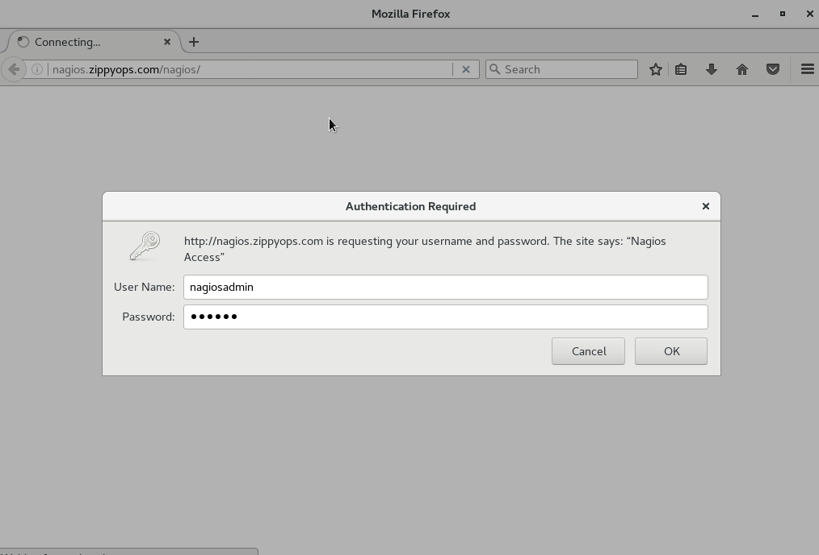

You can get this page , here we have to give nagiosadmin and password which you have given for htpasswd section,

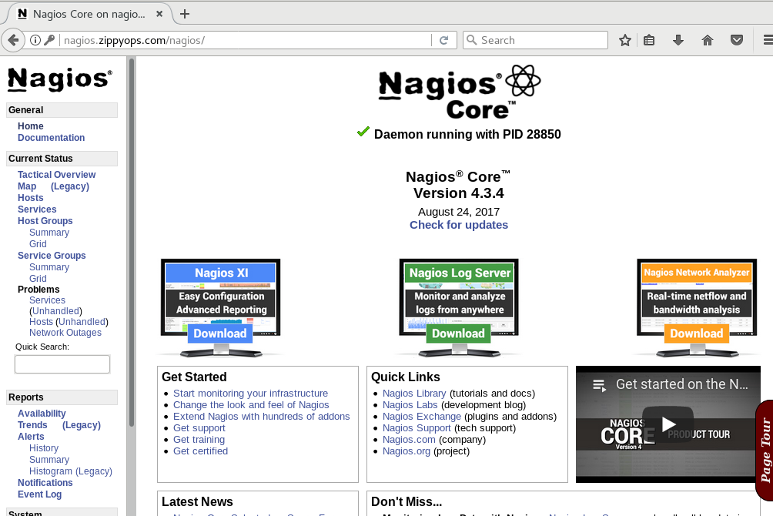

We got nagios web UI !!!

# Working with webUI :

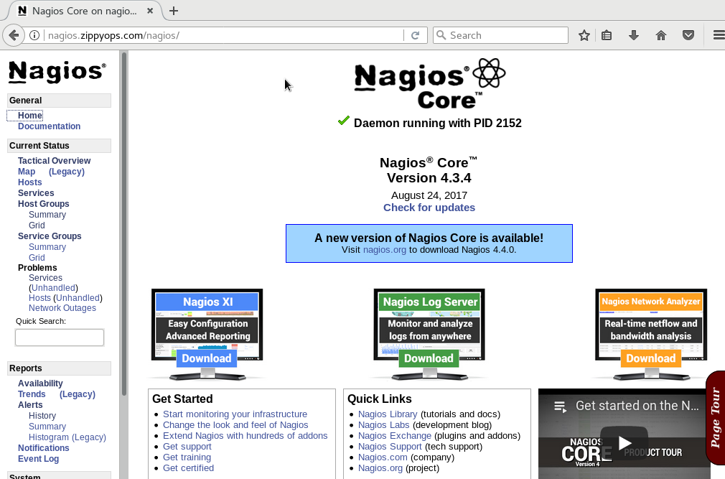

We can see that we are in home page of nagios , in this page we can see different options .

Now we have to click on “**tactical overview**” option,

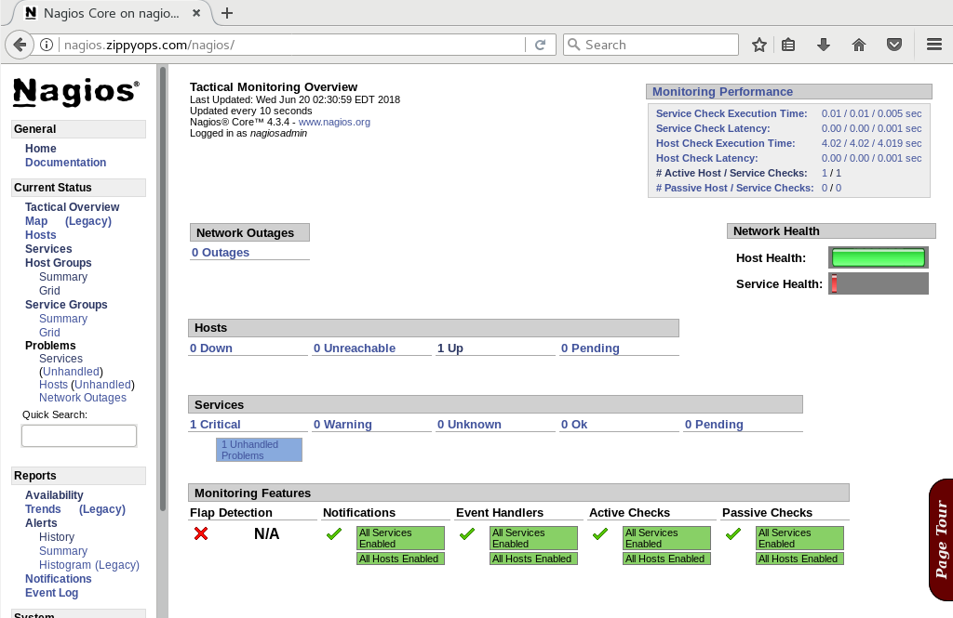

We can see in this page , there is hosts and services and monitoring feature and network outages .

There is only one host up running that is our localhost

In services , one service running which is in critical condition and aslo given 1 unhandled problem .

So click on unhandled problem ,

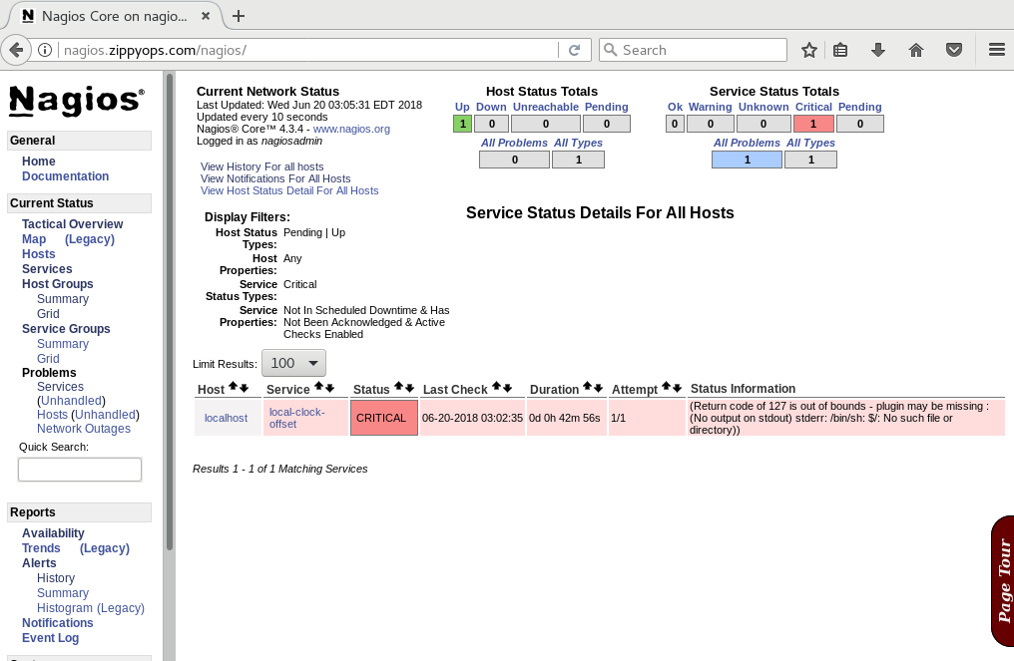

You can see that status information and return code : 127 detail of out bound condtion of local host ,

Now we can rectify this ,

[root@nagios zippyops]# cd /usr/local/nagios/etc/objects/services

[root@nagios services]# ls

local-time-variance.cfg long-time-variance.cfg

[root@nagios services]# cat local-time-offset.cfg

define service{

host_name localhost

service_description local-clock-offset

check_command check-local-clock-offset

max_check_attempts 1

check_period 24x7

contacts nagiosadmin

contact_groups admins

notification_interval 480

notification_period 24x7

}

[root@nagios services]# mv local-time-variance.cfg local-clock-offset.cfg

[root@nagios services]# ls

local-clock-offset.cfg long-time-variance.cfg

[root@nagios services]#

Here, you can see that service description name is local-clock-offset . so I have renamed the local-time-variance.cfg file to local-clock-offset.cfg ,

Now we can verify our configuration ,

[root@nagios services]# /usr/local/nagios/bin/nagios -v /usr/local/nagios/etc/nagios.cfg

Nagios Core 4.3.4

Copyright (c) 2009-present Nagios Core Development Team and Community Contributors

Copyright (c) 1999-2009 Ethan Galstad

Last Modified: 2017-08-24

License: GPL

Website: https://www.nagios.org

Reading configuration data...

Read main config file okay...

Warning: Duplicate definition found for service 'local-clock-offset' on host 'localhost' (config file '/usr/local/nagios/etc/objects/services/long-time-variance.cfg', starting on line 1)

Read object config files okay...

Running pre-flight check on configuration data...

Checking objects...

Checked 1 services.

Checked 1 hosts.

Checked 0 host groups.

Checked 0 service groups.

Checked 1 contacts.

Checked 1 contact groups.

Checked 26 commands.

Checked 5 time periods.

Checked 0 host escalations.

Checked 0 service escalations.

Checking for circular paths...

Checked 1 hosts

Checked 0 service dependencies

Checked 0 host dependencies

Checked 5 timeperiods

Checking global event handlers...

Checking obsessive compulsive processor commands...

Checking misc settings...

Total Warnings: 0

Total Errors: 0

Things look okay - No serious problems were detected during the pre-flight check

[root@nagios services]#

Lets restart the nagios service ,

[root@nagios services]# systemctl restart nagios

Go back to our nagios webUI ,

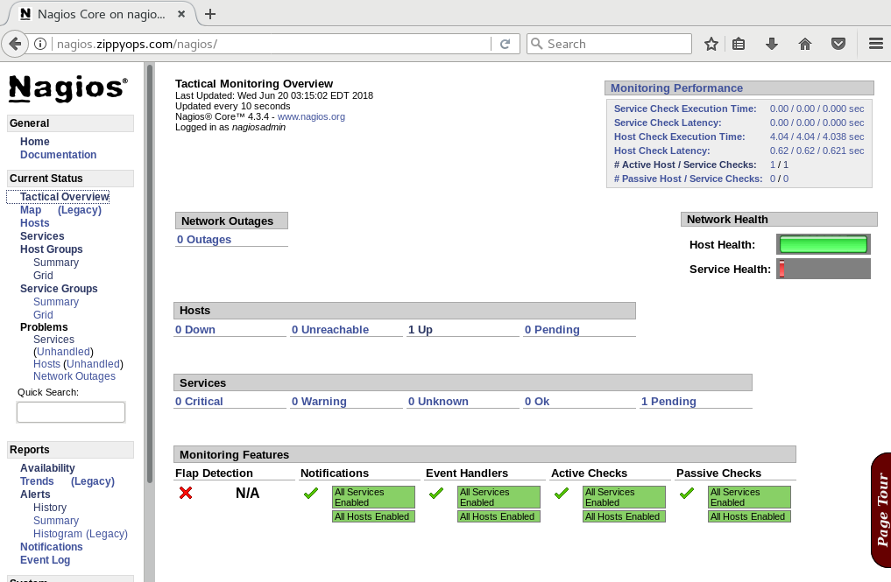

Here you can see status is pending,

So we can go back to termianal to check nagios log file ,

[root@nagios services]# cat /var/log/nagios/nagios.log

[1528909598] Nagios 4.3.4 starting... (PID=1340)

[1528909598] Local time is Wed Jun 13 13:06:38 EDT 2018

[1528909598] LOG VERSION: 2.0

[1529478829] Successfully launched command file worker with pid 13764

[1529479128] Warning: Return code of 127 for check of service 'local-clock-offset' on host 'localhost' was out of bounds. Make sure the plugin you're trying to run actually exists.

[1529479128] SERVICE ALERT: localhost;local-clock-offset;CRITICAL;HARD;1;(Return code of 127 is out of bounds - plugin may be missing : (No output on stdout) stderr: /bin/sh: $/: No such file or directory))

[1529479128] SERVICE NOTIFICATION: nagiosadmin;localhost;local-clock-offset;CRITICAL;notify-service-by-email;(Return code of 127 is out of bounds - plugin may be missing : (No output on stdout) stderr: /bin/sh: $/: No such file or directory))

[1529479421] Caught SIGTERM, shutting down...

[1529479421] Successfully shutdown... (PID=13745)

[1529479421] Event broker module 'NERD' deinitialized successfully.

[1529479422] Nagios 4.3.4 starting... (PID=14052)

[1529479422] Local time is Wed Jun 20 03:23:42 EDT 2018

[1529479422] LOG VERSION: 2.0

[1529479422] qh: Socket '/usr/local/nagios/var/rw/nagios.qh' successfully initialized

[1529479422] qh: core query handler registered

[1529479422] nerd: Channel hostchecks registered successfully

[1529479422] nerd: Channel servicechecks registered successfully

[1529479422] nerd: Channel opathchecks registered successfully

[1529479422] nerd: Fully initialized and ready to rock!

[1529479422] wproc: Successfully registered manager as @wproc with query handler

[1529479422] wproc: Registry request: name=Core Worker 14058;pid=14058

[1529479422] wproc: Registry request: name=Core Worker 14055;pid=14055

[1529479422] wproc: Registry request: name=Core Worker 14056;pid=14056

[1529479422] wproc: Registry request: name=Core Worker 14057;pid=14057

[1529479422] Successfully launched command file worker with pid 1406

We have got waring as return code 127 for check of service local-clock-offset and aslo notification mail set is not found.

[root@nagios nagios]# ls

bin etc include libexec sbin share var

[root@nagios nagios]# cd etc/

[root@nagios etc]# cd objects/

[root@nagios objects]# cd commands/

[root@nagios commands]# ls

check-host-by-ping.cfg check-local-clock-offset.cfg commands.cfg

[root@nagios commands]# cat commands.cfg | grep -A 10 -B 10 'email'

#

# SAMPLE NOTIFICATION COMMANDS

#

# These are some example notification commands. They may or may not work on

# your system without modification. As an example, some systems will require

# you to use "/usr/bin/mailx" instead of "/usr/bin/mail" in the commands below.

#

################################################################################

# 'notify-host-by-email' command definition

define command{

command_name notify-host-by-email

command_line /usr/bin/printf "%b" "***** Nagios *****\n\nNotification Type: $NOTIFICATIONTYPE$\nHost: $HOSTNAME$\nState: $HOSTSTATE$\nAddress: $HOSTADDRESS$\nInfo: $HOSTOUTPUT$\n\nDate/Time: $LONGDATETIME$\n" | /bin/mail -s "** $NOTIFICATIONTYPE$ Host Alert: $HOSTNAME$ is $HOSTSTATE$ **" $CONTACTEMAIL$

}

# 'notify-service-by-email' command definition

define command{

command_name notify-service-by-email

command_line /usr/bin/printf "%b" "***** Nagios *****\n\nNotification Type: $NOTIFICATIONTYPE$\n\nService: $SERVICEDESC$\nHost: $HOSTALIAS$\nAddress: $HOSTADDRESS$\nState: $SERVICESTATE$\n\nDate/Time: $LONGDATETIME$\n\nAdditional Info:\n\n$SERVICEOUTPUT$\n" | /bin/mail -s "** $NOTIFICATIONTYPE$ Service Alert: $HOSTALIAS$/$SERVICEDESC$ is $SERVICESTATE$ **" $CONTACTEMAIL$

}

################################################################################

#

# SAMPLE HOST CHECK COMMANDS

[root@nagios commands]#

Here we can see notifications mail also /bin/mail –s and service notification mail also /bin/mail –s same directory .

So we can check with that directory there is available or not mail directory ,

[root@nagios commands]# ls -la /bin/mail

lrwxrwxrwx. 1 root root 5 Jun 10 10:45 /bin/mail -> mailx

we have it so no problem in it,

Again I have go to web UI ,

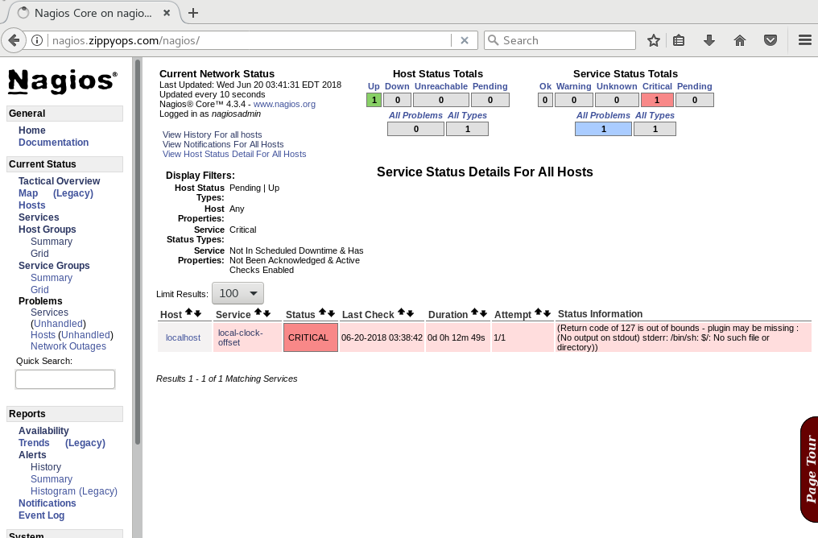

Again got same error code 127 ,

I can verify the nagios log file ,

1529479421] Caught SIGTERM, shutting down...

[1529479421] Successfully shutdown... (PID=13745)

[1529479421] Event broker module 'NERD' deinitialized successfully.

[1529479422] Nagios 4.3.4 starting... (PID=14052)

[1529479422] Local time is Wed Jun 20 03:23:42 EDT 2018

[1529479422] LOG VERSION: 2.0

[1529479422] qh: Socket '/usr/local/nagios/var/rw/nagios.qh' successfully initialized

[1529479422] qh: core query handler registered

[1529479422] nerd: Channel hostchecks registered successfully

[1529479422] nerd: Channel servicechecks registered successfully

[1529479422] nerd: Channel opathchecks registered successfully

[1529479422] nerd: Fully initialized and ready to rock!

[1529479422] wproc: Successfully registered manager as @wproc with query handler

[1529479422] wproc: Registry request: name=Core Worker 14058;pid=14058

[1529479422] wproc: Registry request: name=Core Worker 14055;pid=14055

[1529479422] wproc: Registry request: name=Core Worker 14056;pid=14056

[1529479422] wproc: Registry request: name=Core Worker 14057;pid=14057

[1529479422] Successfully launched command file worker with pid 14066

[1529479722] Warning: Return code of 127 for check of service 'local-clock-offset' on host 'localhost' was out of bounds. Make sure the plugin you're trying to run actually exists.

[1529479722] SERVICE ALERT: localhost;local-clock-offset;CRITICAL;HARD;1;(Return code of 127 is out of bounds - plugin may be missing : (No output on stdout) stderr: /bin/sh: $/: No such file or directory))

[1529479722] SERVICE NOTIFICATION: nagiosadmin;localhost;local-clock-offset;CRITICAL;notify-service-by-email;(Return code of 127 is out of bounds - plugin may be missing : (No output on stdout) stderr: /bin/sh: $/: No such file or directory))

[1529480022] Warning: Return code of 127 for check of service 'local-clock-offset' on host 'localhost' was out of bounds. Make sure the plugin you're trying to run actually exists.

[1529480322] Warning: Return code of 127 for check of service 'local-clock-offset' on host 'localhost' was out of bounds. Make sure the plugin you're trying to run actually exists.

I have got some warning again as local-clock-offset . 127 error code means nagios can’t be fine configuration file .

I have go to commands directory ,

[root@nagios commands]# ls

check-host-by-ping.cfg check-local-clock-offset.cfg commands.cfg

now I will edit my check-local-clock-offset.cfg file ,

[root@nagios commands]# vi check-local-clock-offset.cfg

In this file I have removed $USER1$ to give and exact file location ,

[root@nagios commands]# cat check-local-clock-offset.cfg

define command{

command_name check-local-clock-offset

command_line /usr/local/nagios/libexec/check_ntp_time -H 0.us.pool.ntp.org -w 60

}

Now I can run the command ,

[root@nagios commands]# /usr/local/nagios/libexec/check_ntp_time -H 0.us.pool.ntp.org -w 60

NTP OK: Offset -0.02648901939 secs|offset=-0.026489s;60.000000;120.000000;

[root@nagios commands]#

Now go beck to check again the web UI ,

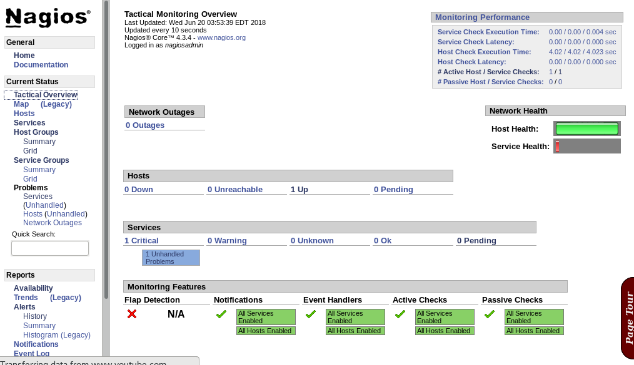

Same error follows , now we can find nagios user have permission to access bin directory ,

[nagios@nagios commands]$ env

XDG_VTNR=1

XDG_SESSION_ID=1

HOSTNAME=nagios.zippyops.com

TERM=xterm-256color

SHELL=/bin/bash

HISTSIZE=1000

USER=nagios

LS_COLORS=rs=0:di=38;5;27:ln=38;5;51:mh=44;38;5;15:pi=40;38;5;11:so=38;5;13:do=38;5;5:bd=48;5;232;38;5;11:cd=48;5;232;38;5;3:or=48;5;232;38;5;9:mi=05;48;5;232;38;5;15:su=48;5;196;38;5;15:sg=48;5;11;38;5;16:ca=48;5;196;38;5;226:tw=48;5;10;38;5;16:ow=48;5;10;38;5;21:st=48;5;21;38;5;15:ex=38;5;34:*.tar=38;5;9:*.tgz=38;5;9:*.arc=38;5;9:*.arj=38;5;9:*.taz=38;5;9:*.lha=38;5;9:*.lz4=38;5;9:*.lzh=38;5;9:*.lzma=38;5;9:*.tlz=38;5;9:*.txz=38;5;9:*.tzo=38;5;9:*.t7z=38;5;9:*.zip=38;5;9:*.z=38;5;9:*.Z=38;5;9:*.dz=38;5;9:*.gz=38;5;9:*.lrz=38;5;9:*.lz=38;5;9:*.lzo=38;5;9:*.xz=38;5;9:*.bz2=38;5;9:*.bz=38;5;9:*.tbz=38;5;9:*.tbz2=38;5;9:*.tz=38;5;9:*.deb=38;5;9:*.rpm=38;5;9:*.jar=38;5;9:*.war=38;5;9:*.ear=38;5;9:*.sar=38;5;9:*.rar=38;5;9:*.alz=38;5;9:*.ace=38;5;9:*.zoo=38;5;9:*.cpio=38;5;9:*.7z=38;5;9:*.rz=38;5;9:*.cab=38;5;9:*.jpg=38;5;13:*.jpeg=38;5;13:*.gif=38;5;13:*.bmp=38;5;13:*.pbm=38;5;13:*.pgm=38;5;13:*.ppm=38;5;13:*.tga=38;5;13:*.xbm=38;5;13:*.xpm=38;5;13:*.tif=38;5;13:*.tiff=38;5;13:*.png=38;5;13:*.svg=38;5;13:*.svgz=38;5;13:*.mng=38;5;13:*.pcx=38;5;13:*.mov=38;5;13:*.mpg=38;5;13:*.mpeg=38;5;13:*.m2v=38;5;13:*.mkv=38;5;13:*.webm=38;5;13:*.ogm=38;5;13:*.mp4=38;5;13:*.m4v=38;5;13:*.mp4v=38;5;13:*.vob=38;5;13:*.qt=38;5;13:*.nuv=38;5;13:*.wmv=38;5;13:*.asf=38;5;13:*.rm=38;5;13:*.rmvb=38;5;13:*.flc=38;5;13:*.avi=38;5;13:*.fli=38;5;13:*.flv=38;5;13:*.gl=38;5;13:*.dl=38;5;13:*.xcf=38;5;13:*.xwd=38;5;13:*.yuv=38;5;13:*.cgm=38;5;13:*.emf=38;5;13:*.axv=38;5;13:*.anx=38;5;13:*.ogv=38;5;13:*.ogx=38;5;13:*.aac=38;5;45:*.au=38;5;45:*.flac=38;5;45:*.mid=38;5;45:*.midi=38;5;45:*.mka=38;5;45:*.mp3=38;5;45:*.mpc=38;5;45:*.ogg=38;5;45:*.ra=38;5;45:*.wav=38;5;45:*.axa=38;5;45:*.oga=38;5;45:*.spx=38;5;45:*.xspf=38;5;45:

SUDO_USER=zippyops

SUDO_UID=1000

USERNAME=zippyops

MAIL=/var/spool/mail/zippyops

PATH=/sbin:/bin:/usr/sbin:/usr/bin

PWD=/usr/local/nagios/etc/objects/commands

LANG=en_US.UTF-8

HOME=/home/nagios

SUDO_COMMAND=/bin/su

XDG_SEAT=seat0

SHLVL=2

LOGNAME=nagios

XDG_DATA_DIRS=/root/.local/share/flatpak/exports/share/:/var/lib/flatpak/exports/share/:/usr/local/share/:/usr/share/

LESSOPEN=||/usr/bin/lesspipe.sh %s

DISPLAY=:0

SUDO_GID=1000

COLORTERM=truecolor

_=/bin/env

I had checked nagios environment there is no permission for access , also we have check the nagios home directory available in .bash

[nagios@nagios ~]$ ls -la

total 24

drwx------. 5 nagios nagios 144 Jun 15 08:32 .

drwxr-xr-x. 4 root root 36 Jun 11 02:17 ..

-rw------- 1 nagios nagios 1032 Jun 13 09:19 .bash_history

-rw-r--r--. 1 nagios nagios 18 Apr 10 20:53 .bash_logout

-rw-r--r--. 1 nagios nagios 193 Apr 10 20:53 .bash_profile

-rw-r--r--. 1 nagios nagios 231 Apr 10 20:53 .bashrc

drwxrwxr-x 3 nagios nagios 18 Jun 13 05:10 .cache

drwxrwxr-x 3 nagios nagios 18 Jun 13 05:10 .config

drwxr-xr-x. 4 nagios nagios 39 Jun 10 06:20 .mozilla

-rw------- 1 nagios nagios 4122 Jun 15 06:33 .viminfo

[nagios@nagios ~]$ cat .bash_profile

# .bash_profile

# Get the aliases and functions

if [ -f ~/.bashrc ]; then

. ~/.bashrc

fi

# User specific environment and startup programs

PATH=$PATH:$HOME/.local/bin:$HOME/bin

export PATH

[nagios@nagios ~]$

Now we can update nagios home directory ,

[nagios@nagios ~]$ cat .bash_profile

# .bash_profile

# Get the aliases and functions

if [ -f ~/.bashrc ]; then

. ~/.bashrc

fi

# User specific environment and startup programs

PATH=$PATH:$HOME/.local/bin:$HOME/bin:/usr/local/nagios/bin:/usr/local/nagios/sbin:/usr/local/nagios/libexec

export PATH

update it and exit from nagios user and restart service ,

[root@nagios commands]# systemctl restart nagios

Now go back to log file ,

[1529481841] Caught SIGTERM, shutting down...

[1529481841] Successfully shutdown... (PID=14052)

[1529481841] Event broker module 'NERD' deinitialized successfully.

[1529481842] Nagios 4.3.4 starting... (PID=15064)

[1529481842] Local time is Wed Jun 20 04:04:02 EDT 2018

[1529481842] LOG VERSION: 2.0

[1529481842] qh: Socket '/usr/local/nagios/var/rw/nagios.qh' successfully initialized

[1529481842] qh: core query handler registered

[1529481842] nerd: Channel hostchecks registered successfully

[1529481842] nerd: Channel servicechecks registered successfully

[1529481842] nerd: Channel opathchecks registered successfully

[1529481842] nerd: Fully initialized and ready to rock!

[1529481842] wproc: Successfully registered manager as @wproc with query handler

[1529481842] wproc: Registry request: name=Core Worker 15067;pid=15067

[1529481842] wproc: Registry request: name=Core Worker 15068;pid=15068

[1529481842] wproc: Registry request: name=Core Worker 15069;pid=15069

[1529481842] wproc: Registry request: name=Core Worker 15070;pid=15070

[1529481842] Successfully launched command file worker with pid 15080

[root@nagios commands]#

All the things come good !!!

Now we can go back to web UI ,

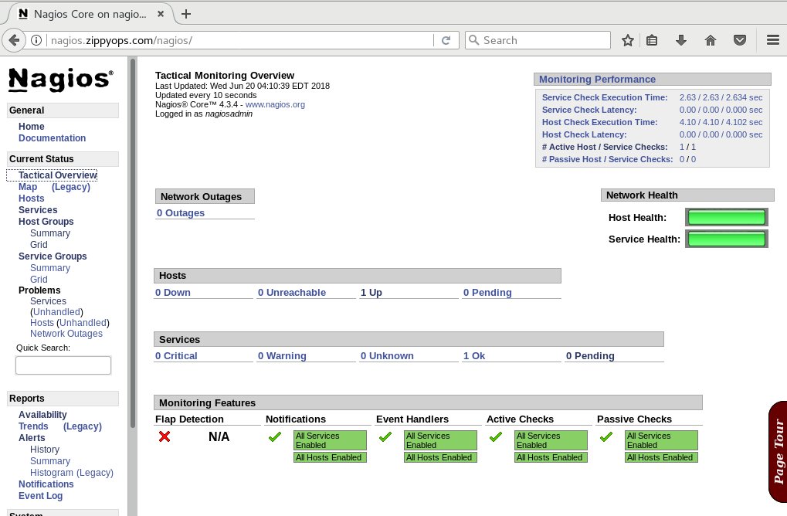

Services are ok now ,

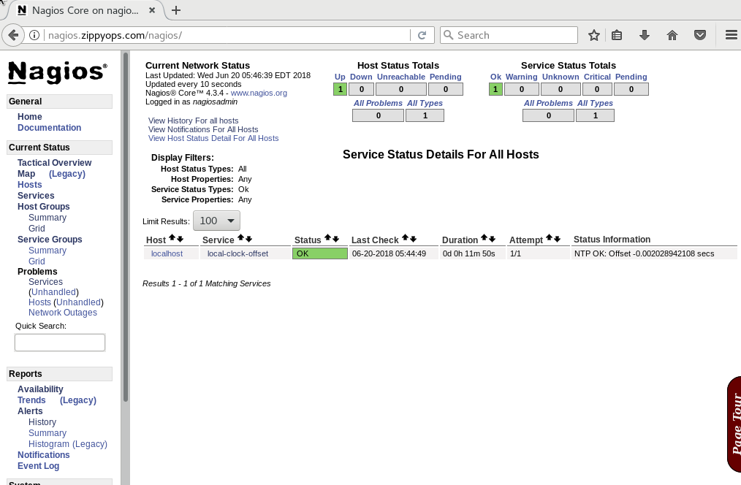

Nagios localhost running good !!!

# Authoring groups:

[root@nagios nagios]# cd etc/

[root@nagios etc]# ls

cgi.cfg htpasswd.users nagios.cfg nagios.cfg.old objects resource.cfg

[root@nagios etc]# cd objects/

[root@nagios objects]# ls

commands contactgroups contacts hostgroups hosts servicegroups services templates timeperiods unused

[root@nagios objects]# cd hostgroups/

[root@nagios hostgroups]# ls

[root@nagios hostgroups]#

Here I can add hostgroup file ,

[root@nagios hostgroups]# vi zippyops-servers.cfg

[root@nagios hostgroups]# ls

zippyops-servers.cfg

[root@nagios hostgroups]# cat zippyops-servers.cfg

define hostgroup{

hostgroup_name zippyops-servers

members localhost

}

[root@nagios hostgroups]#

In here I have created hostgroup and my hostgroup name is zippyops-servers .

Now I am going to edit my nagios core host in host directory,

root@nagios objects]# ls

commands contactgroups contacts hostgroups hosts servicegroups services templates timeperiods unused

[root@nagios objects]# cd hosts

[root@nagios hosts]# ls

localhost.cfg localhost.cfg.old

[root@nagios hosts]# vi localhost.cfg

[root@nagios hosts]# cat localhost.cfg

# localhost: Nagios core Host

define host{

name localhost

host_name localhost

alias nagios-core-host-1

check_period 24x7

check_interval 5

retry_interval 1

max_check_attempts 10

check_command check-host-by-ping

contact_groups admins

notifications_enabled 1

event_handler_enabled 1

flap_detection_enabled 1

process_perf_data 1

retain_status_information 1

retain_nonstatus_information 1

notification_interval 120

notification_options d,u,r,f

notification_period 24x7 ;this is a comment

}

[root@nagios hosts]#

Here I have added alias in localhost.cfg file .

What is mean by alias ?

This directive is used to define a longer name or description used to identify the host. It provide in order to allow you more easily identify a particular host. When used properly, the $HOSTALIAS$ macro will contain this alias/description.

Now I am going to change my localhost.cfg file as nagios-core-host-1 , because we have to show the difference between this two .

[root@nagios hosts]# ls

localhost.cfg localhost.cfg.old

[root@nagios hosts]# mv localhost.cfg nagios-core-host-1.cfg

[root@nagios hosts]# ls

localhost.cfg.old nagios-core-host-1.cfg

[root@nagios hosts]#

Next we have to verify our configuration ,

[root@nagios hosts]# /usr/local/nagios/bin/nagios -v /usr/local/nagios/etc/nagios.cfg

Nagios Core 4.3.4

Copyright (c) 2009-present Nagios Core Development Team and Community Contributors

Copyright (c) 1999-2009 Ethan Galstad

Last Modified: 2017-08-24

License: GPL

Website: https://www.nagios.org

Reading configuration data...

Read main config file okay...

Read object config files okay...

Running pre-flight check on configuration data...

Checking objects...

Checked 1 services.

Checked 1 hosts.

Checked 1 host groups.

Checked 0 service groups.

Checked 1 contacts.

Checked 1 contact groups.

Checked 26 commands.

Checked 5 time periods.

Checked 0 host escalations.

Checked 0 service escalations.

Checking for circular paths...

Checked 1 hosts

Checked 0 service dependencies

Checked 0 host dependencies

Checked 5 timeperiods

Checking global event handlers...

Checking obsessive compulsive processor commands...

Checking misc settings...

Total Warnings: 0

Total Errors: 0

Things look okay - No serious problems were detected during the pre-flight check

[root@nagios hosts]#

No errors found in this configuration , another one thing you can see that one hostgroup has been added .

Now we can restart our nagios service ,

[root@nagios hosts]# systemctl restart nagios

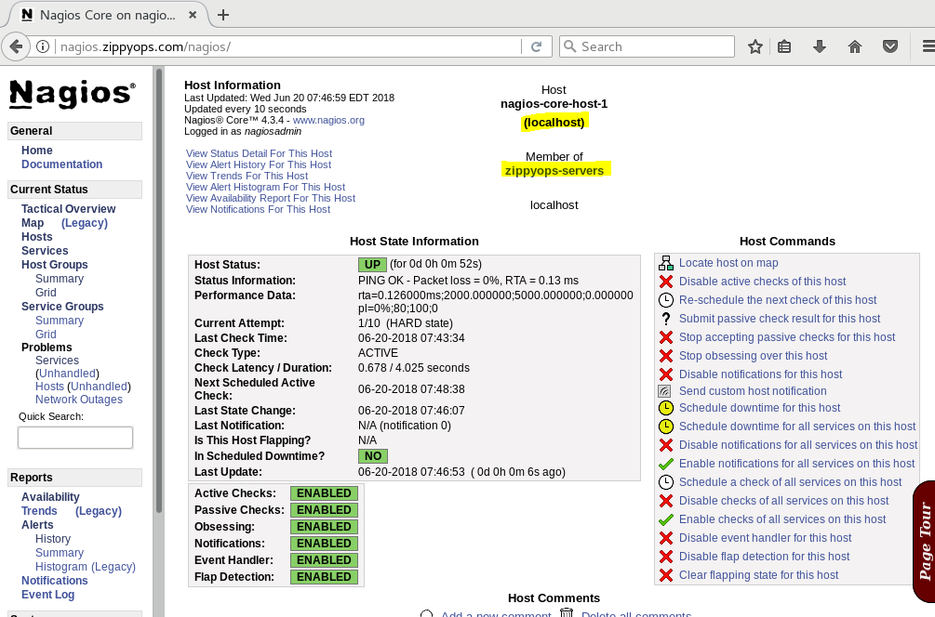

Here you can see that localhost is member of zippyops-servers group . shown in that page above.

But in this page we have not see that alias , so we can do one more thing in this ,

[root@nagios hosts]# ls

localhost.cfg.old nagios-core-host-1.cfg

[root@nagios hosts]# cat nagios-core-host-1.cfg

# localhost: Nagios core Host

define host{

name localhost

host_name localhost

alias nagios-core-host-1

check_period 24x7

check_interval 5

retry_interval 1

display_name nagios-core-host-1

max_check_attempts 10

check_command check-host-by-ping

contact_groups admins

notifications_enabled 1

event_handler_enabled 1

flap_detection_enabled 1

process_perf_data 1

retain_status_information 1

retain_nonstatus_information 1

notification_interval 120

notification_options d,u,r,f

notification_period 24x7 ;this is a comment

}

Here I have added display_name of alias added in this file ,

Next to verify configuration and start nagios service ,

[root@nagios hosts]# /usr/local/nagios/bin/nagios -v /usr/local/nagios/etc/nagios.cfg

Nagios Core 4.3.4

Copyright (c) 2009-present Nagios Core Development Team and Community Contributors

Copyright (c) 1999-2009 Ethan Galstad

Last Modified: 2017-08-24

License: GPL

Website: https://www.nagios.org

Reading configuration data...

Read main config file okay...

Read object config files okay...

Running pre-flight check on configuration data...

Checking objects...

Checked 1 services.

Checked 1 hosts.

Checked 1 host groups.

Checked 0 service groups.

Checked 1 contacts.

Checked 1 contact groups.

Checked 26 commands.

Checked 5 time periods.

Checked 0 host escalations.

Checked 0 service escalations.

Checking for circular paths...

Checked 1 hosts

Checked 0 service dependencies

Checked 0 host dependencies

Checked 5 timeperiods

Checking global event handlers...

Checking obsessive compulsive processor commands...

Checking misc settings...

Total Warnings: 0

Total Errors: 0

Things look okay - No serious problems were detected during the pre-flight check

[root@nagios hosts]# systemctl restart nagios

[root@nagios hosts]#

Go back to web Ui and see servicegroup ,

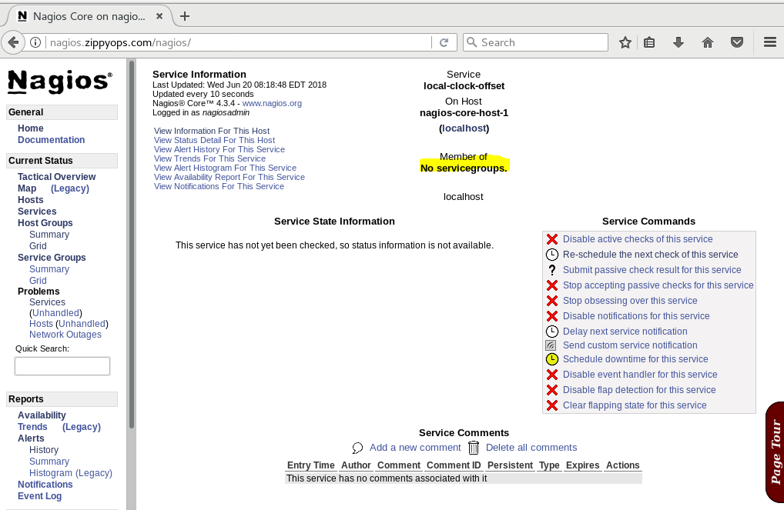there is no service group , so now we can create that ,

[root@nagios objects]# cd servicegroups/

[root@nagios servicegroups]# ls

[root@nagios servicegroups]# vi local-clock-offset-service.cfg

Here I have added servicegroup name and alias ,

[root@nagios servicegroups]# cat local-clock-offset-service.cfg

define servicegroup{

servicegroup_name local-clock-offset-service

alias local clock offset service group

}

After that I have added service group name in the service directory,

[root@nagios servicegroups]# cd ../services

[root@nagios services]# ls

local-clock-offset.cfg

[root@nagios services]# vi local-clock-offset.cfg

[root@nagios services]# cat local-clock-offset.cfg

define service{

host_name localhost

service_description local-clock-offset

check_command check-local-clock-offset

max_check_attempts 1

check_period 24x7

contacts nagiosadmin

contact_groups admins

notification_interval 480

notification_period 24x7

servicegroups local-clock-offset-service

}

To verify our configuration ,

[root@nagios services]# /usr/local/nagios/bin/nagios -v /usr/local/nagios/etc/nagios.cfg

Nagios Core 4.3.4

Copyright (c) 2009-present Nagios Core Development Team and Community Contributors

Copyright (c) 1999-2009 Ethan Galstad

Last Modified: 2017-08-24

License: GPL

Website: https://www.nagios.org

Reading configuration data...

Read main config file okay...

Read object config files okay...

Running pre-flight check on configuration data...

Checking objects...

Checked 1 services.

Checked 1 hosts.

Checked 1 host groups.

Checked 1 service groups.

Checked 1 contacts.

Checked 1 contact groups.

Checked 26 commands.

Checked 5 time periods.

Checked 0 host escalations.

Checked 0 service escalations.

Checking for circular paths...

Checked 1 hosts

Checked 0 service dependencies

Checked 0 host dependencies

Checked 5 timeperiods

Checking global event handlers...

Checking obsessive compulsive processor commands...

Checking misc settings...

Total Warnings: 0

Total Errors: 0

Things look okay - No serious problems were detected during the pre-flight check

Here you have see that one service group has been added . Again we have to restart nagios service ,

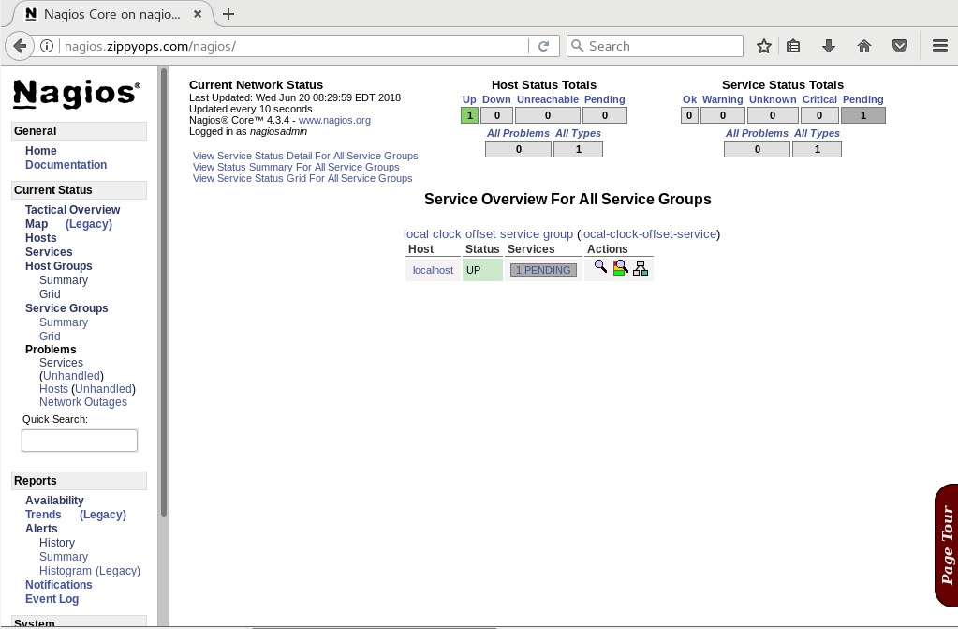

Service group has been added successfully !!

# Templates and inheritance :

Basics :

There are three variables affecting recursion and inheritance that are present in all object definitions. They are indicated in red as follows...

define someobjecttype{

object-specific variables ...

name template_name

use name_of_template_to_use

register [0/1]

}

The first variable is name. Its just a "template" name that can be referenced in other object definitions so they can inherit the objects properties/variables. Template names must be unique amongst objects of the same type, so you can't have two or more host definitions that have "hosttemplate" as their template name.

The second variable is use. This is where you specify the name of the template object that you want to inherit properties/variables from. The name you specify for this variable must be defined as another object's template named (using the name variable).

The third variable is register. This variable is used to indicate whether or not the object definition should be "registered" with Nagios. By default, all object definitions are registered. If you are using a partial object definition as a template, you would want to prevent it from being registered (an example of this is provided later). Values are as follows: 0 = do NOT register object definition, 1 = register object definition (this is the default). This variable is NOT inherited; every (partial) object definition used as a template must explicitly set the register directive to be 0. This prevents the need to override an inherited register directive with a value of 1 for every object that should be registered.

For example :

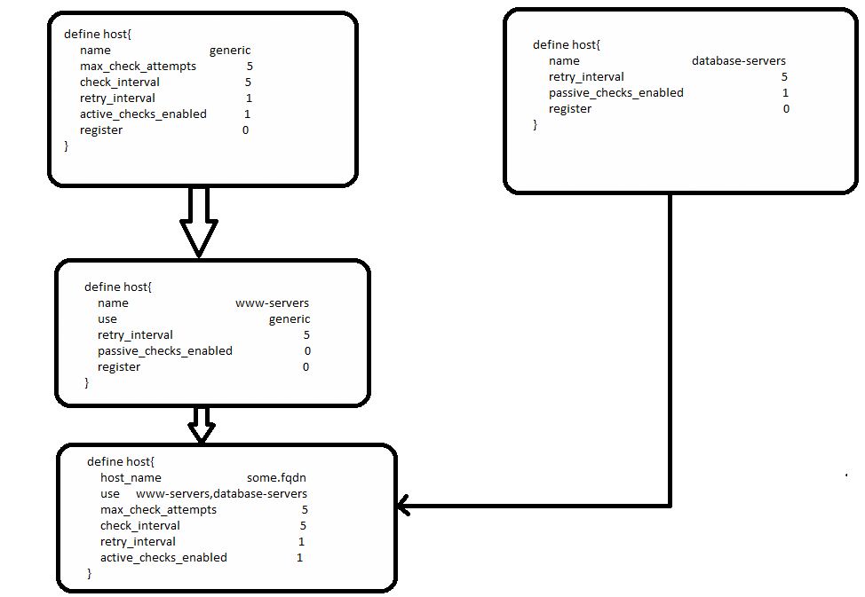

You can see the generic host definition , there is chec_interval set to 5 and retry_interval set to 1

, active_checks_enabled 1 . Also see the www-servers host retry_interval set is 5 .

Finally , you can see the host defineition , generic host active_check_enabled 1 and compare to www-servers passivecheck_enabled set to 0 and template use as generic so its taken active_checks_enabled 1. This way of templates used in chain functions.

Now I am going to edit my nagiosadmin file add generic contact in that file .

Before that we can see our template.cfg file ,

[root@nagios objects]# cd templates/

[root@nagios templates]# ls

templates.cfg

[root@nagios templates]# cat templates.cfg

###############################################################################

# TEMPLATES.CFG - SAMPLE OBJECT TEMPLATES

#

#

# NOTES: This config file provides you with some example object definition

# templates that are refered by other host, service, contact, etc.

# definitions in other config files.

#

# You don't need to keep these definitions in a separate file from your

# other object definitions. This has been done just to make things

# easier to understand.

#

###############################################################################

###############################################################################

###############################################################################

#

# CONTACT TEMPLATES

#

###############################################################################

###############################################################################

# Generic contact definition template - This is NOT a real contact, just a template!

define contact{

name generic-contact ; The name of this contact template

service_notification_period 24x7 ; service notifications can be sent anytime

host_notification_period 24x7 ; host notifications can be sent anytime

service_notification_options w,u,c,r,f,s ; send notifications for all service states, flapping events, and scheduled downtime events

host_notification_options d,u,r,f,s; send notifications for all host states, flapping events, and scheduled downtime events

service_notification_commands notify-service-by-email; send service notifications via email

host_notification_commands notify-host-by-email ; send host notifications via email

register 0 ; DONT REGISTER THIS DEFINITION - ITS NOT A REAL CONTACT, JUST A TEMPLATE!

}

This is contact template , here we will to use generic contact template , this is set to default values . if we have to use this template , then what will happen lets see ,

[root@nagios zippyops]# cd /usr/local/nagios/etc/objects/contacts/

[root@nagios contacts]# ls

contacts.cfg.old nagiosadmin.cfg

[root@nagios contacts]# mv nagiosadmin.cfg nagiosadmin.cfg.old

[root@nagios contacts]# ls

contacts.cfg.old nagiosadmin.cfg.old

[root@nagios contacts]# cp nagiosadmin.cfg.old nagiosadmin.cfg

[root@nagios contacts]# ls

contacts.cfg.old nagiosadmin.cfg nagiosadmin.cfg.old

[root@nagios contacts]# vi nagiosadmin.cfg

[root@nagios contacts]# cat nagiosadmin.cfg

define contact{

contact_name nagiosadmin ; Short name of user

alias Nagios Admin ; Full name of user

use generic-contact

email zippyops@gmail.com

}

[root@nagios contacts]#

Here I have used template name of generic-contact . Now I can verify thgis configuration .

[root@nagios contacts]# /usr/local/nagios/bin/nagios -v /usr/local/nagios/etc/nagios.cfg

Nagios Core 4.3.4

Copyright (c) 2009-present Nagios Core Development Team and Community Contributors

Copyright (c) 1999-2009 Ethan Galstad

Last Modified: 2017-08-24

License: GPL

Website: https://www.nagios.org

Reading configuration data...

Read main config file okay...

Read object config files okay...

Running pre-flight check on configuration data...

Checking objects...

Checked 1 services.

Checked 1 hosts.

Checked 1 host groups.

Checked 1 service groups.

Checked 1 contacts.

Checked 1 contact groups.

Checked 26 commands.

Checked 5 time periods.

Checked 0 host escalations.

Checked 0 service escalations.

Checking for circular paths...

Checked 1 hosts

Checked 0 service dependencies

Checked 0 host dependencies

Checked 5 timeperiods

Checking global event handlers...

Checking obsessive compulsive processor commands...

Checking misc settings...

Total Warnings: 0

Total Errors: 0

Things look okay - No serious problems were detected during the pre-flight check

There is no problem in our configuration . Restart the nagios service .

[root@nagios templates]# systemctl restart nagios

Go to our nagios web UI ,

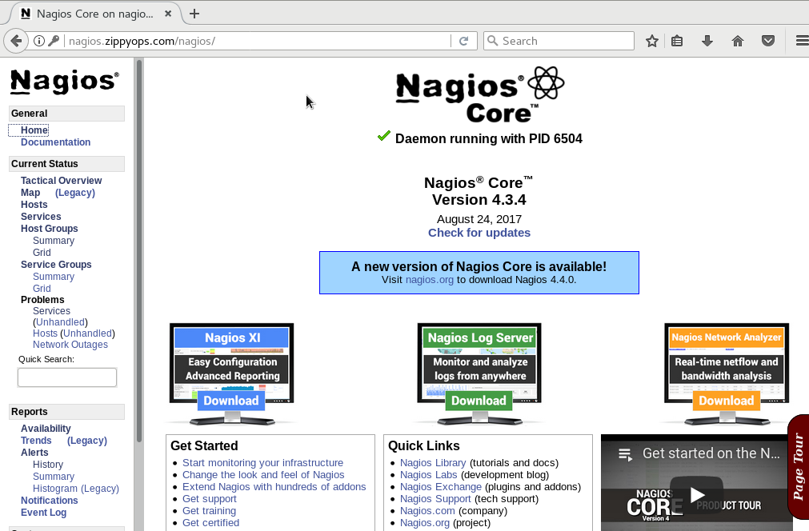

Go to configuration ,

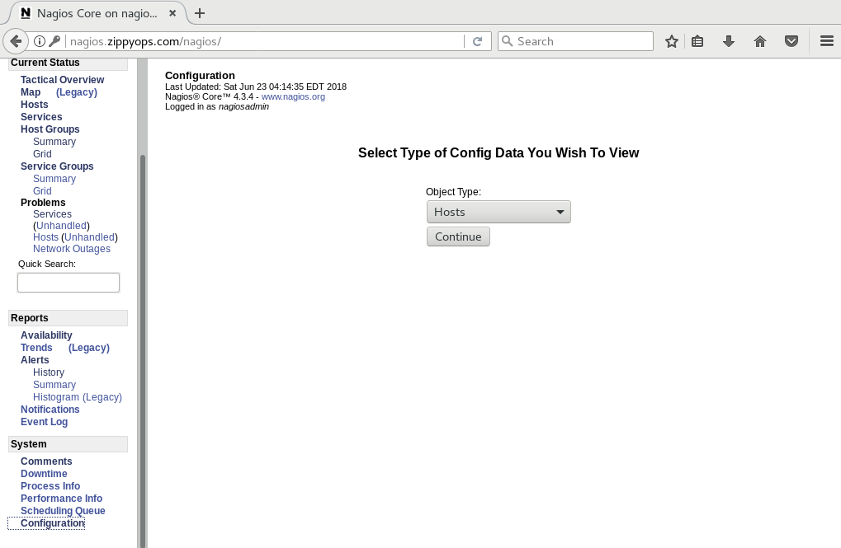

Set as contacts and continue ,

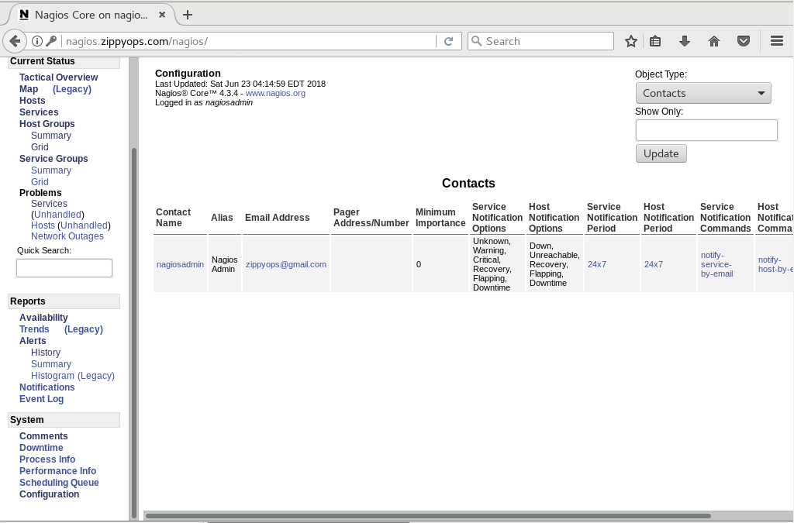

Here you can see that service notficiation and hostnotification periods all are set to be default value . this way we are use this templates in nagios .

# Adding remote hosts :

Before we are adding remote host . We want to think about , what does this group belong in ? and how you choose to manage host . New host join to be proper group and what servie are run on new host.

First we go on check hostgroup definition,

[root@nagios etc]# cd objects/

[root@nagios objects]# cd hostgroups/

[root@nagios hostgroups]# ls

zippyops-servers.cfg

[root@nagios hostgroups]# cat zippyops-servers.cfg

define hostgroup{

hostgroup_name zippyops-servers

members localhost

}

[root@nagios hostgroups]# cp zippyops-servers.cfg remote-hosts.cfg

[root@nagios hostgroups]# vi remote-hosts.cfg

[root@nagios hostgroups]# cat remote-hosts.cfg

define hostgroup{

hostgroup_name remote-hosts

members minion1.zippyops.com

}

Here I have added new host group for remote-hosts and member added as remote hosts name .

We have added hostsgroup next we have to choose what service to be run on this host .

For example , we have to choose this host for http service ,

So go back to our service group directory ,

[root@nagios hostgroups]# cd ..

[root@nagios objects]# cd servicegroups/

[root@nagios servicegroups]# ls

local-clock-offset-service.cfg

[root@nagios servicegroups]# cat local-clock-offset-service.cfg

define servicegroup{

servicegroup_name local-clock-offset-service

alias local clock offset service group

}

There is only one servicegroup that is local-clock-offset-service group , now I have to copy this file to create another one group for http service,

[root@nagios servicegroups]# cp local-clock-offset-service.cfg remote-service.cfg

[root@nagios servicegroups]# vi remote-service.cfg

[root@nagios servicegroups]# cat remote-service.cfg

define servicegroup{

servicegroup_name remote-service

alias Remote service group

}

[root@nagios servicegroups]#

Next is to create http-service.cfg file ,

[root@nagios servicegroups]# cp local-clock-offset-service.cfg http-service.cfg

[root@nagios servicegroups]# vi http-service.cfg

[root@nagios servicegroups]# mv http-service.cfg http-80-service.cfg

[root@nagios servicegroups]# ls

http-80-service.cfg local-clock-offset-service.cfg remote-service.cfg

[root@nagios servicegroups]# cat http-80-service.cfg

define servicegroup{

servicegroup_name http-80-services

alias HTTP port 80 Service Group

}

[root@nagios servicegroups]#

Here I have added http service group .

Next we have to configure to add host,

[root@nagios servicegroups]# cd ../hosts

[root@nagios hosts]# ls

localhost.cfg.old nagios-core-host-1.cfg

[root@nagios hosts]# cp nagios-core-host-1.cfg minion1-zippyops-com.cfg

[root@nagios hosts]# ls

localhost.cfg.old minion1-zippyops-com.cfg nagios-core-host-1.cfg

[root@nagios hosts]# vi minion1-zippyops-com.cfg

[root@nagios hosts]# cat minion1-zippyops-com.cfg

define host{

name minion1-zippyops-com

host_name minion1.zippyops.com

use linux-server

alias minion1.zippyops.com

check_period 24x7

display_name minion1.zippyops.com

max_check_attempts 10

check_command check_ping!2000.00,80%!5000.00,100%

contact_groups admins

}

I have created hosts file for my remote host.

Now I have to give permission for nagios user to edit this file ,

[root@nagios objects]# chown -R nagios:nagios *

[root@nagios objects]# chmod -R 755 *

Now we can verify our configuration ,

[root@nagios objects]# /usr/local/nagios/bin/nagios -v /usr/local/nagios/etc/nagios.cfg

Nagios Core 4.3.4

Copyright (c) 2009-present Nagios Core Development Team and Community Contributors

Copyright (c) 1999-2009 Ethan Galstad

Last Modified: 2017-08-24

License: GPL

Website: https://www.nagios.org

Reading configuration data...

Read main config file okay...

Read object config files okay...

Running pre-flight check on configuration data...

Checking objects...

Checked 1 services.

Checked 2 hosts.

Checked 2 host groups.

Checked 3 service groups.

Checked 1 contacts.

Checked 1 contact groups.

Checked 26 commands.

Checked 5 time periods.

Checked 0 host escalations.

Checked 0 service escalations.

Checking for circular paths...

Checked 2 hosts

Checked 0 service dependencies

Checked 0 host dependencies

Checked 5 timeperiods

Checking global event handlers...

Checking obsessive compulsive processor commands...

Checking misc settings...

Total Warnings: 0

Total Errors: 0

Things look okay - No serious problems were detected during the pre-flight check

There is no error found so we have to restart nagios service.

Now I am go back to my nagios web UI,

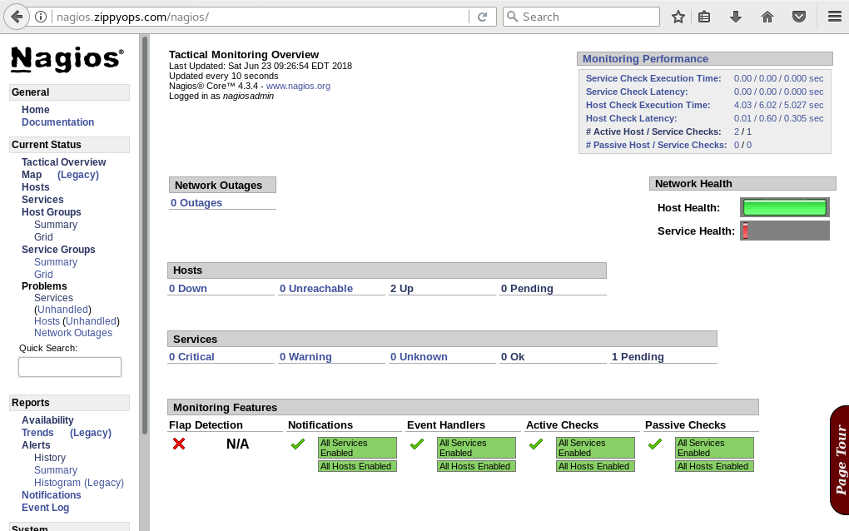

There is two hosts up running one is remotehost another one is localhost,

Click to “hosts”

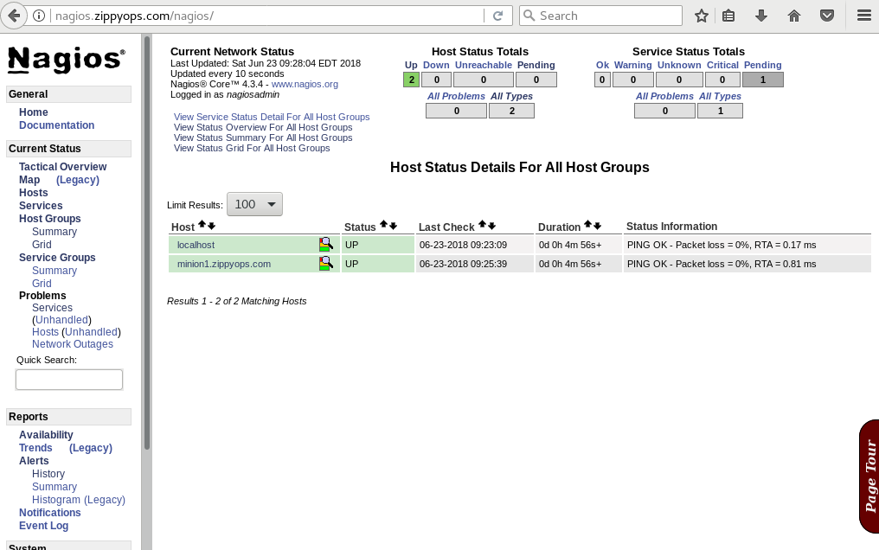

To click hostgroup :

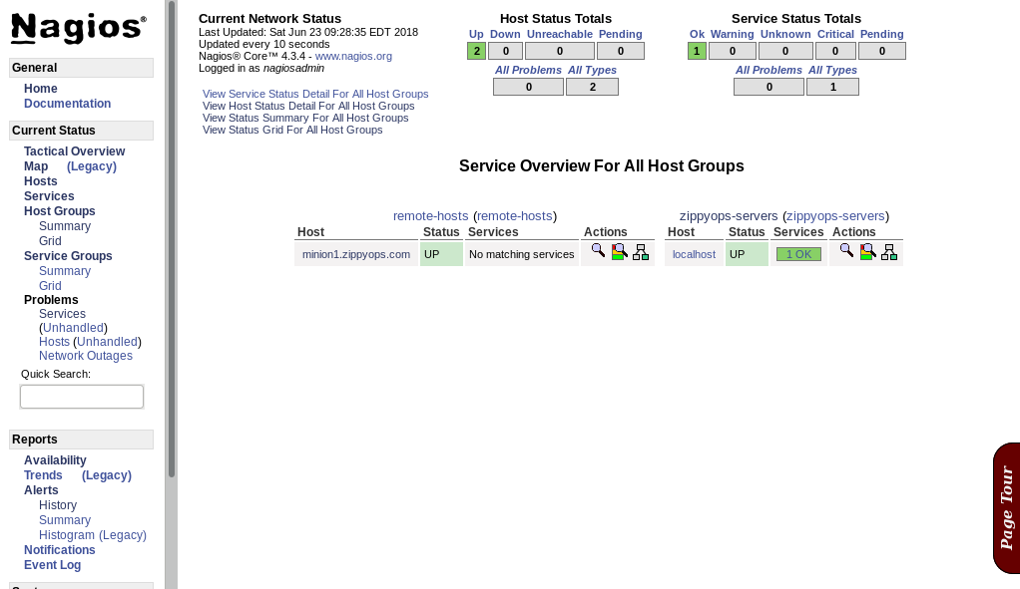

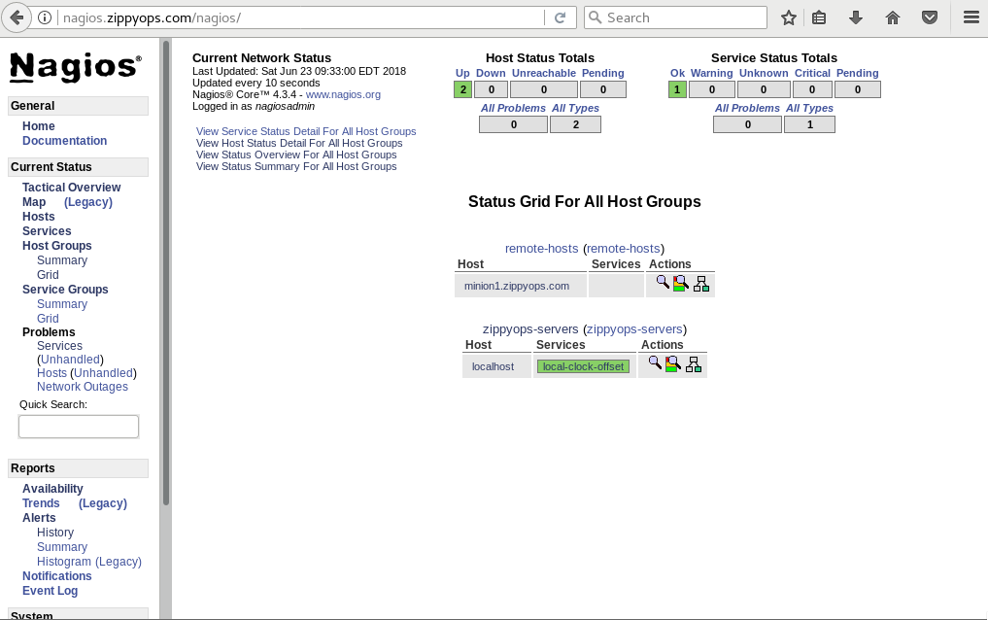

Here we are going add hostgroup for remote host ,

So I have go back to my terminal ,

[root@nagios objects]# cd hostgroups/

[root@nagios hostgroups]# ls

remote-hosts.cfg zippyops-servers.cfg

[root@nagios hostgroups]# vi zippyops-servers.cfg

[root@nagios hostgroups]# cat zippyops-servers.cfg

define hostgroup{

hostgroup_name zippyops-servers

members localhost,minion1.zippyops.com

}

[root@nagios hostgroups]#

In hostgroup zippyops-server.cfg file , I have added another member of my remote host minion1.zippyops.com.

To verify our configuration ,

[root@nagios hostgroups]# /usr/local/nagios/bin/nagios -v /usr/local/nagios/etc/nagios.cfg

Nagios Core 4.3.4

Copyright (c) 2009-present Nagios Core Development Team and Community Contributors

Copyright (c) 1999-2009 Ethan Galstad

Last Modified: 2017-08-24

License: GPL

Website: https://www.nagios.org

Reading configuration data...

Read main config file okay...

Read object config files okay...

Running pre-flight check on configuration data...

Checking objects...

Checked 1 services.

Checked 2 hosts.

Checked 2 host groups.

Checked 3 service groups.

Checked 1 contacts.

Checked 1 contact groups.

Checked 26 commands.

Checked 5 time periods.

Checked 0 host escalations.

Checked 0 service escalations.

Checking for circular paths...

Checked 2 hosts

Checked 0 service dependencies

Checked 0 host dependencies

Checked 5 timeperiods

Checking global event handlers...

Checking obsessive compulsive processor commands...

Checking misc settings...

Total Warnings: 0

Total Errors: 0

Things look okay - No serious problems were detected during the pre-flight check

[root@nagios hostgroups]#

There is no error found . again restart my nagios service.

Go back to nagios web UI :

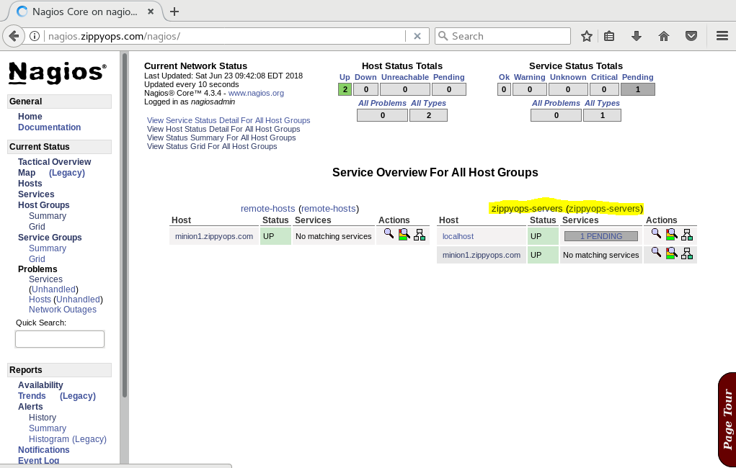

You can see that remote server added to the zippyops-server group . Also available remote-hosts group too.

# Monitoring Remote Hosts via Publicly Available Ports

### Monitoring public ports

Public ports are monitored exactly like any service in nagios. However, because they are available to the network-at-large, they can be monitored from the nagios core host and require no configuration on the host begin monitored. Keep in mind that public ports provide limited information, and may offer little insight beyond whether or not a host is responding over the specified TCP/UDP port.

### Building the service

* Decide which plugin to use and what parameters you want pass to the plugin.
* Author the command definition, using the appropriate $ARG macros to capitalize on reusability.
* Author the service definition, specifying the appropriate command and using macros where possible to increase reusablility.
* Add the service to the appropriate service group.
* Verify the configuration.

I have added my remote host to monitor http 80 port in that remote server ,.

So I can run any service in that port then only we can understand thing .

Now I am going to install apache server in my remote node ,

[root@minion1 zippyops]# yum install httpd -y

Loaded plugins: fastestmirror, langpacks

Loading mirror speeds from cached hostfile

* base: centos.excellmedia.net

* extras: centos.excellmedia.net

* updates: centos.excellmedia.net

Resolving Dependencies

--> Running transaction check

---> Package httpd.x86_64 0:2.4.6-80.el7.centos will be installed

--> Processing Dependency: httpd-tools = 2.4.6-80.el7.centos for package: httpd-2.4.6-80.el7.centos.x86_64

--> Processing Dependency: /etc/mime.types for package: httpd-2.4.6-80.el7.centos.x86_64

--> Running transaction check

---> Package httpd-tools.x86_64 0:2.4.6-80.el7.centos will be installed

---> Package mailcap.noarch 0:2.1.41-2.el7 will be installed

--> Finished Dependency Resolution

Dependencies Resolved

================================================================================

Package Arch Version Repository Size

================================================================================

Installing:

httpd x86_64 2.4.6-80.el7.centos base 2.7 M

Installing for dependencies:

httpd-tools x86_64 2.4.6-80.el7.centos base 89 k

mailcap noarch 2.1.41-2.el7 base 31 k

Transaction Summary

================================================================================

Install 1 Package (+2 Dependent packages)

Total download size: 2.8 M

Installed size: 9.6 M

Downloading packages:

(1/3): httpd-tools-2.4.6-80.el7.centos.x86_64.rpm | 89 kB 00:00

(2/3): mailcap-2.1.41-2.el7.noarch.rpm | 31 kB 00:00

(3/3): httpd-2.4.6-80.el7.centos.x86_64.rpm | 2.7 MB 00:00

--------------------------------------------------------------------------------

Total 3.4 MB/s | 2.8 MB 00:00

Running transaction check

Running transaction test

Transaction test succeeded

Running transaction

Installing : mailcap-2.1.41-2.el7.noarch 1/3

Installing : httpd-tools-2.4.6-80.el7.centos.x86_64 2/3

Installing : httpd-2.4.6-80.el7.centos.x86_64 3/3

Verifying : httpd-tools-2.4.6-80.el7.centos.x86_64 1/3

Verifying : mailcap-2.1.41-2.el7.noarch 2/3

Verifying : httpd-2.4.6-80.el7.centos.x86_64 3/3

Installed:

httpd.x86_64 0:2.4.6-80.el7.centos

Dependency Installed:

httpd-tools.x86_64 0:2.4.6-80.el7.centos mailcap.noarch 0:2.1.41-2.el7

Complete!

To start httpd service,

[root@minion1 zippyops]# systemctl status httpd

● httpd.service - The Apache HTTP Server

Loaded: loaded (/usr/lib/systemd/system/httpd.service; disabled; vendor preset: disabled)

Active: inactive (dead)

Docs: man:httpd(8)

man:apachectl(8)

[root@minion1 zippyops]# systemctl start httpd

To browse IPaddress , you can get starting page of apache

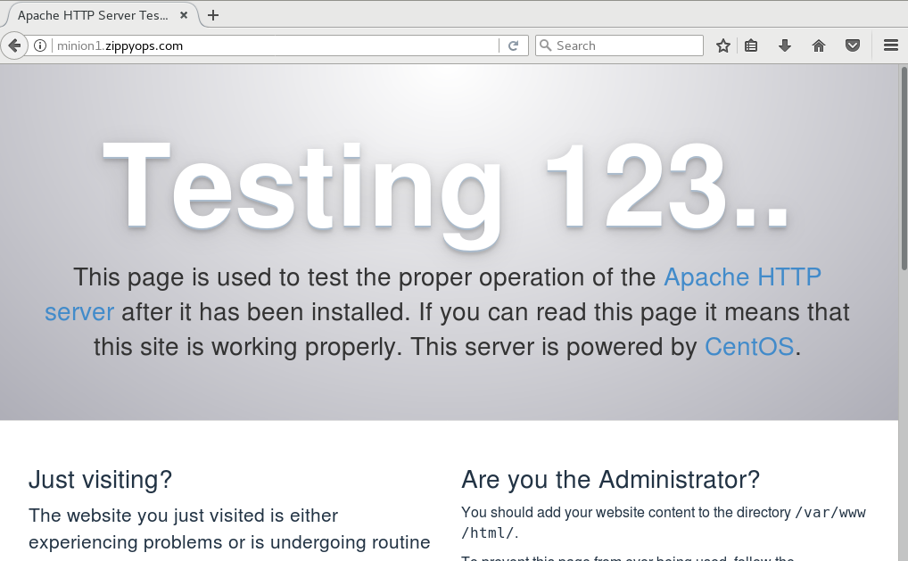

Go back to nagios core server ,

[root@nagios zippyops]# cd /usr/local/nagios/

[root@nagios nagios]# pwd

/usr/local/nagios

[root@nagios nagios]#

Now we can check plugins which is suitable for monitoring http port 80 ,

[root@nagios nagios]# ls -la libexec/

total 6948

drwxr-xr-x. 2 nagios nagios 4096 Jun 11 02:39 .

drwxr-xr-x. 9 nagios nagios 94 Jun 11 02:39 ..

-rwxr-xr-x. 1 nagios nagios 210240 Jun 11 02:39 check_apt

-rwxr-xr-x. 1 nagios nagios 2342 Jun 11 02:39 check_breeze

-rwxr-xr-x. 1 nagios nagios 214240 Jun 11 02:39 check_by_ssh

lrwxrwxrwx. 1 nagios nagios 9 Jun 11 02:39 check_clamd -> check_tcp

-rwxr-xr-x. 1 nagios nagios 162744 Jun 11 02:39 check_cluster

-rwxr-xr-x. 1 nagios nagios 211064 Jun 11 02:39 check_dhcp

-rwxr-xr-x. 1 nagios nagios 222336 Jun 11 02:39 check_dig

-rwxr-xr-x. 1 nagios nagios 226984 Jun 11 02:39 check_disk

-rwxr-xr-x. 1 nagios nagios 9465 Jun 11 02:39 check_disk_smb

-rwxr-xr-x. 1 nagios nagios 230248 Jun 11 02:39 check_dns

-rwxr-xr-x. 1 nagios nagios 126824 Jun 11 02:39 check_dummy

-rwxr-xr-x. 1 nagios nagios 3856 Jun 11 02:39 check_file_age

-rwxr-xr-x. 1 nagios nagios 6500 Jun 11 02:39 check_flexlm

lrwxrwxrwx. 1 nagios nagios 9 Jun 11 02:39 check_ftp -> check_tcp

-rwxr-xr-x. 1 nagios nagios 374608 Jun 11 02:39 check_http

-rwxr-xr-x. 1 nagios nagios 226816 Jun 11 02:39 check_icmp

-rwxr-xr-x. 1 nagios nagios 169608 Jun 11 02:39 check_ide_smart

-rwxr-xr-x. 1 nagios nagios 15271 Jun 11 02:39 check_ifoperstatus

-rwxr-xr-x. 1 nagios nagios 13419 Jun 11 02:39 check_ifstatus

lrwxrwxrwx. 1 nagios nagios 9 Jun 11 02:39 check_imap -> check_tcp

-rwxr-xr-x. 1 nagios nagios 6980 Jun 11 02:39 check_ircd

lrwxrwxrwx. 1 nagios nagios 9 Jun 11 02:39 check_jabber -> check_tcp

-rwxr-xr-x. 1 nagios nagios 187352 Jun 11 02:39 check_load

-rwxr-xr-x. 1 nagios nagios 6669 Jun 11 02:39 check_log

-rwxr-xr-x. 1 nagios nagios 22729 Jun 11 02:39 check_mailq

-rwxr-xr-x. 1 nagios nagios 172936 Jun 11 02:39 check_mrtg

-rwxr-xr-x. 1 nagios nagios 170160 Jun 11 02:39 check_mrtgtraf

-rwxr-xr-x. 1 nagios nagios 186480 Jun 11 02:39 check_nagios

lrwxrwxrwx. 1 nagios nagios 9 Jun 11 02:39 check_nntp -> check_tcp

lrwxrwxrwx. 1 nagios nagios 9 Jun 11 02:39 check_nntps -> check_tcp

-rwxr-xr-x. 1 nagios nagios 219440 Jun 11 02:39 check_nt

-rwxr-xr-x. 1 nagios nagios 218080 Jun 11 02:39 check_ntp

-rwxr-xr-x. 1 nagios nagios 207824 Jun 11 02:39 check_ntp_peer

-rwxr-xr-x. 1 nagios nagios 202752 Jun 11 02:39 check_ntp_time

-rwxr-xr-x. 1 nagios nagios 249792 Jun 11 02:39 check_nwstat

-rwxr-xr-x. 1 nagios nagios 9457 Jun 11 02:39 check_oracle

-rwxr-xr-x. 1 nagios nagios 192648 Jun 11 02:39 check_overcr

-rwxr-xr-x. 1 nagios nagios 222880 Jun 11 02:39 check_ping

lrwxrwxrwx. 1 nagios nagios 9 Jun 11 02:39 check_pop -> check_tcp

-rwxr-xr-x. 1 nagios nagios 223808 Jun 11 02:39 check_procs

-rwxr-xr-x. 1 nagios nagios 185216 Jun 11 02:39 check_real

-rwxr-xr-x. 1 nagios nagios 9675 Jun 11 02:39 check_rpc

-rwxr-xr-x. 1 nagios nagios 1533 Jun 11 02:39 check_sensors

lrwxrwxrwx. 1 nagios nagios 9 Jun 11 02:39 check_simap -> check_tcp

-rwxr-xr-x. 1 nagios nagios 268312 Jun 11 02:39 check_smtp

lrwxrwxrwx. 1 nagios nagios 9 Jun 11 02:39 check_spop -> check_tcp

-rwxr-xr-x. 1 nagios nagios 184896 Jun 11 02:39 check_ssh

lrwxrwxrwx. 1 nagios nagios 9 Jun 11 02:39 check_ssmtp -> check_tcp

-rwxr-xr-x. 1 nagios nagios 166488 Jun 11 02:39 check_swap

-rwxr-xr-x. 1 nagios nagios 252448 Jun 11 02:39 check_tcp

-rwxr-xr-x. 1 nagios nagios 186552 Jun 11 02:39 check_time

lrwxrwxrwx. 1 nagios nagios 9 Jun 11 02:39 check_udp -> check_tcp

-rwxr-xr-x. 1 nagios nagios 199104 Jun 11 02:39 check_ups

-rwxr-xr-x. 1 nagios nagios 163016 Jun 11 02:39 check_uptime

-rwxr-xr-x. 1 nagios nagios 157376 Jun 11 02:39 check_users

-rwxr-xr-x. 1 nagios nagios 3028 Jun 11 02:39 check_wave

-rwxr-xr-x. 1 nagios nagios 153288 Jun 11 02:39 negate

-rwxr-xr-x. 1 nagios nagios 150976 Jun 11 02:39 urlize

-rwxr-xr-x. 1 nagios nagios 1919 Jun 11 02:39 utils.pm

-rwxr-xr-x. 1 nagios nagios 2791 Jun 11 02:39 utils.sh

Here I have used check_http specific plugin for http monitoring :

For example I have used this plugin ,

[root@nagios nagios]# ./libexec/check_http -4 -H minion1.zippyops.com -p 80 -w 2.0 -c 5.0 -t 10:2

HTTP WARNING: HTTP/1.1 403 Forbidden - 5168 bytes in 0.027 second response time |time=0.026947s;2.000000;5.000000;0.000000 size=5168B;;;0

Where ,

H –hostname , p- port , w –warning , c-critical

We have got waring because our apache home page got some error . so we can go back to that server to verify that errors ,

[root@minion1 zippyops]# hostname

minion1.zippyops.com

[root@minion1 zippyops]# cd /etc/httpd/

[root@minion1 httpd]# cat /var/log/httpd/error_log

[Sat Jun 23 10:14:00.324868 2018] [suexec:notice] [pid 8683] AH01232: suEXEC mechanism enabled (wrapper: /usr/sbin/suexec)

[Sat Jun 23 10:14:00.340183 2018] [auth_digest:notice] [pid 8683] AH01757: generating secret for digest authentication ...

[Sat Jun 23 10:14:00.340932 2018] [lbmethod_heartbeat:notice] [pid 8683] AH02282: No slotmem from mod_heartmonitor

[Sat Jun 23 10:14:00.350587 2018] [mpm_prefork:notice] [pid 8683] AH00163: Apache/2.4.6 (CentOS) configured -- resuming normal operations

[Sat Jun 23 10:14:00.350632 2018] [core:notice] [pid 8683] AH00094: Command line: '/usr/sbin/httpd -D FOREGROUND'

[Sat Jun 23 10:14:34.058074 2018] [autoindex:error] [pid 8688] [client 192.168.140.4:56440] AH01276: Cannot serve directory /var/www/html/: No matching DirectoryIndex (index.html) found, and server-generated directory index forbidden by Options directive

[Sat Jun 23 10:32:21.601609 2018] [mpm_prefork:notice] [pid 8683] AH00170: caught SIGWINCH, shutting down gracefully

[Sun Jun 24 03:37:47.846320 2018] [suexec:notice] [pid 3205] AH01232: suEXEC mechanism enabled (wrapper: /usr/sbin/suexec)

[Sun Jun 24 03:37:47.885685 2018] [auth_digest:notice] [pid 3205] AH01757: generating secret for digest authentication ...

[Sun Jun 24 03:37:47.886671 2018] [lbmethod_heartbeat:notice] [pid 3205] AH02282: No slotmem from mod_heartmonitor

[Sun Jun 24 03:37:47.897912 2018] [mpm_prefork:notice] [pid 3205] AH00163: Apache/2.4.6 (CentOS) configured -- resuming normal operations

[Sun Jun 24 03:37:47.897963 2018] [core:notice] [pid 3205] AH00094: Command line: '/usr/sbin/httpd -D FOREGROUND'

[Sun Jun 24 03:47:22.305190 2018] [autoindex:error] [pid 3208] [client 192.168.140.7:58314] AH01276: Cannot serve directory /var/www/html/: No matching DirectoryIndex (index.html) found, and server-generated directory index forbidden by Options directive

[root@minion1 httpd]#

So many errors accours . we can copy file to this directorys to rectifie this errors ,

[root@minion1 httpd]# cp -R /usr/share/httpd/noindex/* /var/www/html/

[root@minion1 httpd]# ls /var/www/html/

css images index.html

We have copied index.html file from httpd directory to /var/www/html directory .

[root@minion1 httpd]# chown -R apache:apache /var/www/html

[root@minion1 httpd]# chmod -R 755 /var/www/html/

I have given file permission for apache user to this directory /var/www/html.

[root@minion1 httpd]# systemctl start httpd

Restart the httpd service in my remote host . I have go back to my nagios server to reissue that command ,

[root@nagios nagios]# ./libexec/check_http -4 -H minion1.zippyops.com -p 80 -w 2.0 -c 5.0 -t 10:2

HTTP OK: HTTP/1.1 200 OK - 5161 bytes in 0.002 second response time |time=0.002203s;2.000000;5.000000;0.000000 size=5161B;;;0

There is no problem in home page of httpd site . serving good .

Now I am going to create the command file ,

[root@nagios etc]# cd /usr/local/nagios/etc/objects/commands/

[root@nagios commands]# ls

check-host-by-ping.cfg check-local-clock-offset.cfg commands.cfg

[root@nagios commands]# vi check_http.cfg

[root@nagios commands]# vi check-http-port-80.cfg

[root@nagios commands]# cat check-http-port-80.cfg

define command{

command_name check-http-port-80

command_line $USER1$/../libexec/check_http $ARG1$ -H $HOSTNAME$ -p $ARG2$ -w $ARG3$ -c $ARG4$ -t $ARG5$

}

[root@nagios commands]#

Here I have given aguments to run this value .

Now I have go back to my service directory ,

[root@nagios commands]# cd ../services/

[root@nagios services]# ls

local-clock-offset.cfg

[root@nagios services]#

There is only one service is currently running in our nagios, now we can add another one service for http port ,

[root@nagios services]# ls

local-clock-offset.cfg

[root@nagios services]# vi http-port-80.cfg

[root@nagios services]# ls

http-port-80.cfg local-clock-offset.cfg

[root@nagios services]# cat http-port-80.cfg

define service{

name http-port-80

use generic-service

host_name minion1.zippyopos.com

service_description check HTTP port 80

check_command check-http-port-80!-4!80!2.0!5.0!10:2

}

[root@nagios services]#

Now we can verify our configuration.

[root@nagios services]# /usr/local/nagios/bin/nagios -v /usr/local/nagios/etc/nagios.cfg

Nagios Core 4.3.4

Copyright (c) 2009-present Nagios Core Development Team and Community Contributors

Copyright (c) 1999-2009 Ethan Galstad

Last Modified: 2017-08-24

License: GPL

Website: https://www.nagios.org

Reading configuration data...

Read main config file okay...

Read object config files okay...

Running pre-flight check on configuration data...

Checking objects...

Checked 2 services.

Checked 2 hosts.

Checked 2 host groups.

Checked 3 service groups.

Checked 1 contacts.

Checked 1 contact groups.

Checked 27 commands.

Checked 5 time periods.

Checked 0 host escalations.

Checked 0 service escalations.

Checking for circular paths...

Checked 2 hosts

Checked 0 service dependencies

Checked 0 host dependencies

Checked 5 timeperiods

Checking global event handlers...

Checking obsessive compulsive processor commands...

Checking misc settings...

Total Warnings: 0

Total Errors: 0

Things look okay - No serious problems were detected during the pre-flight check

[root@nagios services]#

There is no error found in this configuration.

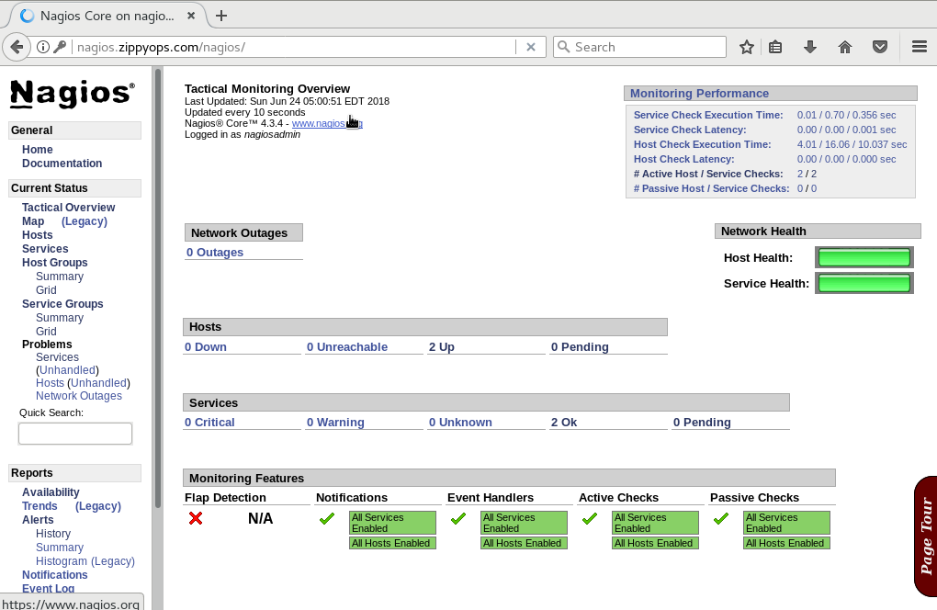

Hosts:

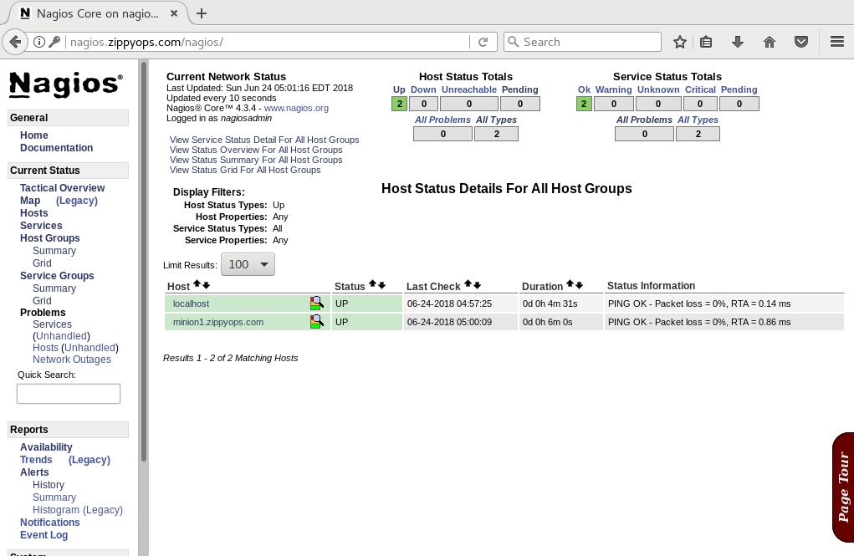

Service group:

